***Equipments Use in Equine Castrations***

1. Scalpel Blade
2. Suture materials & needles
3. Reimer Emasculator
4. Serra Emasculator
5. Sand’s Emasculator
6. Hendersons Equine Castration Instrument & power drill

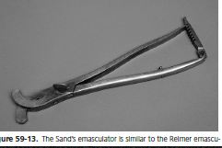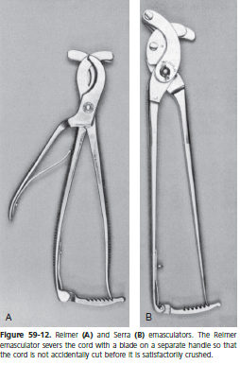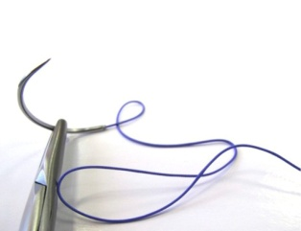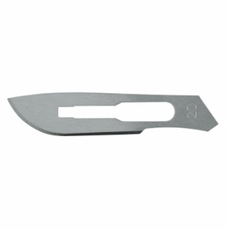

1. 2. 3& 4. 5.

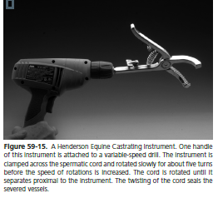

6.