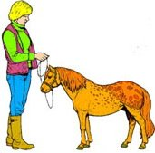**POST -OPERATIVE CONSIDERATIONS**

After the procedure the veterinarian and owner must monitor the recovering horse closely. Bleeding should stop within an hour or two after surgery, the horse should be supervised until bleeding stops completely.

Note that you might see dripping for as many as 12 hours or more. Drips are not a problem, but a steady stream must be halted. Usually the veterinarian will find the bleeder and tie it off, or pack the surgical area full of gauze if he/she can’t find it. Packing puts pressure on the blood vessel and (the bleeding) will stop, and the gauze can be taken out in a day or so.

Clients should keep the horse confined for the first 12 to 24 hours following surgery to make sure the blood clots well in the area. The horse should not be running around—this elevates his heart rate and blood pressure, which could increase the risk of bleeding resuming. After this initial period, however, the horse must get moving.

The horse needs exercise to prevent excessive swelling and aid any drainage from the incisions, (The owner needs) to take him out for 20 minutes at a trot, or lead him three or four miles (at the walk—a walker or longe line). Just turning him out doesn’t always work because the horse is sore and doesn’t want to move.

Many veterinarians recommend 15 minutes of longing once or twice a day for two weeks after castration. This will help minimize swelling, which is the body’s normal reaction to injury, and facilitate drainage to reduce infection risk.

Some horses appear lame, just because it hurts to advance the leg around the swollen area,” says Connally. “If the swelling goes clear down into their belly they definitely need more exercise.

Taking horses’ temperatures daily is extremely important, if horses have fevers, medical attention is required, and an antibiotic drug would be administered such as Procaine penicillin.

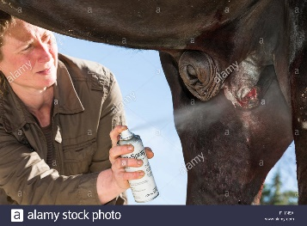Managing pain and inflammation is important as well, so that the horse will be comfortable enough to exercise and stave off swelling. Anti-inflammatory drugs administered are

* flunixin meglumine (Banamine)
* phenylbutazone (Bute)

An insect repellent / screwworm is applied around the infected area.

The horse is also protected against the risk of tetanus at the time of surgery by the administration of tetanus anti-toxin.

Recently castrated colt should not be in contact with mares for between 1-2 months post castration to ensure that they are no longer fertile and that they have lost the hormonal urge to exhibit stallion-like behaviour.

**Behavior**

Depending upon the horse’s age and maturity level, it may take several weeks for the testosterone levels to decrease. Aggression, especially to other horses, may still be seen for this short period of time. However, stallions castrated after maturity (six years old or older), especially those that have bred mares, may continue to possess stallion-like behavior, which could include the development of an erection and an attempt to mount and breed mares in estrus.

Semen remains in the horse’s accessory sex glands and the portion of the vas deferens not removed during surgery. There is usually enough present for one ejaculation. Therefore, gelded mature horses should be quarantined from mares for 14 to 30 days post-surgery.

**Positive Perspective of Castration**

Horse owners can promote equine welfare by becoming educated on castration practices and working proactively to address widespread concerns of the unwanted horse.

If the goal is to continue to improve a breed and minimize the number of horses that fail to meet expectations, the surgical procedure of castration should be utilized to decrease the number of unwanted horses.

Horse owners can act responsibly by putting the horse first.

