INTRA OPERATIVE SURGICAL PROCEDURES
- After induction of general anesthesia.
- Horse is placed in lateral recumbency with its head and neck extended moderately (for surgical exposure).
- Transnasal video endoscope is inserted to allow intra-operative viewing of the larynx.
- A 10 to 12 cm (4 to 5 inch) skin incision is made ventral and parallel to the linguofacial vein, extending caudally from a point 4 cm (one and a half inch) cranial to the ramus of the mandible.
- A Metzenbaum scissor is then used to separates the linguofacial vein from the lateral margin of the omohyoideus muscle along the length of the incision.
- If needs be ligate and divide a branch of the linguofacial vein that enters the omohyoideus muscle.
- An Allis tissue forceps is used to elevate the linguofacial vein attached to perivascular tissues at the middle of the incision allows a cleavage plane between the sternocephalicus and cricothyroideus muscles which can be digitally opened and enlarged thus, exposing the lateral and dorsal boarder of the larynx.
- A 6 to 8 cm wide malleable retractor placed under the linguofacial vein and sternocephalicus muscle is used to expose and maintain access to the larynx.
- The muscular process of the arytenoid cartilage lies beneath the cranial portion of the cricopharyngeus muscle and can be exposed by sharply separating the cricopharyngeus and thyropharyngeus muscles along the junction of their aponeuroses.
- Alternatively, a plane dissection can be created off the back edge of the cricopharyngeus muscle, under the vascular plexus that lies over the CAD muscle.
- Rostral retraction of the cricopharyngeus muscle exposes the CAD muscle and muscular process (no cricopharyngeus muscle interference).
- The prosthetic suture is first placed through the cricoid cartilage. The choice of prosthetic suture is often based on surgeon preference. Materials that have been used include braided polyester, with (No. 5 Ticron) or without silicone coating, 6-mm surgical stainless steel wire, braided lycra, and nylon.
- Using the left index finger as a guide, the needle is “walked off” the caudal edge of the cricoid cartilage 2 to 3 mm lateral to the dorsal midline until the point slips under the cartilage.
- The needle is then advanced cranially while avoiding penetration into the lumen of the larynx. Then the needle is then rotated to penetrate the cricoid cartilage 2 to 3 cm cranial to its caudal border and 1 cm lateral to the dorsal ridge.
- Inspect the laryngeal lumen via videoendoscope before drawing the needle through the cartilage and overlying CAD muscle.
- After the needle has been drawn through the cartilage and out of the incision, the needle is cut off and the suture ends are tagged with a small hemostat.
- A second suture is usually placed 10 mm lateral to the first using the same technique.
- If the cricopharyngeus muscle has not been retracted forward, a large hemostat is passed under the cranial aspect of the cricopharyngeus muscle to bring both ends of the first and second sutured cranial toward the muscular process of the cricoid cartilage.
Placing the suture through the muscular process can be done using the following methods;
- Heavy needle drivers and a reverse cutting No. 6 Mayo needle.
- A No. 6 Martin uterine needle.
- A 3-mm bone trocar to create a tunnel through the process.
- A 12- to16-gauge hypodermic needle can also be used to create the tunnel through the muscular process.
- The prosthesis can be placed through a loop of No. 1 stainless steel wire that is passed through the tunnel to facilitate prosthesis placement through the muscular process.
- After removal of the needle, firm tension is placed on the cranial and caudal ends of the suture to remove any slack, ensuring the prosthesis is tight against the larynx.
- If a trocar is being used, both sutures can pass through a single tunnel; otherwise, the second suture is placed approximately 5 mm more caudad in the muscular process.
- The trailing ends of the prosthetic sutures can be drawn under the cricopharyngeus muscle if necessary with a hemostat, and the sutures are tied.
- After the prosthetic suture or wire is tied or tightened, all retractors should be removed to allow the larynx to assume a normal, nonrotated central position to allow accurate assessment of the degree of abduction.
- When using suture as the prosthesis, leaving the cut ends 1.5 to 2 cm long can allow the knot to be undone and retied if repeat laryngoplasty is performed within the first week of the original surgery.
- After the sutures have been tied, the thyropharyngeus and cricopharyngeus muscles can be reapposed with simple continuous suture using 2-0 absorable suture.
- Then apposition of the fascia adjacent to the linguofacial vein to the omohyoideus muscle with simple-interrupted or continuous sutures of 2-0 synthetic absorbable suture material.
- The skin is closed with staples or 2-0 nonabsorbable monofilament suture material.

Important Points To Note
- Accidentally incising the linguofacial vein.
- Tissue trauma associated with the initial blunt dissection over the larynx.
- Esophagus, thyroid gland, laryngeal and thyroid vessels, and ventral branch of the first cervical and cranial laryngeal nerves should be avoided during site preparation and suture placement.
- Care must be taken to ensure that each trailing suture end is matched to its leading end and that both sutures are placed before one is tied (to avoid cutting the tied suture).
- Incorrect Placement of the suture: too far laterally results in inadequate abduction.
- Mucosal penetration of the needle into the lumen of the larynx.
Intra Operative Complications
- Hemorrhage: hemorrhage can arise from the plexus of laryngeal vessels that are inadvertently punctured.
- Needle breakage: Breakage of the needle when passing through cartilage can occur and all reasonable effort should be made to retrieve the broken portion.
- Perforation of the laryngeal mucosa: Occurs when placing the needle under the caudal border of the cricoid cartilage.
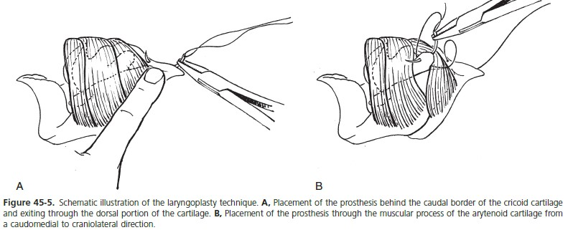
- Prosthetic suture “cut-through” of either the cricoid cartilage or muscular process of the arytenoid cartilage.

