PRE-OP FOR LARYNGOHYOID REDUCTION OR LARYNGEAL TIE FORWARD

Anatomical location for the surgery site

:

 The caudal free margin of the soft palate, the epiglottis and the larynx in a horses’ Upper respiratory tract.

The soft palate is the anatomic extension of the hard palate, also referred to as the roof of the mouth. In the horse, the soft palate is very long. It extends from the termination of the hard palate all the way to the base of the epiglottis. The epiglottis, therefore, lies on top of the soft palate, making the horse an obligate nasal breather. The epiglottis is one of several cartilaginous structures that make up the larynx .

Therefore when the soft palate moves dorsal to or lies on top of the epiglottis, it creates a functional obstruction within the airway.

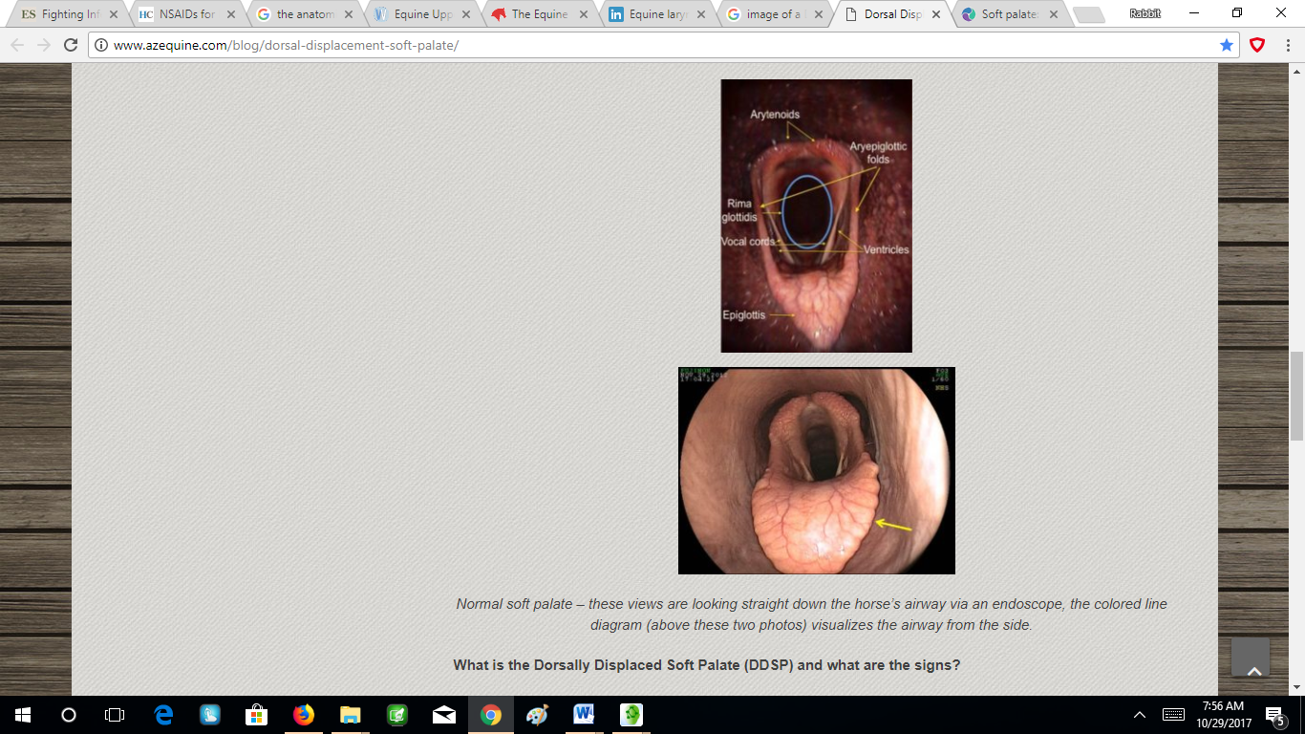 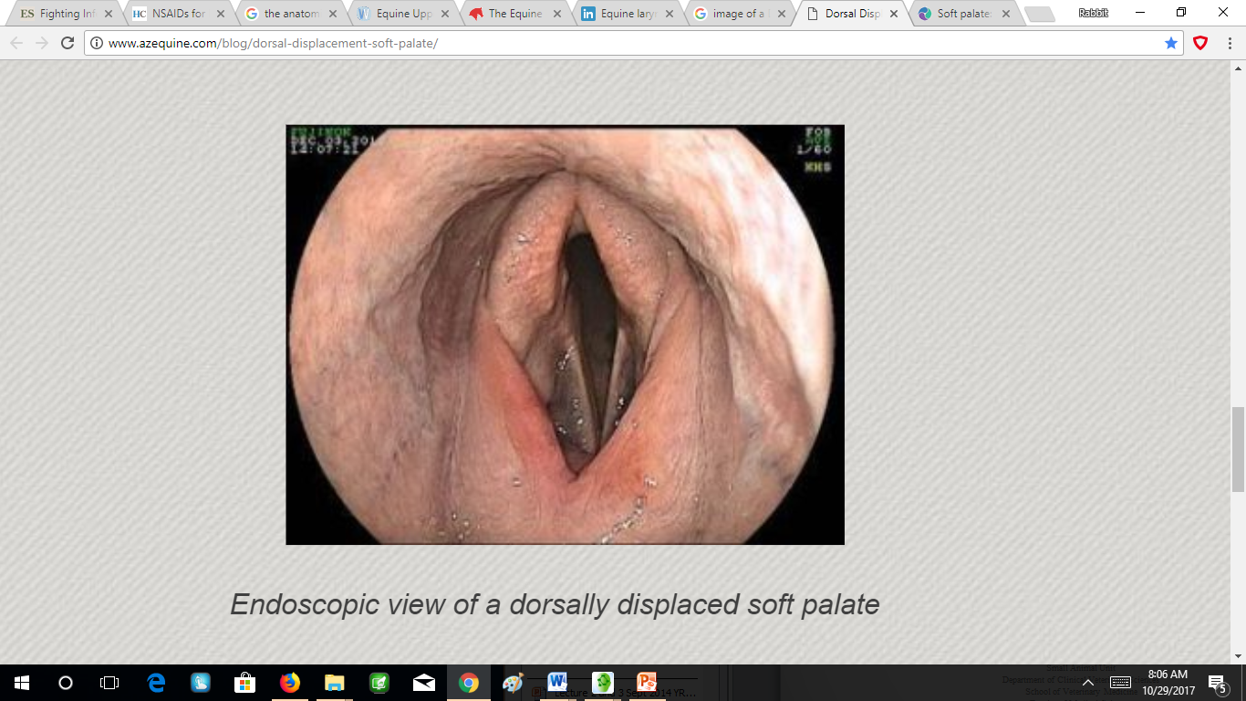

IMAGE1 IMAGE2

IMAGE 3 showing the epiglottis sitting firmly on top of the soft palate maintaining the seal between the oral and nasal cavities and thus allowing the horse to breathe entirely through its nose.

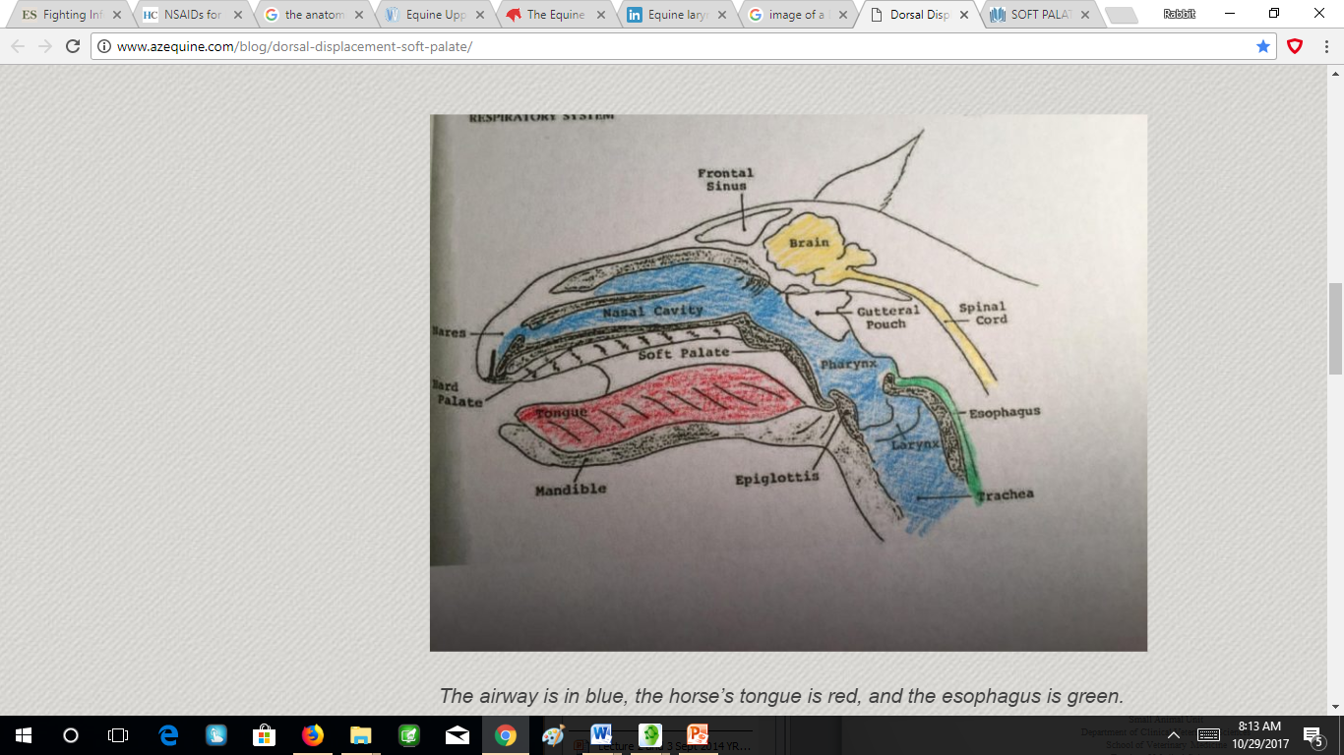

Drugs given:

Systemic antibiotics- Pencillin injectable via IM

Pencillin V is from the class of Beta lactams and it is used to prevent and treat infections caused penicillin organisms

Gas anaesthesia - https://instruction.cvhs.okstate.edu/vmed5412/pdf/23EquineAnesthesia2006.pdf

Anti-inflammatory drug - Flunixin Meglumine Injection via I.V.

This is given to treat pain and inflammation. It can be given pre and post operatively.

Plasma half-life in horse serum is 1.6 hours following a single dose of 1.1 mg/kg. Measurable amounts are detectable in horse plasma at 8 hours post injection.

Surgical Preparation of the site:

The ventral area of the horse’s neck by its throat is shaved. From the base of the jaw, the whole area of the throat and down to the upper 1/3 of the neck. The area is scrubbed and cleaned with diluted Chlorohexidine on cotton. This was followed by repeat applications of 70% Alcohol and 7% Iodine to ensure an aseptic environment.

Instruments used in this surgery:

Retractors

3.2 Drill bit

Scalpel and no.24 scalpel blade

Cotton

Gauze

Drapes

Suture materials: - no. 2 poligecaprone , no. 2.0 lactomer (Polysorb), suture needles

Skin staples

Disposable stapler

Rat tooth tissue forceps

Syringes

Gas anaesthesia equipment.