Dorsal displacement of the soft palate
Dorsal displacement of the soft palate is a disorder of the upper airway in horses. It is one of the most common upper airway obstructions, and it causes poor performance and abnormal noise while exercising. It's usually a disease of racehorses, for which it is often a performance-limiting problem. Over the years, a number of treatments have been developed for this condition; however, none are universally successful, mostly because we do not as yet fully understand the exact cause(s) of this disorder. But before we can further discuss this abnormality, you first need to understand what is normal for the equine upper airway.

Normal Upper Airway Anatomy
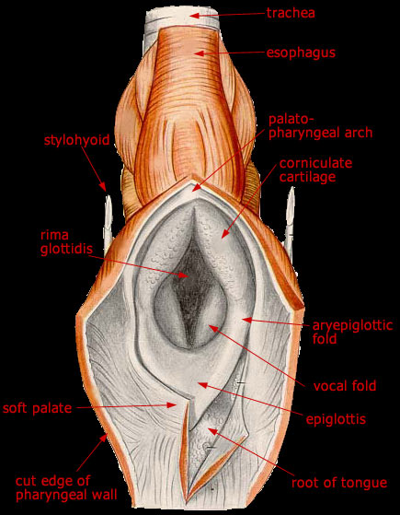 Picture 1 showing Laryngeal cavity and entrance

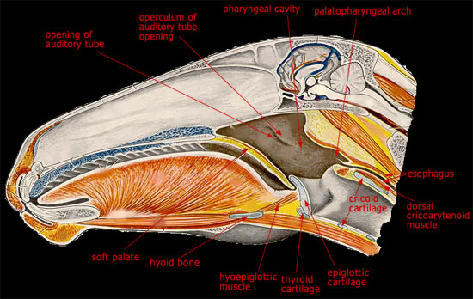
Picture 2 showing Normal Upper respiratory airway antatomy

To understand DDSP, you must be familiar with the anatomy of the naso-pharynx and larynx of the horse. The nasopharynx is one part of the pharynx, which is divided into the nasopharynx and oropharynx. The nasopharynx is that section of the horse's head that lies caudal to the nasal passages and is rostral to the larynx (voice box). The nasal passages sit directly above the oral cavity and hard palate. The nasopharynx is composed mostly of muscle tissue, while the soft palate is a direct extension of the hard palate and forms the floor of the nasopharynx. This is the partition between the mouth and the nasal cavity. The back edge of the soft palate (caudal free edge) is only attached on the sides of the nasopharynx, but extends back to connect with the larynx.
The larynx is essentially a conduit between the pharynx and the trachea (windpipe) of the horse. It is composed of cartilage and muscle tissue. The most easily recognizable structures of the larynx are the epiglottis and the arytenoid cartilages. The epiglottis is a triangular-shaped structure with smooth, scalloped edges and normally lies just above the soft palate. The arytenoid cartilages, often called the "flappers," are paired structures that lie above the epiglottis and form the opening to the trachea.
What's the Function?
Besides joining the nasal passages with the trachea, the soft palate and larynx serve several functions in the horse; two of the most important involve swallowing and breathing. The arytenoid cartilages and epiglottis are very important during swallowing, as they coordinate to protect the trachea from a food or water bolus being inhaled instead of swallowed. During swallowing, the arytenoid cartilages close and the epiglottis flips upward to protect the opening of the trachea.
The soft palate and larynx also have a coordinated function during strenuous exercise. During exercise, the nasopharynx dilates and the arytenoid cartilages open maximally to accommodate as much airflow as possible.
What Went Wrong?
When DDSP occurs, the epiglottis--which normally lies on top of the soft palate--becomes displaced below the soft palate. If this happens when a horse is at racing speed, breathing very fast, then this creates a partial airway obstruction. On expiration (as the horse breathes out), some air goes underneath the now-exposed soft palate and it billows upward (like a sail) just in front of the opening to the trachea and blocks the airway.
Racehorses need maximal oxygen to keep up racing speed, so this decrease in airflow gives them no choice but to put on the brakes. After they slow down, they usually can swallow, allowing the soft palate and epiglottis to go back into their normal anatomical positions and correct the problem themselves. But by that time, the race is over. This scenario is called intermittent DDSP.
Some horses are affected by persistent DDSP--their soft palates are displaced all the time. Swallowing does not correct the problem. Although these horses can breathe normally at rest, they cannot exercise at speed. Many of these horses also have problems swallowing food and/or water correctly (dysphagia).
Since the soft palate and epiglottis also help direct food boluses, when they are not in their normal positions, they cannot protect the opening of the trachea. Therefore, theses horses sometimes inhale food and water while eating, leading to coughing, food and water being expelled through the nostrils, and aspiration pneumonia. This is obviously a much more serious condition, as it can be life-threatening.
What Causes DDSP?
There are several suspected causes for DDSP, but there's no one unifying theory. Intermittent DDSP, which occurs during racing, is thought to be caused by a combination of factors, such as laryngeal inflammation (especially in young horses), excessive backward movement of the larynx, and/or opening of the mouth during racing. Other causes include malformations or problems with the epiglottis.
Persistent DDSP is thought to be caused by severe inflammation around the horse's larynx--more specifically, inflammation that involves the nerves that control movement of the soft palate and larynx, such as fungal or bacterial infections of the guttural pouch.
Diagnosis
Intermittent DDSP can be difficult to diagnose because it only occurs when the horse is exercising at strenuous levels. The first step is to have a physical examination performed by a veterinarian to rule out other causes of exercise intolerance. Then, a standing endoscopic examination of the upper airway can be performed to rule out any structural abnormalities of the upper airway. During the examination, many horses will displace their soft palates, then quickly swallow and replace them. This is normal, and it does not prove that DDSP is the reason for poor performance or noise made during exercise.
Persistent DDSP is easily diagnosed with standing endoscopy of the upper airway. In these cases, the epiglottis, which should be readily visible during endoscopy, is hidden underneath the soft palate (see images at left). If the upper airway is normal, then an endoscopic examination can be performed on the horse while he is exercising on a treadmill. Before the advent of high-speed treadmill endoscopy, DDSP was overestimated as a cause of poor performance in racehorses due to a lack of endoscopic findings.

