POST OPERATIVE CARE AND MANAGEMENT FOR HERNIA REPAIRS
AFTER SURGERY CARE  The most important aspects of after surgery care are “recovery and monitoring”. The recovery and monitoring period includes everything from the time the anesthesia/surgery is ended until the animal is alert, ambulatory and all vitals have returned to normal ranges.  All animals: Immediately after surgery the incision site should be sprayed with and antibiotic wound spray, if possible a water resistant wound spray and finally a lavicidal spray to aid in the prevention of myiasis. All animals TPR and mm/CRT should be accessed immediately post-surgery, then every 10 to 15 minutes as needed until the animal starts to recover from the anaesthesia. All post surgical and monitoring information should be properly recorded. Animals recovering from anaesthesia should be separated from other animals and placed in a holding pen with clean, warm, and dry bedding.  After care for the surgery performed  Immediately after umbilical hernia surgery the animals’ incision site was sprayed using Tetravet (Oxytetracycline Hydrochloride), then Aluspray (silver sulfadiazine & aluminium) was used as a water resistant covering and then the area around the surgical site was sprayed with a Larvicide.  The animals were then placed into separate holding pens containing clean dry bedding and their vital signs were monitored and recorded every 15mins until they showered signs or recovery. Both sets of animals TPR and mm/CRT were monitored but the calf rumen contractions was also monitor. This is because rumen stasis is a fatal problem in ruminants. Animals in lateral recumbency had their mouth open and their tongue to the side to prevent asphyxiation. Water was also removed from the pens to prevent accidental aspiration and drowning. The recovery signs observed for the pigs include, grunting, moving the ears, legs and tail. While the signs of recovery seen in the calf were bellowing, moving the legs and tail.  Thirty to forty-five (30-45) minutes after surgery, the animals’ vital signs were approaching normal and they started to show signs of arousal. Any animal that showed signs of recovery but were not aroused, their side would be rubbed to increase arousal time. Subsequently, their vital signs returned to normal.  Sutures for all animals should be removed in no later than 2 weeks/ 14 days post surgery. | POST OPERATIVE CARE  Post operative pain treatment: Post-Op analgesia/NSAIDs are very important following a surgical process such as a hernia repair. This is because pain and inflammation persist at the surgical site for days post surgery. Animals should be treated 3-5 days post surgery or until the swelling, pain and inflammation subsides.  Post-op pain management  Pigs: The pigs were given the first dose of Banamine (flunixin meglumine) day 1 post surgery, IM and a follow up treatment was given on day 3. On day 4 slight swelling was still observed around the incision site so another treatment of banamine was given.  Calf: The calf was also treated with Banamine post-surgery. The treatment was also identical to that of the pigs, the only differences were the route of administration which was IV instead of IM and the calf was only given Banamine day 1 and day 3, post surgery.  The withdrawal period for Banamine is 12 days.  Post-op antibiotic treatment  Hernia repair is suppose to be an aseptic procedure, but in order to prevent any accidental contamination antibiotics should be administered post-op to help fight off any bacterial infection that might arise. Therefore antibiotic should be given for 3 to 5 days post surgery.  Pigs: The pigs were given the first dose of Penicillin-Streptomycin (Pen Strep) on day 3 post surgery.  Calf: the calf was also given the first dose of Penicillin-Streptomycin (Pen Strep) on day 3 post surgery.  The withdrawal period for Penicillin-Streptomycin is 21 days. | POST-OP COMPLICATIONS  Hernia repair is an invasive surgical procedure therefore a lot of post surgical complications can arise. The following are complications that could arise following surgery:  - Superficial dehiscence.  - Myiasis  - Hemorrhage  - Hernia reoccurrence  - Risk of infection of the surgical site  - Hypothermia  - Abscess formation  - Hyperesthesia or prolong post-surgical pain.  - Seroma  CLIENT ADVICE  Unless the underlying cause of the hernia is known to be by trauma, or infection the animal should not be used within the breeding program. This is because umbilical hernias are known to be hereditary so it can be genetically passed on to the offspring.  Owners should keep recovery area clean and remove animal waste & garbage.  Surgical site should be checked daily and should be cleaned and dressed regularly.  Proper neonatal care: clipping the external umbilicus and dipping it within 7% iodine to prevent infectious cause of umbilical hernia.  Proper stockmen and husbandry care for both piglets and adult pigs.
FURTHER INVESTIGATION OF THE HERNIA
The masses removed from the female pig and calf was an adhesive hernia. It was remnants of the umbilicus and urachus that was attached to the fibrous omentum. To identify what structures were within the mass, samples could be taken and sent to the lab for further diagnosis.
On later dissection of the mass from the female pig, a straw coloured fluid was discovered, which had a fluid and colour consistence with urine. This fluid sample along with other samples of the mass was taken for biochemical and histological analysis.

POST OP IMAGES AND VIDEOS OF THE ANIMALS AFTER SURGERY.

IMAGE 1:
Image showing animal placed in a holding pen with clean, warm, and dry bedding after coming out of surgery.
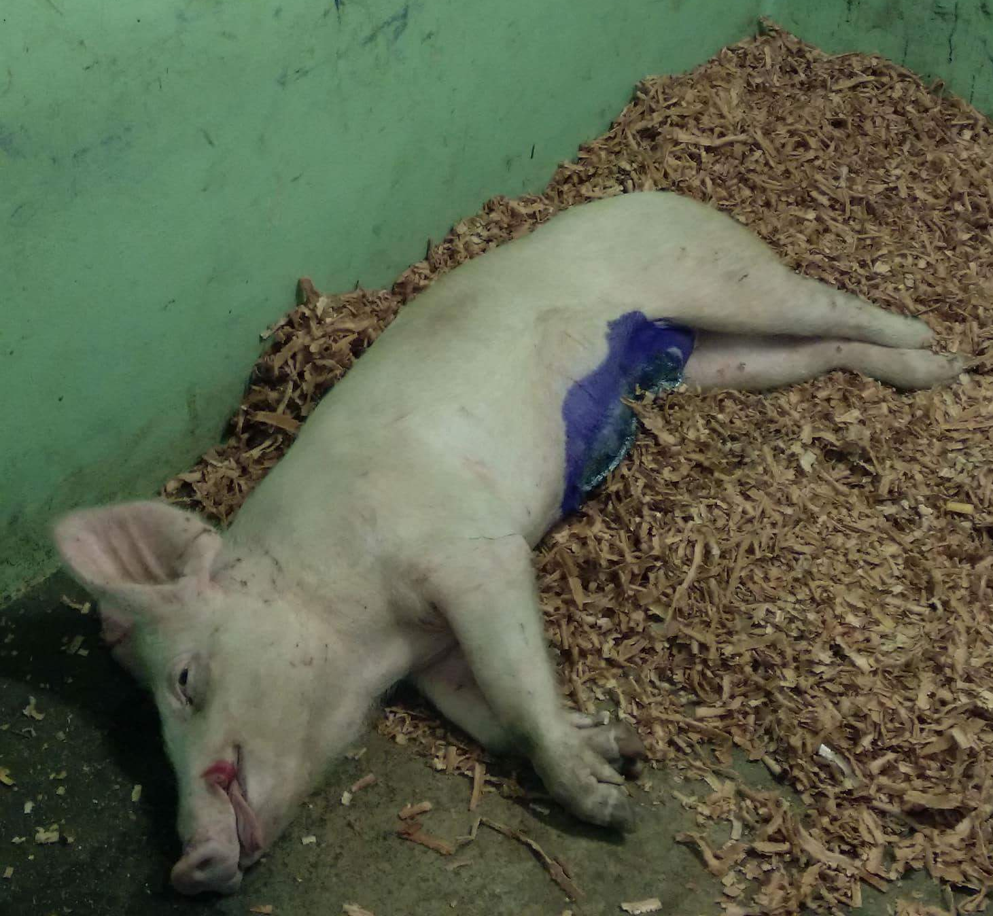

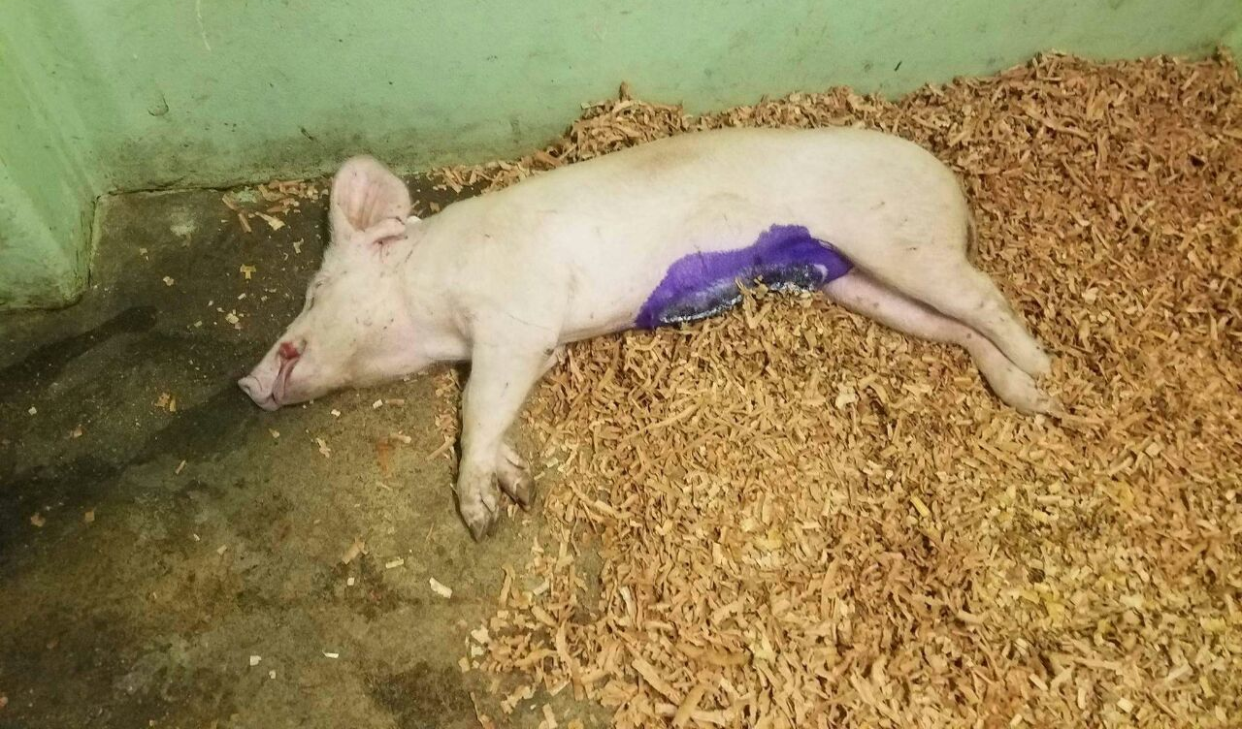

IMAGE 2: Showing the female pig the morning after the surgery. The animal is bright , alert and responsive. Its vitals were checked too.(Image 2b) . The surgery site was investigated and it displayed some swelling caudally of the umbilical surgery area. (Image 2c)

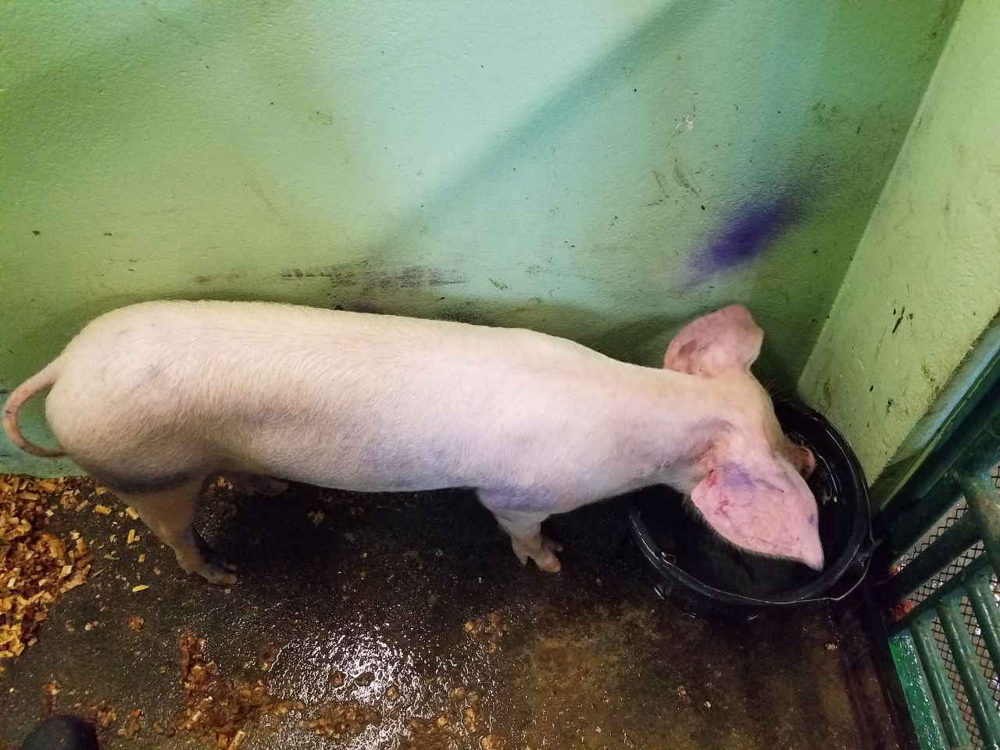IMAGE 2

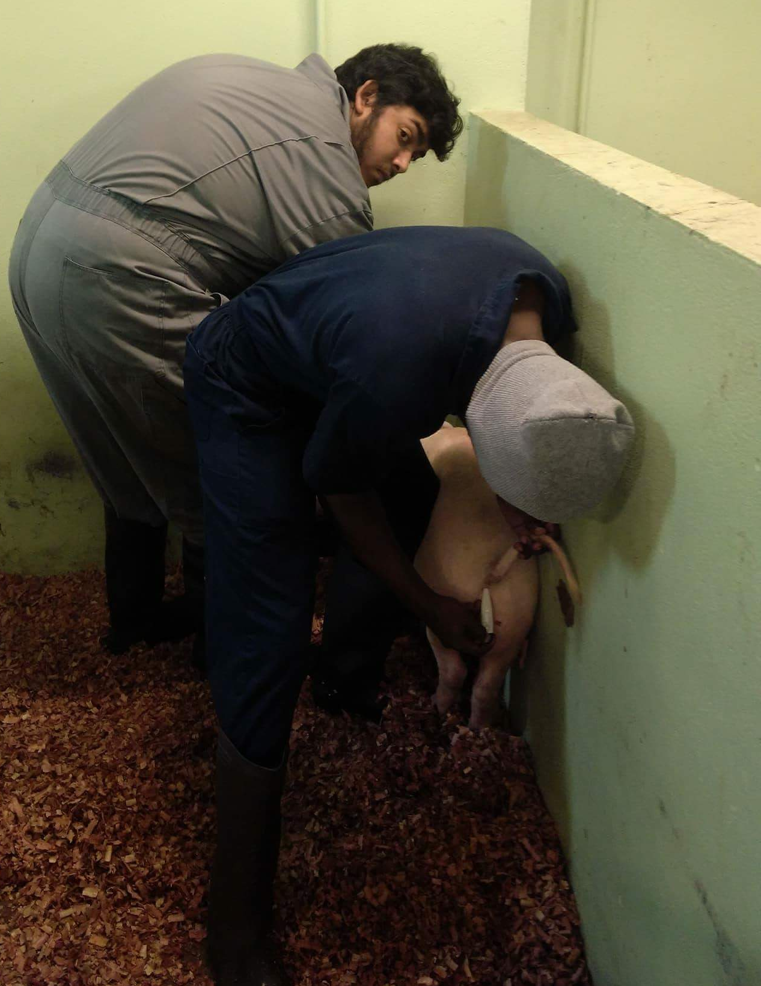 IMAGE 2b
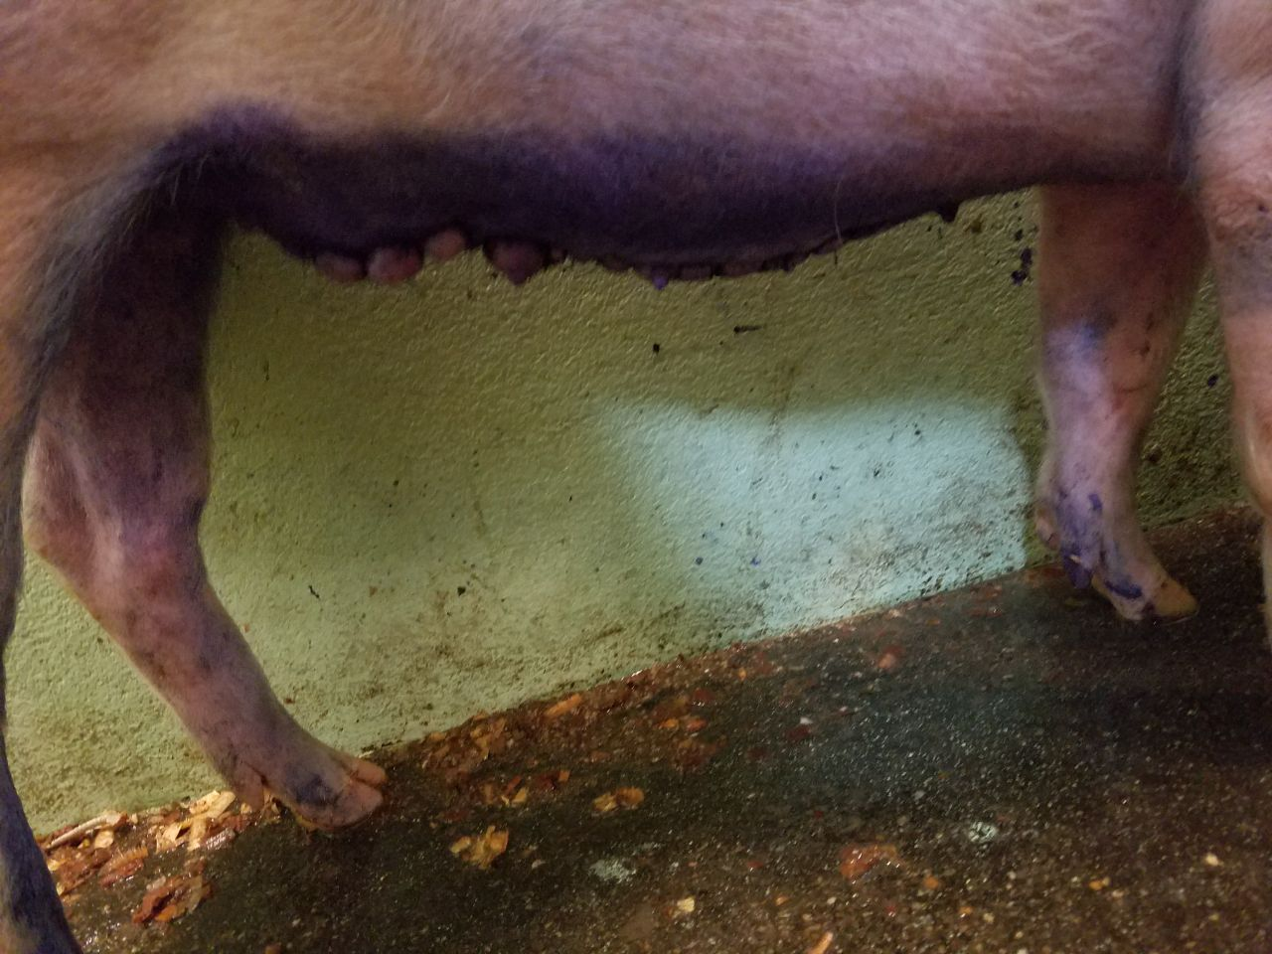 IMAGE 2 C

IMAGE 3: Showing the female pig on Day 3. She was Bright, alert and responsive and in good health.
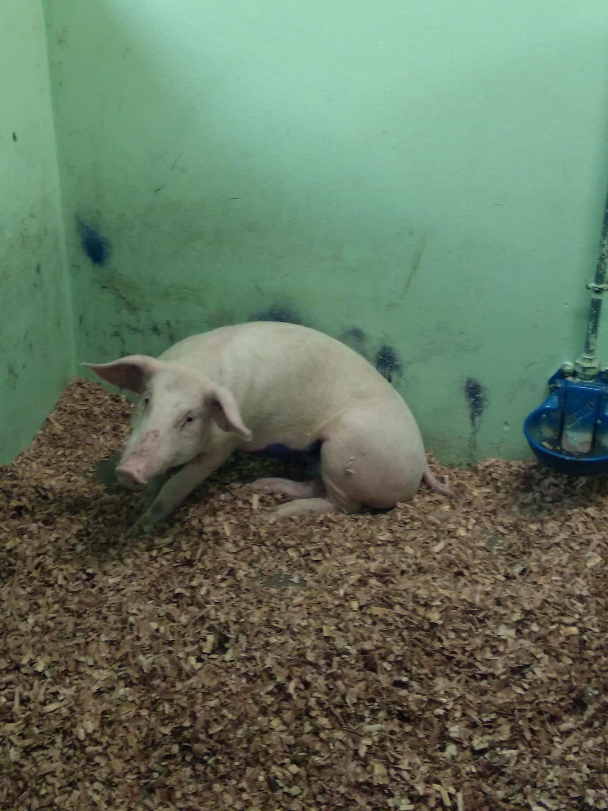

IMAGE OF FEMALE CALF
After the surgery, Calf was out of the anaesthesia, standing and moving around.

Image of the surgical area of the calf day 1 after the surgery.
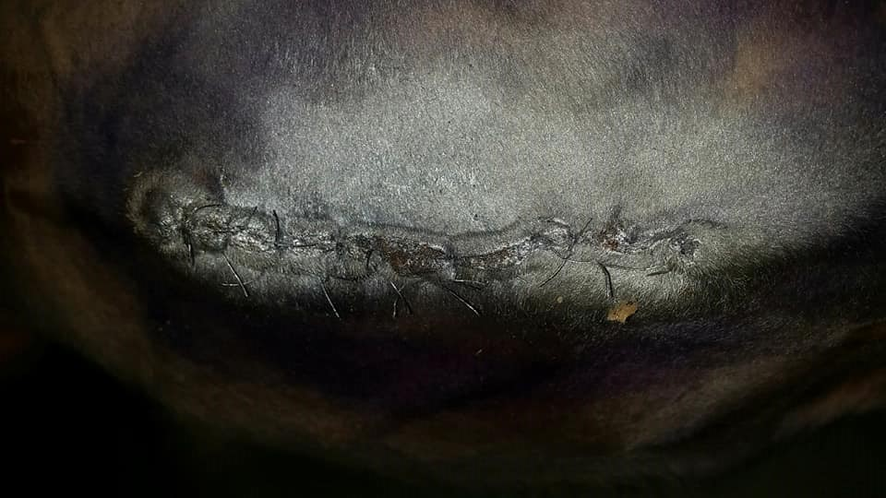

Image 3 showing the surgical site on the calf three days after the surgery.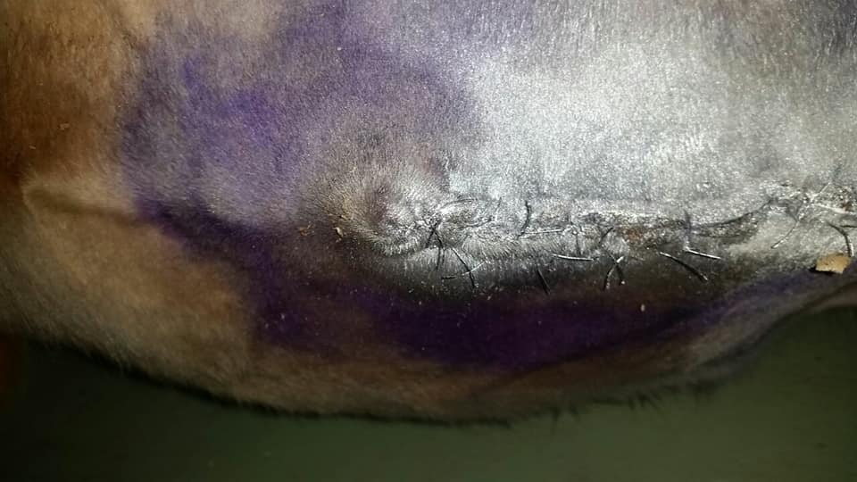

Image 3 Showing the calf 5 day after the surgery eating. She was bright, alert and responsive
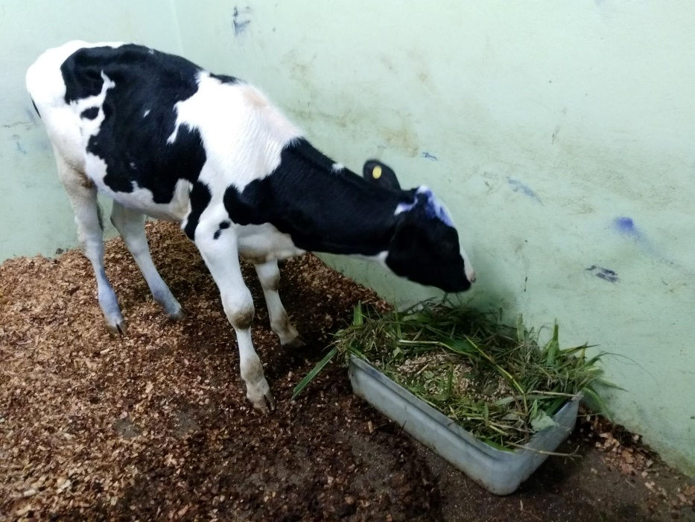

IMAGE OF THE MALE PIG
Image1: showing male pig lying in a holding pen with clean, warm, and dry bedding after coming out of surgery.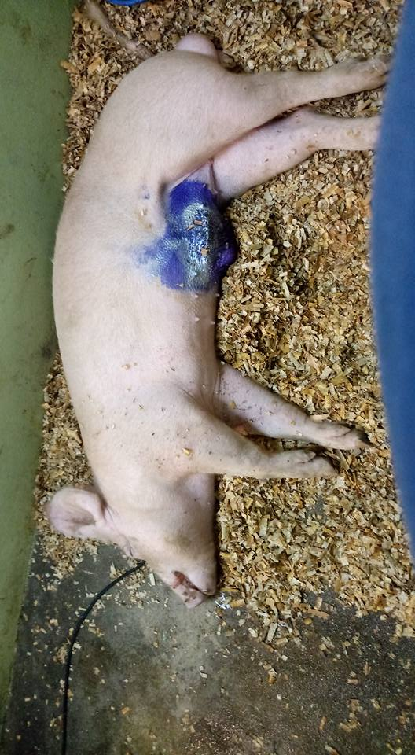
Image 2 Showing the male pig day 2 after surgery. The animal was bright alert and responsive.
The surgical area was swollen
