INTRA OP
For a reducible umbilical hernia in a male pig.
Note: For a male pig, the surgical procedure must be carefully done especially if the hernia is situated close to the penis. To avoid incising any structure connected to the penis, make an U- shaped incision in front of the penis.
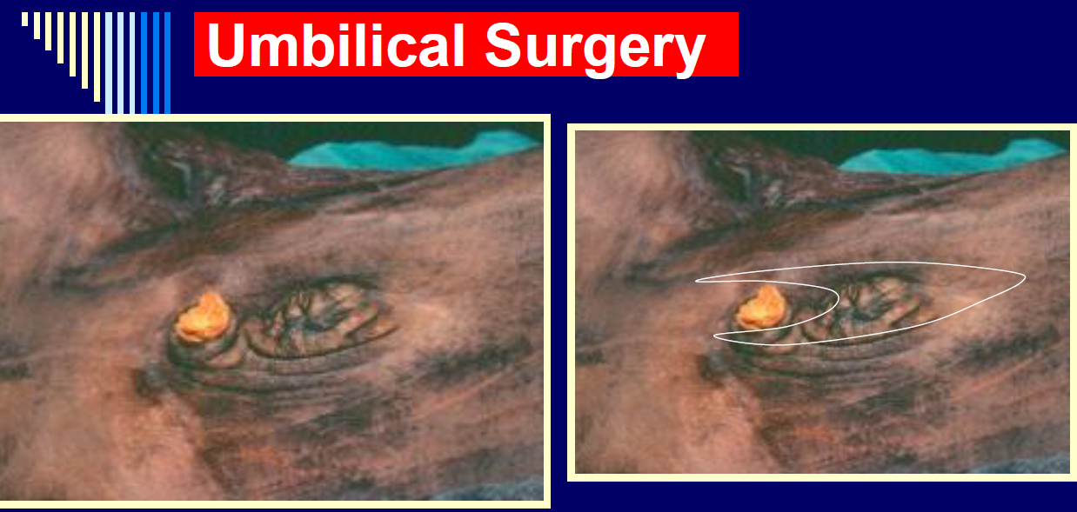

PROCEDURE:
Step 1: Sterile drapes where place on the patient and around surgical area.
Step 2: A lateral incision was made on the medial side of the hernia and penis using a #24 Scalpel blade.
Step 3: Blunt dissection of the subcutaneous layer was accomplished with the surgeon’s fingers and traction with a blunt curved mayo scissor.
Step 4: Further tissue adhesions to the mass was broken down by blunt dissection.
Step 5: The abdominal wall was incised along the lateral aspect of the hernia ring and the surgeon’s finger was used to feel for any adhesions to the mass. This was done by sweeping her fingers up and under the mass and around in the peritoneum.
Step 6: Sterile gauzes were used to wipe any excessive bleeding in the surgical wound.
Step 7: Used haemostats throughout the surgery intermittently to control bleeding.
Step 8: Splash blocks were used throughout the surgery when the animal showed signs of feeling pain.
Step 9: No attachments were found. The hernia ring was determined and the abdominal wall was sutured with Nylon (non-absorbable suture material) using a vest over pants suture pattern.
Step 10: The subcutaneous layer was sutured using no. 2 polypropolene absorbable suture with a simple continuous suture pattern.
Step 11: The skin was sutured using nylon with an interrupted cruciate, tension relieving, suture pattern.
Step 12: The surgical site was cleaned with sterile gauze to remove any additional blood.
Step 13: A gauze with diluted chlorhexidine was used to clean any additional blood away from the surgical site and body.
Step 14: The surgical site was sprayed with Tetravet followed by Alushield spray and larvicide around the surgical.

Image from the surgery

Image showing the hernia ring found in the male pig.
Note: the Army Navy retractors used to retract skin to see the area more clearly
and towel clamps used to hold a bunch of the tissue.
