Anatomy of Umbilicus
The umbilicus is the remnant of the fetal-maternal connection. It contains paired umbilical arteries, a single umbilical vein, and the urachus.
Prior to Birth
The umbilical vein carries Oxyen (O₂₎ to fetus via liver/portal vein. The umbilical arterioles are branches of the internal iliac artery and carry waste materials and unoxygenated blood to the placenta. The urachus connects the fetal bladder to allantoic sac.
Flow of blood (review)
https://www.youtube.com/watch?v=XDF2QyQtd_Q

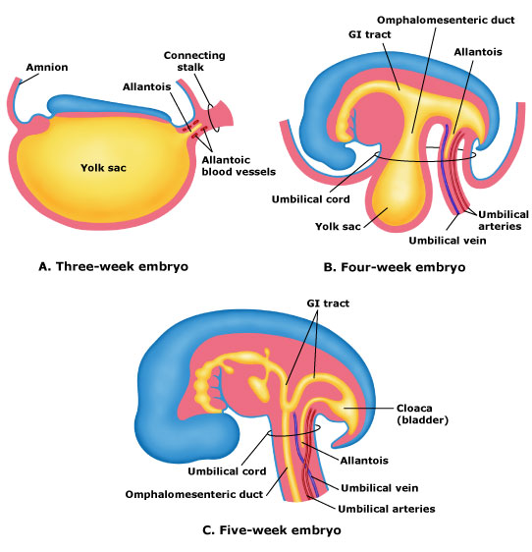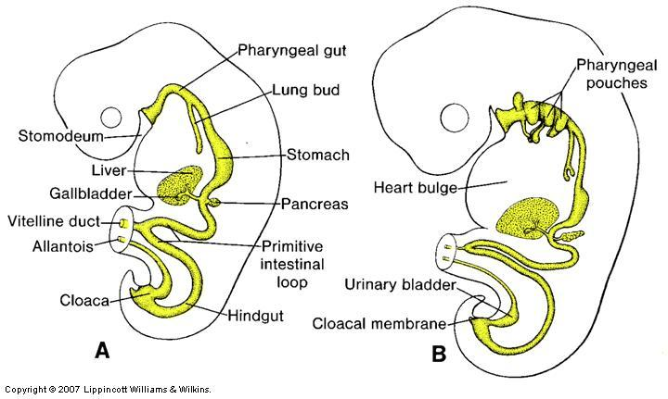
Bladder
Uranchus

Post Partuation
After normal delivery, the smooth muscle surrounding the umbilicus contracts in response to stretching at parturition. Umbilical arterioles and urachus retract into abdomen and undergo transformation into bladder round ligament or atropies respectively. The umbilical vein becomes the round ligament of the liver and amniotic membrane remnants remain outside the body wall but rapidly collapse with smooth muscle contraction.
