INTRA OP
COMPLICATED HERNIA
Step 1: Drapes where place on the patient and around surgical area. (See Image below)
Step 2: An elliptical incision was made 4cm cranial from the mass, passing along the lateral sides of the mass, and connecting 3 cm caudally to the mass using a #24 scalpel blade. (See Image below)
Step 3: The skin flap was removed.
Step 4: Blunt dissection of the subcutaneous layer and tissue adhesions around the mass was done using a blunt curved mayo scissor along with the surgeon’s fingers. (See Image below)
Step 5: The curved scissor was further advanced laterally around the mass on both sides until the tissue adhesions around the mass were separated.
Step 6: Splash blocks were used throughout the surgery when the animal showed signs of feeling pain. (See Image below)
Step 7: Some ligatures were made to stop excessive bleeding of blood vessels when detaching the tissue adhesions with the blunt scissor.
Step 8: Haemostats were used throughout the surgery intermittently to control bleeding.
Step 9: A 2 cm incision was made laterally to the abdominal wall
Step 10: The surgeon’s finger was then placed inside the peritoneum to feel for intestine and any further adhesions to the mass. This was done by sweeping her fingers up and under the mass and around in the peritoneum.
Step 11: The mass was discovered to be attached to the omentum and body wall. The mass also included remnants of the umbilicus. (See Image below)
Step 12: The mass was removed from the body wall using a blunt straight mayo siccors and with blunt dissection with fingers.
Step 13: The 8cm in diameter mass was placed on an awaiting steel tray. (See Image below)
Step 14: Sterile gauzes were used to wipe any excessive bleeding when the mass was removed.
Step 15: The hernia ring was determined and the abdominal layers and muscles were sutured with Nylon (Non-absorbable suture material) using six (6) vest over pants tension relieving suture patterns. Army navy retractors were used to keep the intestine into the peritoneum by pressing down the intestine with them and to prevent puncture of the intestine. The retractors were also used to assist in holding the layers upwards to facilitate appropriate grasping of tissues for suturing. Sterile gauze was used in this step also to remove any excessive bleeding in the area. (See Image below)
Step 16: The subcutaneous layer was sutured using no. 2 polypropolene absorbable suture with a simple continuous suture pattern. (See Image below)

Step 17: The skin was sutured using Nylon (non-absorbable suture material) with an interrupted horizontal mattress, tension relieving, suture pattern. It was also followed with a simple continuous suture pattern in between the horizontal mattress suture pattern, to reassure non-exposure of the inner layer of the epidermis and the dermis. (See Image below)

Step 18: The surgical site was cleaned with sterile gauze to remove any additional blood.
Step 19: A gauze with diluted chlorhexidine was used to clean any additional blood away from the surgical site and body.
Step 20: The surgical site was sprayed with Tetravet followed by Alushield spray and larvicide around the surgical. (See Image below)
Step 21 The mass was dissected and samples were taken for histological analysis.

IMAGES from the surgery

DETAILS | IMAGE
Sterile drapes were placed on the animal and attached onto the animal’s body with towel clamps by the surgeons. | 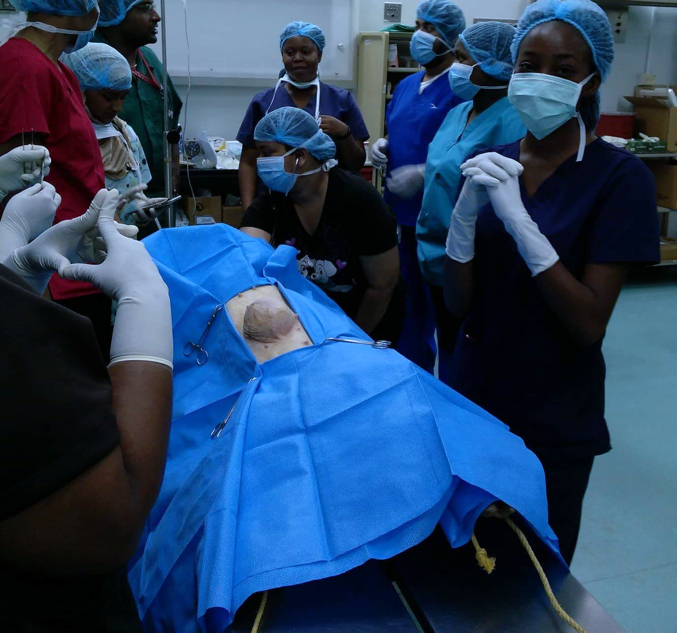
Elliptical incision being made on the patient’s skin
Student surgeon using curved mayo scissor (image a)  and fingers (image b)  to blunt dissect around the mass | 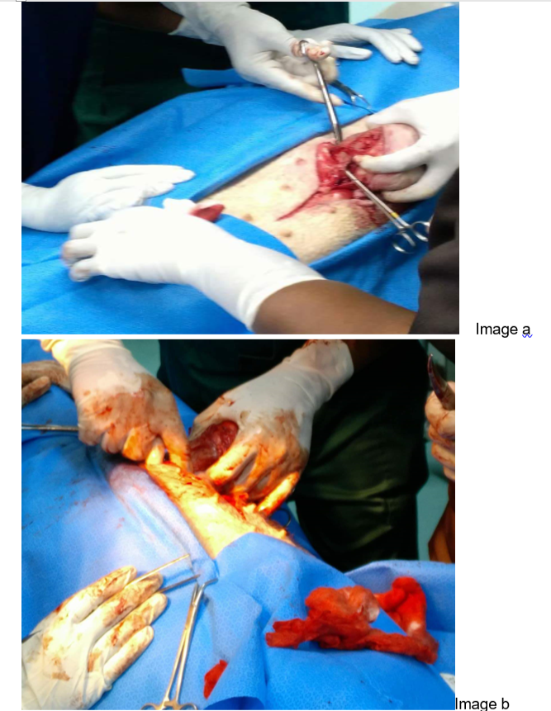
Splash block with solution being used during the surgery when the animal appeared to feel the pain of the procedure going on | 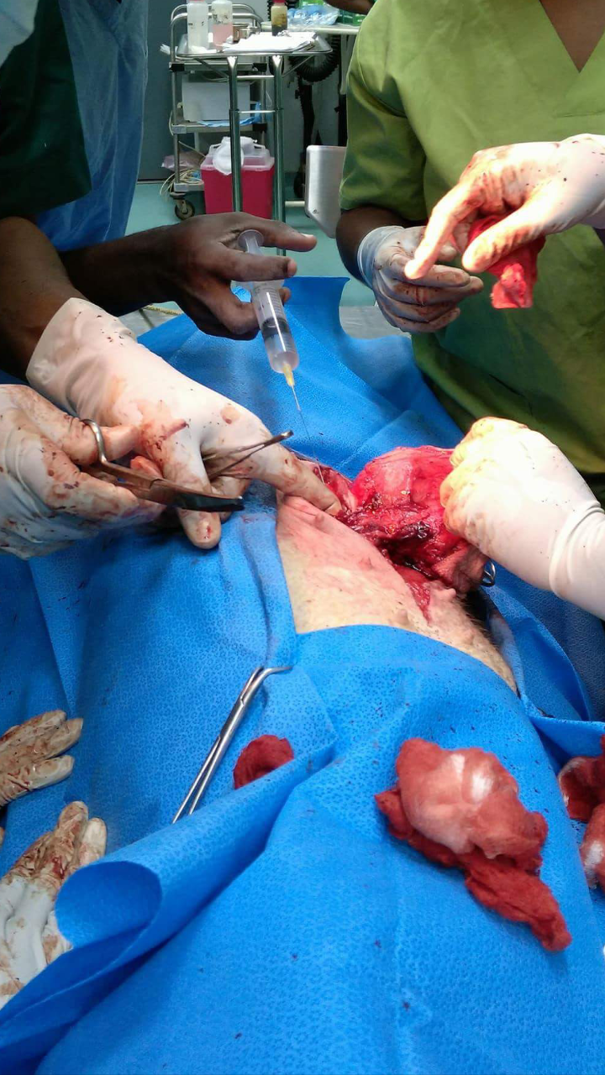
Patient vitals being monitored during the surgery by the assisting surgeons | 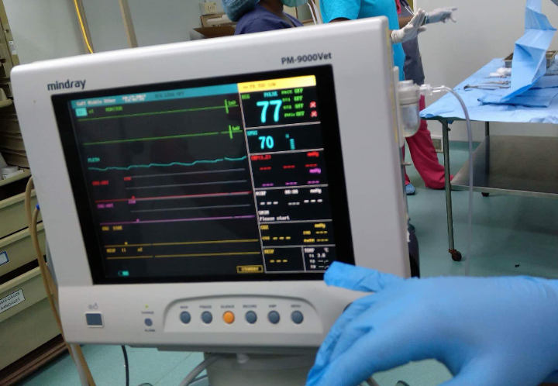
Hernia mass being identified in and from the peritoneum. After which it was determined the mass was attached to the omentum and body wall. | 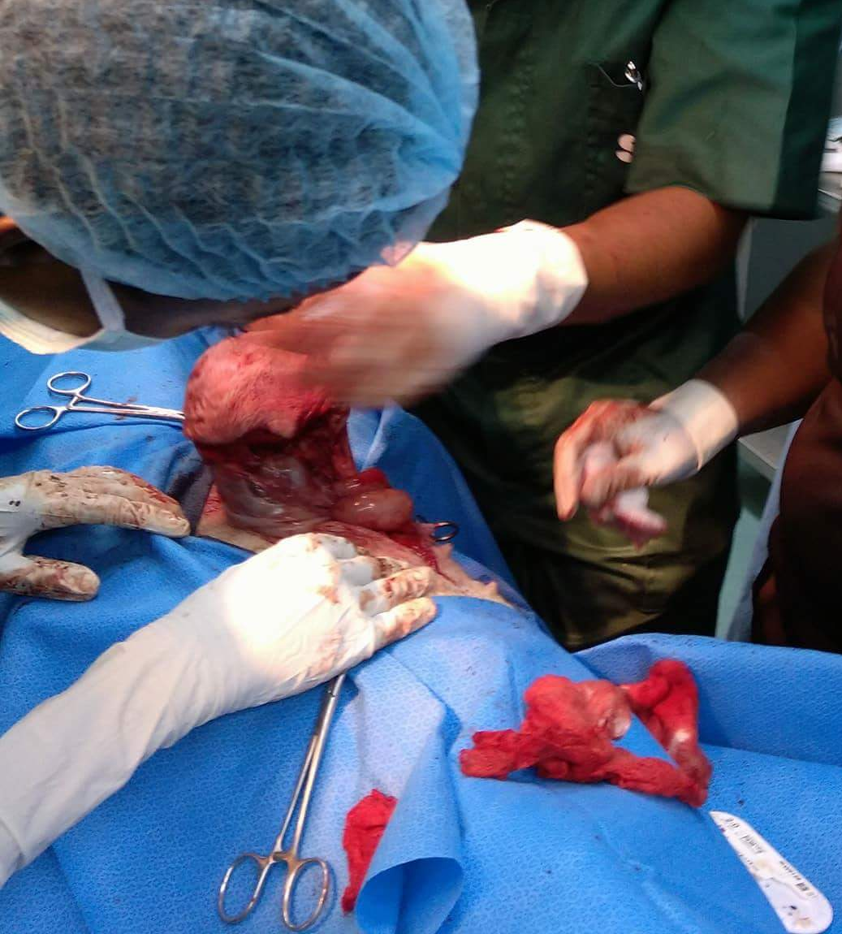
Hernia Mass that was removed from the patient. | 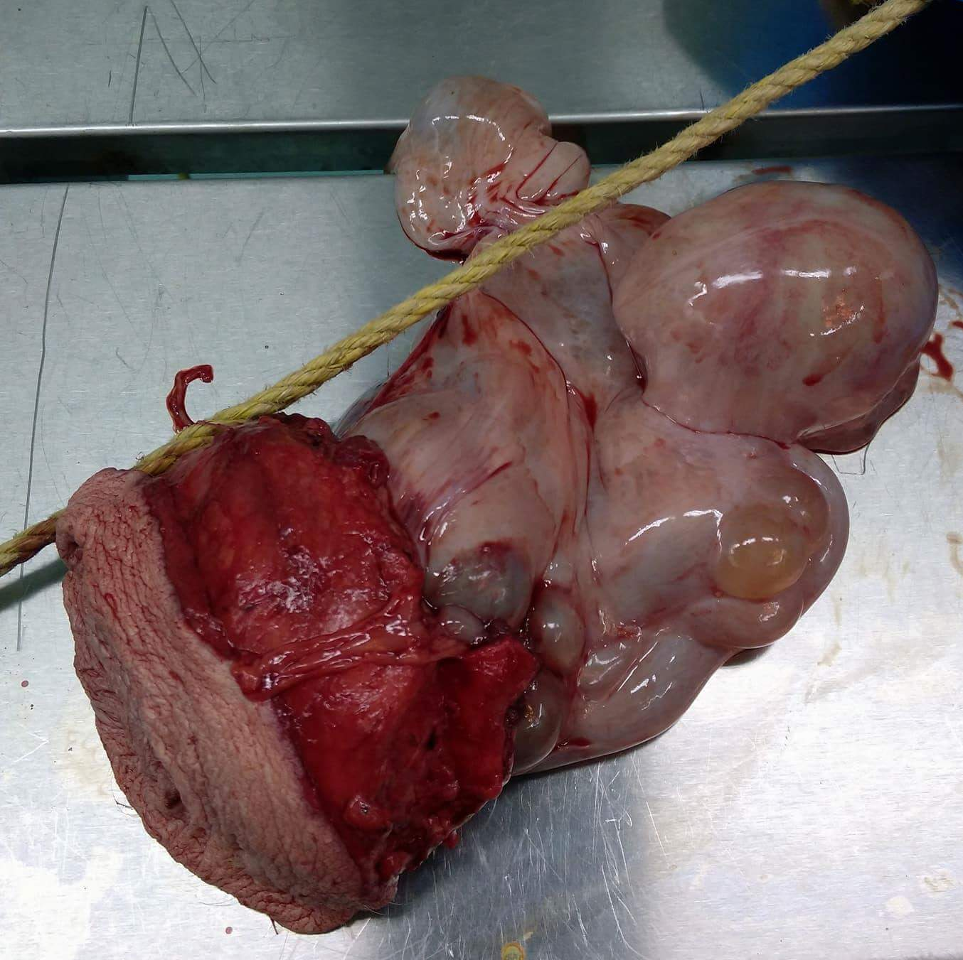
Image showing use of Army naval retractors by one surgeon to raise one end of the abdominal layer while another student surgeon perform the vest over pant suture pattern on the abdominal layer. | 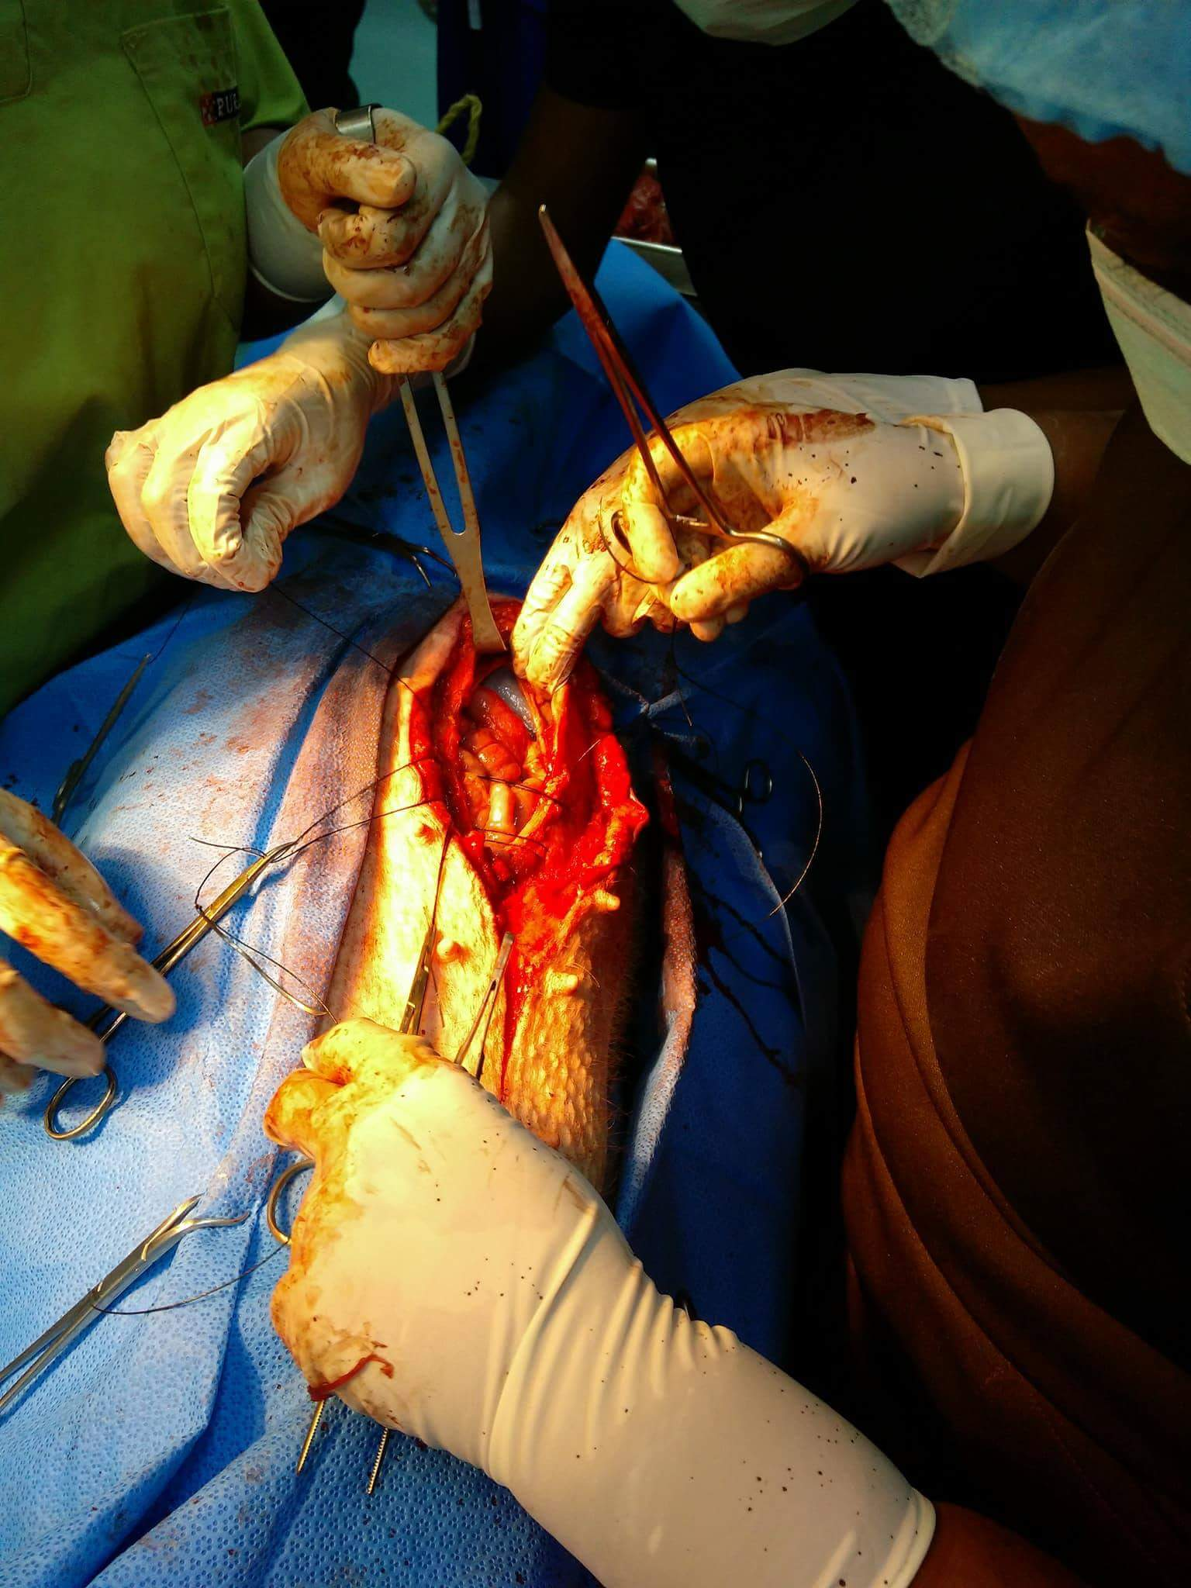
Image showing student perfoming a simple continuous suture pattern on the subcutaneous layer of the pig’s abdomen | 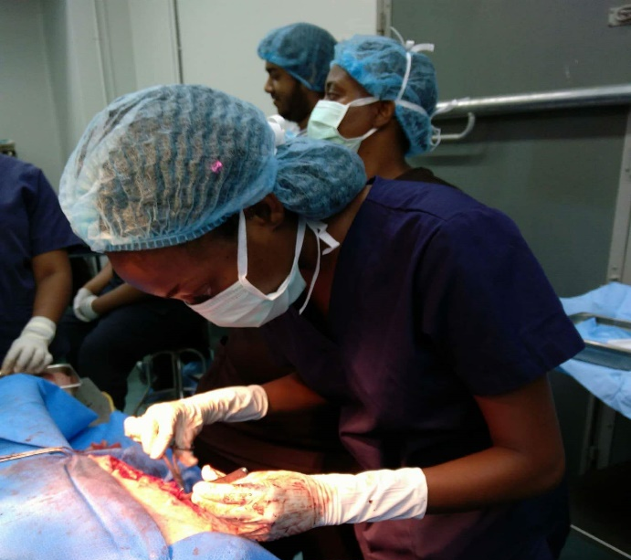
Image of student performing a horizontal mattress suture on the skin layer of the pig’s abdomen | 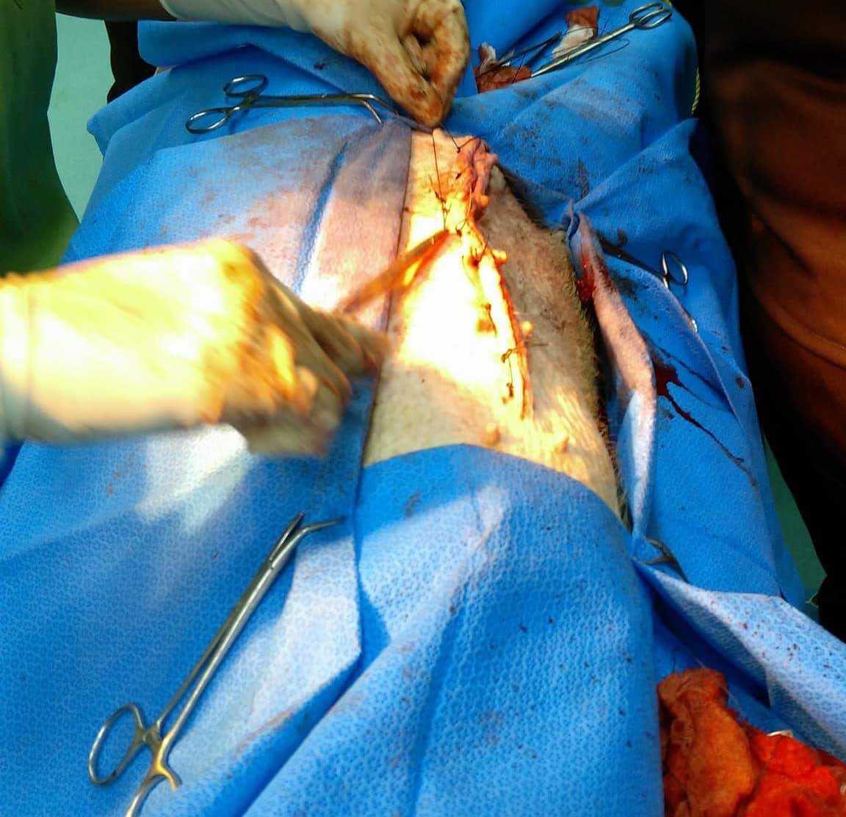
Image of the suture site after surgery  Image a) After all sutures where placed  Image b  After the surgical site was sprayed with Tetravet followed by Alushield spray and larvicide around the surgical. | 