INTRA-OP

Umbilicus surgery in a calf with a reducible hernia
Procedure:
Step 1: Sterile drapes were placed on the patient and around the surgical site by the surgeons. They were held in placed with towel clamps. ( See image below)
Step 1: An elliptical incision was made around the hernia using a #24 scalpel blade.
Step 2: The skin flap was removed.
Step 3: Blunt dissection of the subcutaneous layer was accomplished with the surgeon’s fingers and traction with a blunt curved mayo scissor
Step 4: The superficial sheath of rectus abdominis, was broken down by blunt dissection.
Step 5: The abdominal wall was incised along the lateral aspect of the hernia ring and the surgeon’s finger was used to feel for any adhesions to the mass. This was done by sweeping her fingers up and under the mass and around in the peritoneum.
Step 6: Sterile gauzes were used to wipe any excessive bleeding in the surgical wound.
Step 7: Haemostats were used throughout the surgery intermittently to control bleeding.
Step 8: Splash blocks were used throughout the surgery when the animal showed signs of feeling pain.
Step 9: A caudally directed firm tubular structure of 10 cm from the herniated material was identified. It was composed of remnant tissue of the umbilicus within the omentum. This was detached from the omentum.
Step 10: Detachment was done using two extra-large haemostat clamps (Rochester-Carmalt Haemostat), to clamp down fully on the omentum 10 cm away from the end of the firm tubular structure. Two (2) transfixional sutures with catgut was placed just above each clamp.
Step 11: A needle attached to 1.0 cat gut absorbable suture material was inserted through one end of the omentum and a knot was placed at that point just above one haemostat. The suture material was wrapped around the omentum to make a circumferential ligature. Upon removing the haemostat, the knot was firmly tightened and sat within the groove made by the haemostat. The cat gut was tied off securely. This procedure was repeated above the other haemostat. (see image below)
Step 12: A scalpel blade was used to cut along the lower clamp which causes detachment of the mass from the omentum.
Step 13: Swabs were used to wipe away excessive bleeding and a Miller's knot with 1.0 catgut was placed on the exposed omentum tissue.
Step 14: The hernia ring was determined, and the abdominal wall was sutured with Nylon (non-absorbable suture material) using a vest over pants suture pattern. Army navy retractors were used to pull up the abdominal wall by one surgeon while another surgeon used another retractor to press down the abdominal contents so the vest over pants suture would be performed safely and not puncture any abdominal structures.
Step 15: The subcutaneous layer was sutured using absorbable 2.0 lactomer (Polysorb) suture with a simple continuous suture pattern.
Step 16: The skin was sutured using nylon with an interrupted horizontal mattress, tension relieving, suture pattern.
Step 17: The surgical site was cleaned with sterile gauze to remove any additional blood.
Step 18: A gauze with diluted chlorhexidine was used to clean any additional blood away from the surgical site and body.
Step 19: The surgical site was sprayed with Tetravet followed by Alu spray and larvicide around the surgical.

Images from the umbilical surgery of the calf
IMAGE1 : Image of sterile drapes being placed on the calf , cornering off the surgical site.

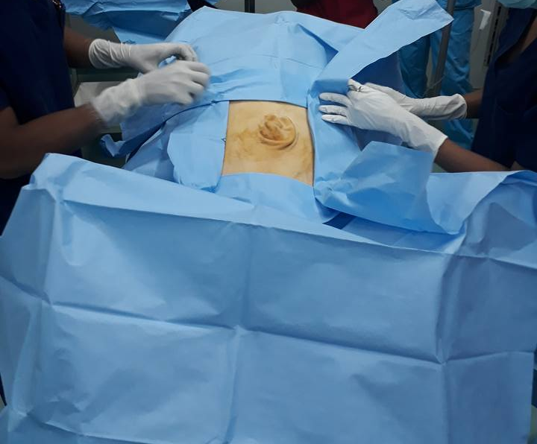

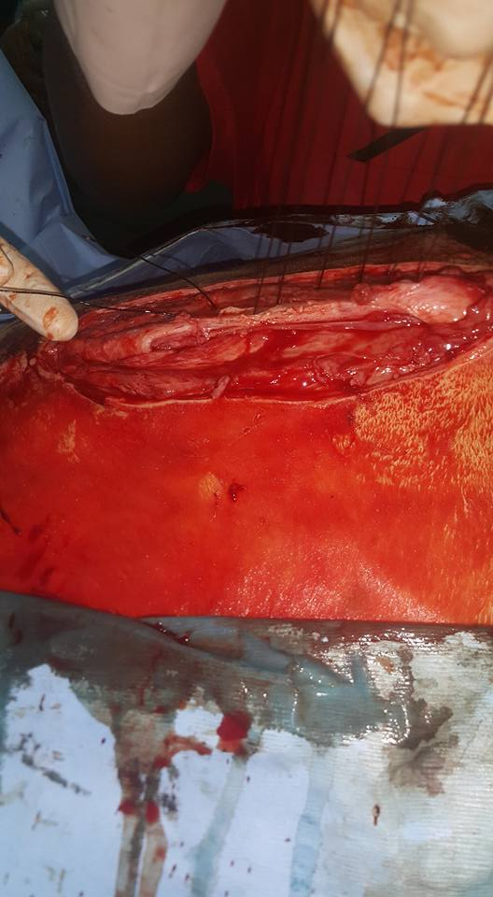
IMAGE 2: Image of vest over pants suture on the calf’s abdomen tissue.
.

IMAGE 3: Image of the umbilical hernia mass.
