‘Tie Forward’ Surgery
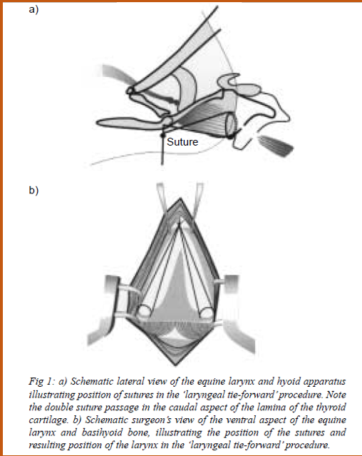

Procedure
- The horse is placed under general anaesthesia in dorsal recumbency and endotracheal intubation is performed
- A 15cm ventral midline incision is made, extending from the rostral aspect of the basihyoid bone to 1cm caudal to the cricoids cartilage
- The paired sternohyoid muscles are bluntly separated on the midline, and dissection is bluntly extended to the ventral aspect of the larynx
- The sternothyroid muscle tendon of insertion on the thyroid cartilage lamina is undermined and isolated in preparation for transaction
- One size 5 polybend suture is inserted at the ventral aspect of the right sternothyroid tendon of insertion and exited from the lamina of the thyroid cartilage and through the thyrohyoideus muscle 1cm rostrally and slightly dorsally from its insertion point
- The suture is then placed again through the right lamina of the thyroid cartilage slightly more dorsal (0.5cm) and exits more dorsally than the previous bite forming a loop in the thyroid lamina - The procedure is repeated on the left side
- The sternothyroid tendon of insertion is transected after the sutures are placed in the thyroid lamina
- A suture or wire passer is used to pass the most dorsal suture on the right side and most ventral suture on the left side dorsal to the basihyoid to exit on the right side of the lingual process where they are tagged with separate hemostats
- The most dorsal suture on the left side and most ventral suture on the right side are then similarly passed dorsal to the basihyoid to exit on the lingual process where they are tagged with separate hemostats
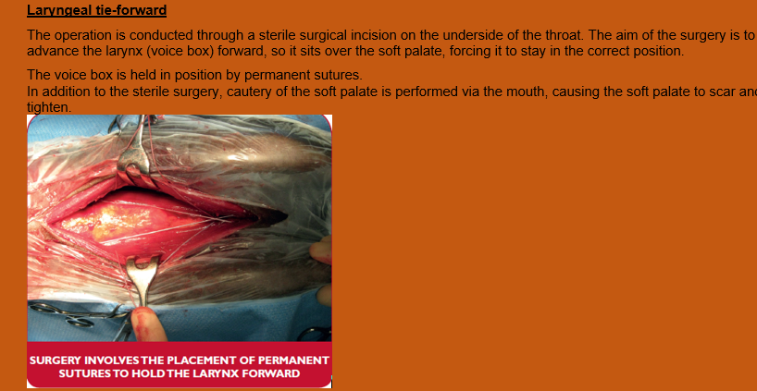
Complications
- Low complication rate procedure
- Intra-operative bleeding (4.1%)
- Excessive swelling (0.4%)
- Incisional infection (0.7%)
Aftercare
- Maintenance on antibiotics and anti-inflammatories for short period of time
- Return to training at 2 weeks
- In first 2 weeks feed and water should be given at shoulder height

