Post-operative follow up findings:
Days post-op | Calf #237 | Female pig #Pinky | Male pig
Wednesday (Day 1) | Subjective: BAR  Observed:  T- 39.4°C  P- 44bpm  R – 28breaths/min  CRT- <2seconds  Pink mucous membranes, mild dehydration, normal strong heartbeat, eyes, ears and nares all observed normal. 1 weak, faint sounding rumen contraction in 2 minutes. No urine observed. Feces normal, well formed with some mucoid plaques.  Assessment:  Wound site red, slightly swollen, no abnormal discharges (NAD), wound edges well appositioned, and no sign of fly strike. Apparent pain on touching wound.  Plan:  4.5ml Flunixin given IV. Tetravet, aerosol bandage Aluspray sprayed on incision site. Periphery of incision sprayed with Larvacid. Calf was fed.  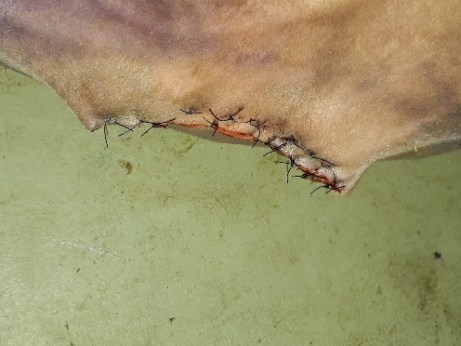 | Subjective: BAR, active, moving around  Observed:  T- 37.2°C  P- 94bpm  R – 40breaths/min  Assessment:  No visible swelling at wound site, no pain on palpation, no heat on touching the wound site.  Plan:  3.4ml Flunixin given IM. Tetravet, aerosol bandage Aluspray sprayed on incision site. Periphery of incision sprayed with Larvacid. Pig was fed.  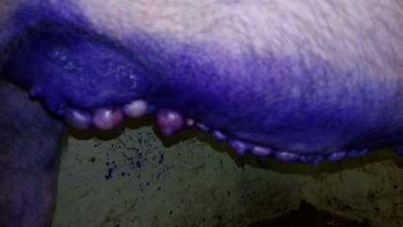 | Subjective: BAR, slight temperament  Observed:  T- 39.3°C  P- 80bpm  R – 56breaths/min  Assessment:  Slight lameness observed in right hindlimb.  Plan:  3.1ml Flunixin given IV via the ear vein. Tetravet, aerosol bandage Aluspray sprayed on incision site. Periphery of incision sprayed with Larvacid. Pig was fed.  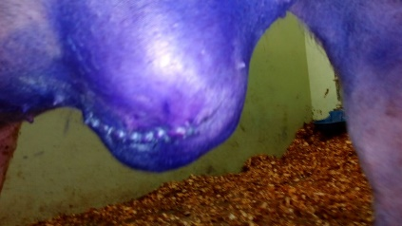
Thursday  (Day 2) | Subjective: BAR  Observed:  T- 38.7°C  P- 52bpm  R – 40breaths/min  CRT- <2.5seconds  Pink mucous membranes, eyes, ears and nares all observed normal. 3 strong rumen contractions in 3 minutes. Urine and feces normal.  Assessment:  Decreased swelling around incision, minor redness. No sign of fly strike.  Plan:  Catheter removed due to loss of patency. Tetravet, aerosol bandage Aluspray sprayed on incision site. Periphery of incision sprayed with Larvacid. Calf was fed. | Subjective: BAR, active  Observed:  T- 39°C  P- 96bpm  R – 52breaths/min  Assessment:  No swelling observed at wound site.  Plan:  Tetravet, aerosol bandage Aluspray sprayed on incision site. Periphery of incision sprayed with Larvacid. Pig was fed. | Subjective: BAR  Observed:  T- 38.3°C  P- 56bpm  R – 56breaths/min  Assessment:  Mass at wound site observed approximately 12x15cm in width. Feels firm to the touch.  Plan:  Tetravet, aerosol bandage Aluspray sprayed on incision site. Periphery of incision sprayed with Larvacid. Pig was fed.
Friday  (Day 3) | Subjective: BAR  Observed:  T- 38.9°C  P- 58bpm  R – 28breaths/min  CRT- <2seconds  Pink mucous membranes, strong heartbeat, eyes, ears and nares all observed normal. 2 strong rumen contractions in 3 minutes. No urine or feces observed.  Assessment:  No swelling around the wound site observed. No abnormal discharges (NAD) and no sign of fly strike.  Plan:  10ml Penstrep given IM. Tetravet and Aluspray sprayed on incision site. Periphery of incision sprayed with Larvacid. Calf was fed at 11:30am. | Subjective: BAR  Observed:  TPR within normal range  Assessment:  NAD, stool observed in pen.  Plan:  3.4ml Flunixin given IM and 3.8ml Penicillin given IM. Tetravet, aerosol bandage Aluspray sprayed on incision site. Periphery of incision sprayed with Larvacid. Pig was fed. | Subjective: BAR  Observed:  T- 37.3°C  P- 72bpm  R – 40breaths/min  Assessment:  Crusting on the inside of the ears. Mass at wound site observed approximately 12x15cm in width. Feels warm and firm to the touch.  Plan:  Tetravet, aerosol bandage Aluspray sprayed on incision site. Periphery of incision sprayed with Larvacid. Pig was fed.  3.1ml Flunixin and 7ml Penstrep given IM.
Saturday  (Day 4) | Subjective: BAR  Observed:  T- 38.3°C  P- 60bpm  R – 28breaths/min  CRT- <2seconds  Pink mucous membranes, good hydration, eyes, ears and nares all observed normal. 3 strong rumen contractions in 2 minutes. Urine and feces normal.  Assessment:  Wound site swollen caudally on the right side and cranially on the left side. The incision was slightly reddened but there were no abnormal discharges (NAD) and no sign of fly strike. No apparent pain on touching wound.  Plan:  Tetravet sprayed on incision site. Periphery of incision sprayed with Larvacid. Calf was fed. | Subjective: BAR, active  Observed:  T- 38.1°C  P- 88bpm  R – 40breaths/min  Assessment:  Normal feces observed. Wound site looked well, NAD and no sign of fly strike  Plan:  Tetravet sprayed on incision site. Periphery of incision sprayed with Larvacid. Pig was fed. | Subjective: BAR, active  Observed:  T- 38°C  P- 105bpm  R – 48breaths/min  Assessment:  Crusting on the inside of the ears. Mass at wound site observed approximately 12x15cm in width. Feels warm and firm to the touch.  Plan:  Tetravet sprayed on incision site. Periphery of incision sprayed with Larvacid. 3.1ml Penstrep given IM. Pig was fed.
Sunday  (Day 5) | Subjective: BAR  Observed:  T- 37.3°C  P- 68bpm  R – 32breaths/min  CRT- <2seconds  Pink mucous membranes, eyes, ears and nares all observed normal. 3 strong rumen contractions in 2 minutes. Feces normal, well formed.  Assessment:  Wound site red, slightly swollen cranially, no abnormal discharges (NAD) and no sign of fly strike. Mild bruxism observed. No signs of pain on touching the wound.  Plan:  Tetravet sprayed on incision site. Periphery of incision sprayed with Larvacid. Calf was fed.  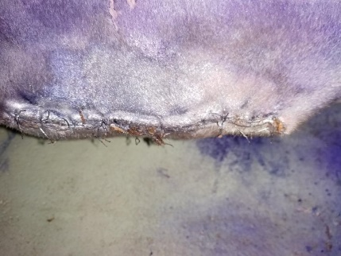 | Subjective: BAR, active  Observed:  T- 39.1°C  P- 85bpm  R – 40breaths/min  Assessment:  Normal urine and feces observed. Wound site looked well, NAD and no sign of fly strike  Plan:  Tetravet sprayed on incision site. Periphery of incision sprayed with Larvacid. Pig was fed.  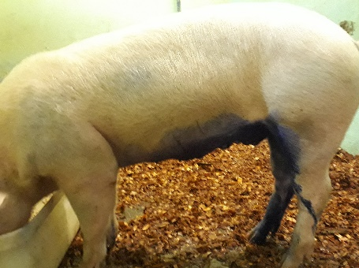 | Subjective: BAR  Observed:  T- 38.4°C  P- 104bpm  R – 52breaths/min  Assessment:  Mass at wound site observed approximately 12x15cm in width. Feels warm and firm to the touch. Smegma and urine expressed.  Plan:  Tetravet sprayed on incision site. Periphery of incision  