Constant inFusion Rates

Picture below showing fluids (CRI) calculation for Calf
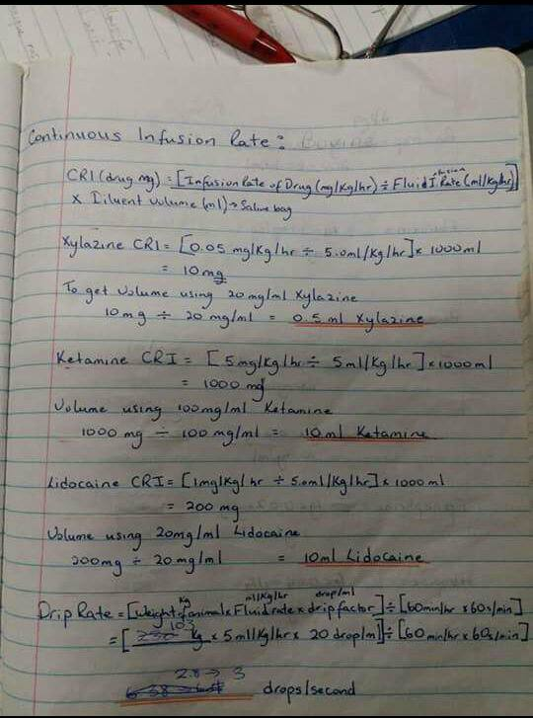

Table showing Comparative Doses Given Intra Op for Fluids/ Constant Infusion Rate (CRI)
Patient | Drug | Volume given | Drip Rate
Calf | Xylazine | 0.5ml | 3 drops/min
 | Ketamine | 10ml
 | Lidocaine | 10ml
Female Pig | Xylazine | 10ml | 2.5 drops/min
 | Ketamine | 10ml
 | Lidocaine | 10ml
Male Pig | Xylazine | 10ml | 2.5 drops/min
 | Ketamine | 10ml
 | Lidocaine | 10ml

