Inferior Check Ligament
What is it?
The inferior check ligament is also known as accessory ligament of the deep digital flexor tendon (ALDDFT). The inferior check ligament desmotomy is frequently done on foals (2-8 months old) for deformities of flexure in the distal interphalangeal joint (coffin joint). This type of deformity can lead to chronic intermittent lameness for young race horses. The desmotomy provides more length on the deep digital flexor tendon to allow for proper realignment of the hoof angle.
How is it done?
This procedure is done under general anaesthesia with the horse in lateral recumbency with the affected leg elevated. The site is cleaned using alcohol and aseptic technique is done for this surgery. A 10cm incision is made in the skin at the proximal one third of the cannon extending distally in the groove between the flexor tendons and the cannon bone. The subcutaneous tissues and fascia are dissected using Metzenbaum scissors to reveal the tendons. A plain of dissection is created using a blunt tool between the flexor tendons and the sheath containing the digital vessels and nerve. Using both sharp and blunt methods of incision, the vasculature and the deep digital flexor tendon are separated. The superior flexor tendon is reflected from the deep digital flexor tendon (DDFT) and the inferior check ligament. The bundle of the DDFT and the ALDDFT is raised and the two are separated with a groove between them using blunt incision. The ALDDFT is then the only one left raised and is transected with care taken not to cut the DDFT and superior digital flexor tendon. The incision can be checked by extending the toe to see the fibres of the ALDDFT separating at the incision site. The subcutaneous and skin tissues are closed according to preference of the surgeon.
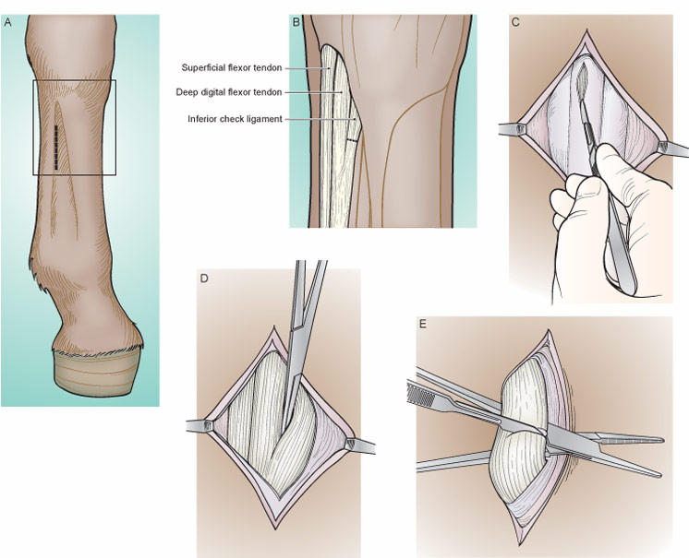
Fig. 1 A Brief Guide to the Inferior Check Ligament Desmotomy.

