**PRE-OPERATIVE CONSIDERATIONS**

**ASA Classification**

ASA CLASSIFICATION SYSTEM

ASA 1: A healthy horse

ASA 2: Horse with mild systemic disease (mild anemia, mild recurrent airway obstruction)

ASA 3: Horse with severe systemic disease (severe anemia, strangles)

ASA 4: A horse with severe systemic disease that is a constant threat to life (ruptured bladder, intestinal incident)

ASA 5: A moribund horse not expected to live for more than 24 hours (foal with a uroperitoneum with severe metabolic damage)

E The letter E is added to any classification when it is an emergency procedure

**Anatomy of Surgical Site:**

FORELIMB ANATOMY:

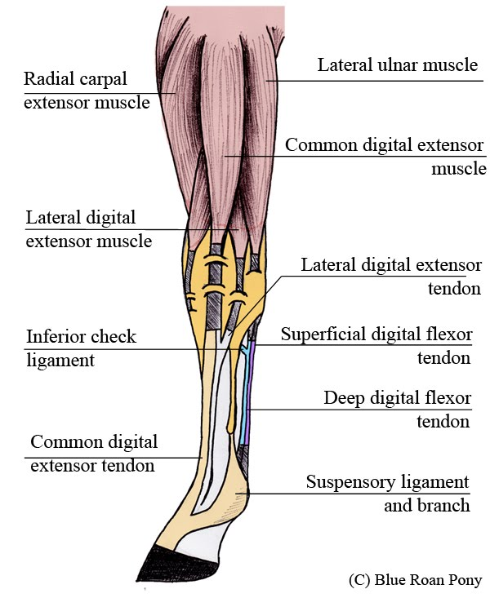

HINDLIMB ANATOMY:

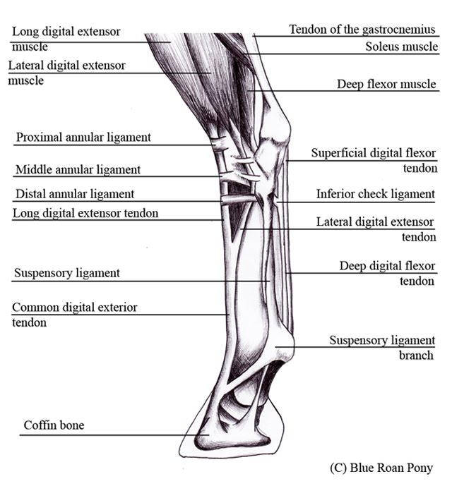

**Physical and Distance Exam of a Horse:**

<http://www.equineguelph.ca/pdf/facts/Horse_Health_Check_description.pdf>

**Pre- surgery drugs**

Most Common Anesthetic Drug Combination for Induction

• Xylazine premedication and ketamine (±diazepam) Induction

• Ketamine administered alone without sedative premedication to the horse causes excitement.

• Ketamine is injected 3-5 min after apparent xylazine induced sedation

• Ketamine is not used by IM injection in the conscious horse because the horse may be injured during the period of incoordination occurring while the drug is taking effect.

• Biologic half-life of ketamine is 45 minutes in the horse, with 99% of a bolus dose eliminated in 4 hours. Recovery to consciousness is due to extensive extravascular distribution of the drug.

• Induction of anesthesia occurs about 60 seconds after ketamine injection. Horse falls to the ground characteristically with the forelimbs buckling and the hindlimbs straight. The person holding the horse’s head should exert steady backward pressure on the horse during loss of consciousness in an attempt to make the horse sit on its hindquarters and not fall on its nose.

• Xylazine-ketamine anesthesia is accompanied by strong muscle tone for the first 5 minutes, and usually nystagmus, a strong palpebral reflex, and pupillary dilation.

• The duration of anesthesia varies from 7 min to 20 min. Anesthesia is often short in young horses and in Thoroughbreds.

• The major advantage of this combination is that recovery is usually smooth, with less incoordination than is seen with thiobarbiturate or guaifenesin combinations. The horse is usually standing 30-40 minutes following a single administration of xylazine and ketamine.

• Glyceryl Guaicolate Ether (GGE) is another useful drug for equine anesthetic induction

• Also known as guaifenesin (US) or guaiphenesin (Europe), it is administered at 50 – 100mg/kg IV to effect to produce sedation/muscle relaxation

• Because of its muscle relaxant effect, this drug alone is not suitable to produce sedation as the ataxic horse may panic.

• When animal knuckles following adequate dose (usually 50 mg/kg), a rapid bolus dose of 0.5 mg/kg ketamine IV or 2 mg/kg thiopental sodium is administered to provide smooth anesthetic induction

• Anesthesia can then be maintained either on inhalational agent or intravenous anesthetics.

• Available in 5, 10, 15 % in commercial preparation, but concentration higher than 15 % is not recommended for use due to hemolysis.

• Can be mixed with thiopental sodium, ketamine or xylazine in the diluent

• Home-made GGE may form precipitates if left unused for prolonged period, but rewarming the diluent will resolve this, and the efficacy of the agent is not altered. This problem is not seen with commercial preparations.

**Preparation of the Patient**

* Remove hair from the surgery site ( #40 blade, vacuum)
* Initial or preparative scrub
* Povidone-iodine followed by alcohol rinse
* Chlorhexidine followed by saline rinse
* Move to surgical room / area
* Final surgical scrub/paint
* Povidone-iodine followed by alcohol rinse
* Chlorhexidine followed by saline rinse
* Duraprep®, chloraprep®
* Sterile draping of surgical site
* Establish a sterile field

**Maintenance of Anesthesia**

Mostly carried out using inhalants, but intravenous techniques can be used for a

short anesthetic.

**Inhalational anesthesia**

• Problems occur more frequently and in greater magnitude than during canine anesthesia

• More pronounced hypotension, hypoventilation, reduction of cardiac output

• More dramatic consequence to the operator and the patient if anesthetic plane is not well

controlled

• Halothane, isoflurane, sevoflurane, desflurane recovery differ. The fasted recovery may

not be the best quality

**Nitrous oxide**

• Analgesia from N2O reduces inhalational anesthetic requirement therefore less

cardiovascular depression.

• However, even with 50 % oxygen and 50 % nitrous oxide mixture hypoxemia is common

probably due to the nitrous oxide dissolving into gaseous space such as GIT and leading

to the V/Q mismatches.

• Use of this agent is not recommended in this species (exception is foals and small-sized

equids)

**Halothane (Fluothane®)**

• Halothane has the highest metabolism, so avoid in hepatic insufficiency

• This agent is being largely displaced by newer agent such as sevoflurane and isoflurane

as the cost of the newer agents becomes more affordable, however some equine

practitioners use it other than cost reason, mainly for superior recovery quality

(particularly important for orthopedic cases)

• 1 MAC halothane in horses is 0.9%, and 0.7 % in foals

• Always administered via endotracheal tube after induction of anesthesia with injectable

drugs.

• Halothane decreases ventilation. RR may be normal or decreased but arterial carbon

dioxide levels increase and oxygen levels decrease.

• Halothane sensitize the myocardium to circulatory catecholamines with more frequent

dysrhythmias exhibited

• A lightly anesthetized (1 MAC), spontaneously breathing horse will have a 40-50%

decrease in CO

• Heart rate is maintained in the normal range (28 to 44 beats/min)

• The arterial blood pressure decreases from conscious value (MAP 110) to 80 mmHg

• As anesthesia is deepened by increasing halothane concentration, CO and arterial

pressure decrease further. HR usually remains constant.

**Isoflurane (Aerrane®, Forane®, IsoFlo®)**

• Used to be much more expensive than halothane, but the price has come down substantially for the past few years, so more frequently used

• Quicker anesthetic stabilization and more rapid recovery

• However, in some recovery from anesthesia to consciousness is too quick leading to poorer quality. Sedation with a minute dose (0.2 mg/kg) of xylazine has been recommended to provide better recovery in some orthopedic procedures.

• 1 MAC in horses is 1.3%, and 0.9% in foals.

• The degree of respiratory depression is greater with isoflurane than halothane.

• As anesthesia deepens, the respiratory rate tends to increase with halothane and decrease with isoflurane.

• Controlled ventilation (IPPV) is recommended for isoflurane anesthesia

• Isoflurane, similar to halothane, induces a dose-dependent cardiovascular depression.

• Little difference in cardiovascular function has been noted between halothane and isoflurane when horses are breathing spontaneously.

• Under controlled ventilation, the cardiac output has been demonstrated to be significantly higher during isoflurane anesthesia.

• Isoflurane causes more peripheral vasodilation than halothane, which is responsible for a low arterial blood pressure, but tissue looks more bright and pinky indicating better perfusion.

**Sevoflurane (Ultane®)**

• Anesthetic induction, recovery, and intraoperative modulation of anesthetic depths to be notably faster than halothane and isoflurane.

• More expensive than halothane and isoflurane, but the price is getting lower.

• Sevoflurane (1 MAC = 2.3 %) is less potent than halothane or isoflurane, but more potent than desflurane.

• Sevoflurane induces dose-dependent cardiovascular depression to a degree similar to that of isoflurane.

• Sevoflurane and isoflurane cause greater increases in PaCO2, decreases in pH and

ventilatory response to hypercapnia than does halothane in horses. Respiratory rate is lower than with halothane, and minute ventilation decreases

• Two sevoflurane breakdown products are of potential concern because of their nephrotoxicity: Compound A and inorganic fluoride.

• No clinical studies of humans demonstrate significant changes in BUN, creatinine, or the ability to concentrate urine after sevoflurane anesthesia when compared to other inhalant anesthetics. This is true also for a study in horses.

• Currently, more than 90 % of BVMTH equine cases are anesthetized with sevoflurane

• The recovery quality may suffer due to rapid emergence from anesthesia, hence sedating with 0.2 mg/kg of xylazine at the time to move to the recovery stall may help

**Desflurane (Suprane®)**

• Lower blood/gas partition coefficient than the inhalants mentioned above, so control of anesthetic depth is relatively quick

• Horses’ recovery from desflurane anesthesia is fast (e.g. 15 min to standing after 100 minutes of anesthesia), and quality rated good to excellent

• The least potent among the volatile anesthetics in clinical use (MAC = 7.6 %)

• Cardiovascular effects of desflurane are similar with those of isoflurane

• Causes dose-dependent respiratory depression, the magnitude similar to isoflurane

• May cause airway irritation with resulting coughing, secretions and breath holding

• Expensive as sevoflurane, and requires electronically controlled vaporizer which adds to

the inconvenience

**Total Intra-venous Anesthesia (TIVA)**

• Xylazine 1.1 mg/kg premedication and ketamine 2.2 mg/kg induction providesapproximately 10 - 20 minutes of general anesthesia.

• Prolongation of xylazine-ketamine anesthesia in horses is done with 0.35 mg/kg of xyalzine and 0.7 mg/kg IV of ketamine starting 12 minutes after the initial ketamine induction. This dose can be repeated each 12 minutes for additional two doses, but accumulative prolonged recovery may be seen.

• Additional one fifth dose of induction agent provide a buying time until increased vapor setting deepens anesthetic depth in the event animal suddenly wakes up during inhalation maintenance anesthesia

• Alternatively,

o Xylazine and ketamine added to a bottle of guaifenesin (GKX) is very popular for procedures not extending beyond 1 hour and administered as a continuous infusion.

o In 50 g of 1 L GGE, add 500 mg of xylazine and 2000 mg of ketamine and administer

1 – 3 ml/kg/hr depending on the CNS reflexes of the animal as assessed by ocular reflex (brisk palpebral reflex, occasional nystagmus must be present), changes of breathing pattern and rate, and changes of BP, HR etc.

o Given IV, not IM and never just for sedation

o Any procedure which is anticipated to last longer than 1 hour should not be done with

GGE-xyalzine/ketamine or GGE-barbiturate anesthesia alone. Prolonged recovery for extended anesthesia

* Limitations:

• The main limitation to continued administration of intravenous anesthetics is the arterial oxygenation.

• While it is true that progressive collapse of the down lung occurs with time, thus increasing the ventilation-perfusion mismatch and decreasing arterial oxygenation, this can be an unreliable guideline. One horse can be anesthetized and breathing air for an hour or more and have acceptable levels of oxygen and carbon dioxide, whereas another horse will become hypoxemic within 10 minutes.

• IV anesthesia should not be prolonged beyond 45 minutes in an adult horse without supplying the horse with oxygen to breathe and means of ventilatory support.

• Propofol: non-accumulative but very expensive

• Propofol and medetomidine combo (0.1 mg/kg/min of propofol and 3.5 mcg/kg/hr of medetomidine) provides satisfactory anesthetic plane in response to supramaximal noxious stimuli, and recovery in 4 hr + anesthesia was very smooth, rapid and complete.

• Tight anesthetic depth control is harder with TIVA so abrupt awakening during anesthesia is more likely if one is not familiar with the technique (inhalant anesthetic provides advantage in this respect as by monitoring anesthetic concentration in breathing gases, one can control anesthetic depth better).

**Welfare/Risks Associated:**

* Pain associated with the surgery.
* Potential airway obstruction during surgery.
* Reduced production ability of the animal.
* Haematoma formation.
* Potential site for Myasis.
* Infection of the site.
* One of the major risks associated with equine general anesthesia is “post anesthetic
* myopathy”
* Myopathy or nerve damage in the limbs sometimes develops following general
* anesthesia as a result of ischemia or pressure damage.
* Most common form is ischemia of shoulder muscles or hindquarters resulting in lameness
* or inability to stand
* The horse cannot stand or will have difficulty in standing. Horses that were in lateral
* recumbency are most frequently lame in the dependent forelimb and/or hind limb
* Lameness is not always present immediately after the horse stands, but may develop 1-2
* hours later.
* Post anesthetic myopathy prevention
* Positioning of limbs: lower forelimb forward, upper limbs elevated and supported, lower
* hind limb backward
* Foam pads, air mattress, water bed
* Maintain mean arterial pressure above 60-70 mm Hg

**POST-OPERATIVE CONSIDERATIONS**

* Immediate Post-Op
* Move the animal to a warm, dry area and monitor vital signs every 15 minutes until the animal is sternal.
* Turn side to side frequently to prevent pooling of fluid in recumbent side.
* Remove endotracheal tube when swallowing/chewing this prevents regurgitation and vomiting.
* Do not return to home cage until able to maintain body temperature and hold itself in sternal position.
* Antibiotic administration.
* Daily Check:
* Date/Time
* Attitude
* Rectal temperature
* Heart rate
* Respiratory rate
* Mucous membrane color
* Capillary refill time (CRT)
* Intestinal sounds
* Digital pulse
* Number of bowel movements
* Number of urination spots
* Appetite
* Water consumption
* Surgical site check
* Post-anesthetic complications

• One of the major risks associated with equine general anesthesia is “post anesthetic myopathy”

• Myopathy or nerve damage in the limbs sometimes develops following general anesthesia as a result of ischemia or pressure damage.

• Most common form is ischemia of shoulder muscles or hindquarters resulting in lameness or inability to stand

• The horse cannot stand or will have difficulty in standing. Horses that were in lateral recumbency are most frequently lame in the dependent forelimb and/or hind limb

• Lameness is not always present immediately after the horse stands, but may develop 1-2 hours later.

• Post anesthetic myopathy prevention

• Positioning of limbs: lower forelimb forward, upper limbs elevated and supported, lower hind limb backward

• Foam pads, air mattress, water bed

• Maintain mean arterial pressure above 60-70 mm Hg

• Treatment of post-anesthetic myopathy

o Pain management and anti-inflammatory agents (NSAID, Corticosteroids)

o Fluid therapy

o Diuresis

o Calcium

o Sling and rope to support the torso

o Physical therapy (gentle massage)

o Positive inotropes to maintain CO and BP

o If not responsive to the Tx within days, and the symptom deteriorates causing severe distress and pain to the animal, euthanasia maybe the only option.

https://instruction.cvhs.okstate.edu/vmed5412/pdf/23EquineAnesthesia2006.pdf