Drug name | Active ingredient | Time given/onset/ duration | Indication | Contraindication | route of administration/Withdrawal time | Direction for use/ Withdrawal time
Tetravet aerosol  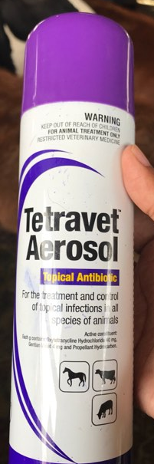 | Oxytetracycline HCI 2.5% and Gentian Violet 0.2%. | Given at 3:29pm | For the treatment and control of topical infections in all species of animals. | NOT FOR USE IN FIBRE PRODUCING ANIMALS | Route : topical | SHAKE WELL BEFORE USE. For topical use only.  Remove any dead tissue, dried serum or secretions and debris from infection site.  Hold pack upright approximately 15 – 20cm from the surface and cover affected area completely once or twice a day and repeat for 3 – 5 days or as required.
Agropharm Screwworm aerosol  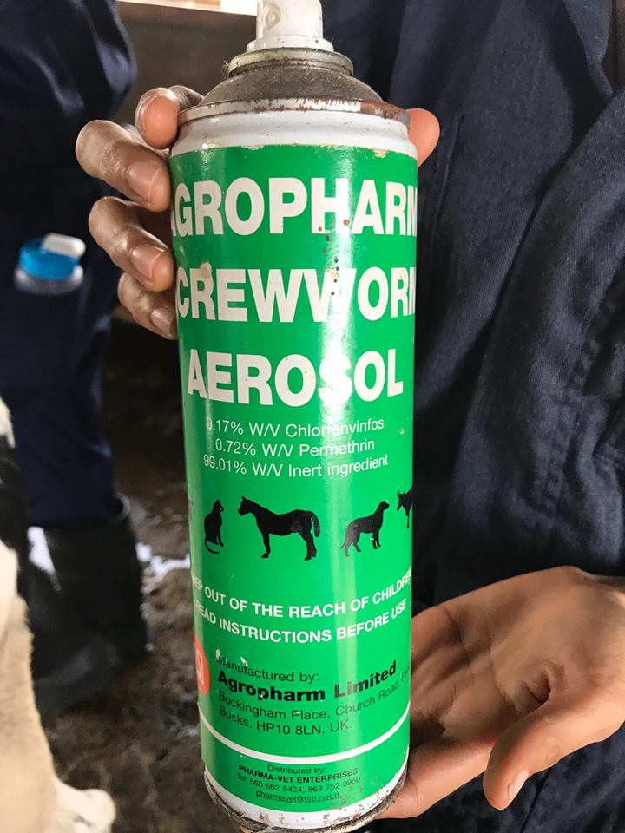 | Permethrin  0.5% | Given at 3:29pm | Kills flies and fly maggots on wounds.  For Use On:  Beef and Dairy Cattle, Sheep, Goats, Swine and Horses. | Harmful if swallowed, absorbed through the skin or inhaled. Causes moderate eye irritation. Avoid breathing spray mist. Avoid contact with skin, eyes or clothing. Wash thoroughly with soap and water after handling and before smoking or eating. Remove contaminated clothing and wash before reuse. Avoid contamination of feed and foodstuffs | Route : topical | Remove protective cap, hold container upright and spray from a distance of 12 to 15 inches.
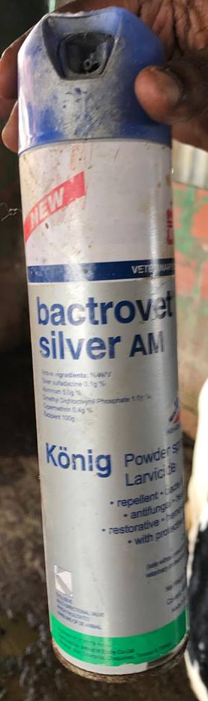 | Silver sulfadiazine 0.1%  Aluminum 5.0g%  Dimethyl Dichlorovynil Phospahte  Cypermethrin 0.4g%  Dosage:  Preventive: a single application  Healing: a daily application usually for 4 to 5 days. | Given at 3:3opm | Bactrovet Silver AM is indicated for cattle of all ages, including for newborns: It  acts as larvicide on infested wounds, with rapid healing;  Routinely applied to accidental or surgical wounds (castration, dehorning), it eliminates bleeding from them (astringent and haemostatic effects), forming a protective film that prevents infection;  Its repellent effect prevents the treated wounds from being attacked by the flies that cause the myiasis;  Due to its high penetration and grip, Bactrovet Silver AM is excellent in curing navels;  The multi-directional valve of Bactrovet Silver AM allows to treat wounds of difficult access, by the maneuver of the packaging in any desired direction. |  | Route: topical | Shake the bottle well before each application. Place the vial at a distance of approximately 10 cm from the wound or infested area.  - Treatment of myiasis: carefully introduce the product into the cavities where the larvae are housed. In cases of very serious myiasis, it is advisable to remove the larvae from the affected areas and clean it before applying the product.  - Prevention of myiasis and scarring: apply directly on all recent injury caused by accident or by castration, dehorning, etc.
Combikel 40 LA  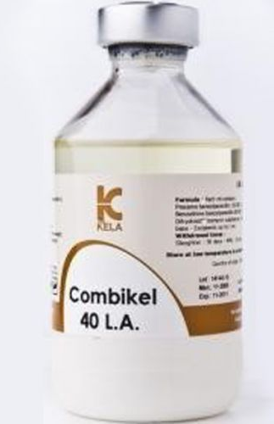 | Procaine benzylpenicillin eq.120 000 I.U. –  Benzathine benzylpenicillin eq.80 000 I.U. - Dihydrostreptomycin sulphate eq. 200 mg base - Excipients up to 1 ml | Given at 2:45pm  3 day duration of activity with minimum adverse effects | Prevention and treatment of infections caused by penicillin G and/or DHS susceptible microorganisms such as respiratory tract infections (shipping fever, bronchopneumonias, upper respiratory tract infections), uro-genital tract infections, necrobacillosis in calves and piglets, anaerobe infections (clostridial infections, tetanus, anthrax), polyarthritis (navel ill), mastitis, septicaemia, bacterial infections secondary to viral ones.  The drug also can be used in postoperative prevention of infections | With the administration of the drug, rapidly developing allergic reactions sometimes appear. Treatment of allergic reactions: glucocorticosteroids or / and antihistamines. Possible neural phenomena, neuromuscular blockade, vomiting, febrile state, abortions in pigs. Prolonged use of the drug may lead to deafness, vestibulotoxic and nephrotoxic symptoms.  Contraindications.  Do not use the drug with individual hypersensitivity to one of the components. Do not use lactating animal if milk is used for food purposes. Do not use intravenously.  Do not administer to animals with kidney failure | Route: IM | Dose –  Give a dose of 20,000I.U/kg (conc. 200,000I.U/ml) IM before the surgical procedure so the animal is protected for possible intra-operative infections.  Cattle, horses - 1 ml of the drug for 10-20 kg of animal weight once a day.

