INTRA-OPERATIVE PROCEDURE AND TECHNIQUES
OPEN CLOSE METHOD: This method involves an incision into the scrotal sac but the vaginal tunic remains intact.
EQUIPMENT | PROCEDURE
Newberry Knife + emasculator  Newberry Knife + emasculator + scalpel blade  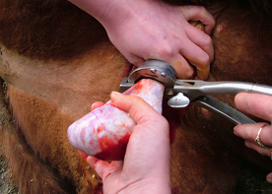  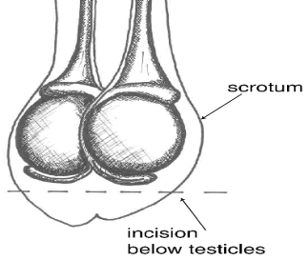  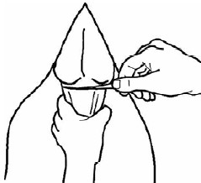  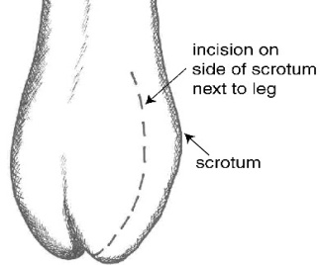  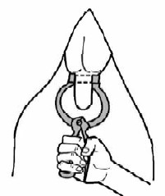  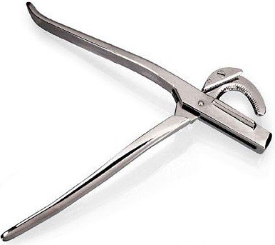  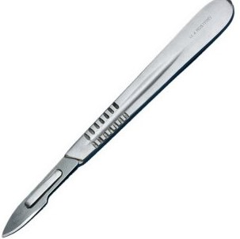  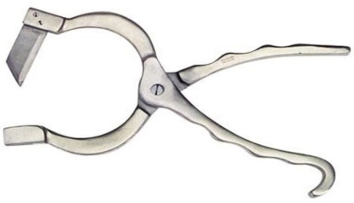  Scalpel blade + emasculator  Avantage/Reasons:  - 100% effective; sure castration because the testicles are removed.  - Surgical wounds heal more quickly than those from rubber ring.  - Can be used on bull calves and adult bulls.  - No testosterone so reduction in aggressive behavior.  Disavantages/ Complications:  - Hemorrhage- bleeding is a risk due to the open wound.  - Require skill personnel to perform procedure accurately.  - Take a longer time to perform than close castration methods.  - Risk of infections because of open wounds.  - Risk of myiasis occurrence.  - Has a negative effect on weight gain.  - Risk of injury to the animal and the surgeon. | - Proper pre-operative techniques are required (see pre-op techniques).  - Proper restraint and pain management.  - Proper antiseptic techniques should be done, this includes; cleaning and sanitizing and disinfect the surgical area (scrotum) using iodine, cleaning and disinfecting surgical equipment, wearing clean latex gloves and for animals in lateral recumbency clean bedding placed under surgical site.  Surgical Method 1: (Vertical incision) Newberry knife  - Pull the scrotal sac down ensuring that the testes remain in the upper two third (1/3) of the sac.  - Open the cutting jaws of the knife and place them lateral to the scrotal sac or to the side of the lower one third (2/3) of the scrotal sac.  - Squeeze the handles of the knife together to close the jaws of the knife. Ensure that the blade penetrates both sides of the scrotal sac, and the testes are not cut during this process.  - The scrotum is then incised by forcefully pulling the Newberry knife downwards.  - Each testis surrounded by the vaginal tunic is then pulled through the incision site using one hand while the other hand is pushing the scrotum upwards.  - Slowly continue this procedure until the muscle in the spermatic cord separates.  Surgical Method 2: (Horizontal incision) Scalpel blade, sharp knife or surgical scissors  - Pull the scrotal sac down ensuring that the testes remain in the upper two third (1/3) of the sac.  - Let the assistant hold the testes in the upper two third (2/3) of the scrotum while the lower one third (1/3) of the scrotal sac is surgically removed in a horizontal fashion using a #10 scalpel blade.  - After making the incision the testes will fall down through the incision site surrounded by the vaginal tunic.  - Using one hand slowly pull the testes downward while the other hand is pushing the scrotum upwards. Continue this procedure until the muscle in the spermatic cord separates.  Castration using the Emasculator:  - After the incision process both spermatic cords are tightly double ligated using absorbable sutures to constrict the blood vessels in the spermatic cord.  - Then the jaws of the emasculator are opened and position distal to the ligations 2cm over the testes, with the knut facing downwards (knut to knut).  - The handle of the emasculator is the squeeze together to close the jaws.  - Keep the emasculator clamped onto the spermatic cords for at least one minute ensuring optimal crushing and constriction of the blood vessels.  - If a crush only emasculator is used a scalpel blade can be used to remove the portion of the spermatic cord distal to the crush.  - Proper sanitation and post operative techniques are required after surgery (see post OP techniques).  https://www.youtube.com/watch?v=hs74thANqBw  https://www.youtube.com/watch?v=UtLsSXOKPow

