OBSERVATIONAL POST-OP REVIEW
Upon distance examinations of both calves, appeared bright, alert and responsive (B.A.R) with normal parameters.
Normal Parameters of calves:
Temperature | 101-103°F
Pulse | 100-140 beats/min
Respiration | 30-60 breaths/min

Due to the hyperactivity displayed by this young animal it was impossible to obtain most parameter readings post-operatively.
- There was no vocalization which indicated no pain was felt from affected areas.
- There was no abnormal behaviour which indicated the surgical procedure did not affect the animal.
- There was haemorrhage from the surgical site which indicated the area was properly cauterized.
- There were no flies present on or around the surgical site which indicated there was proper post-op management and the screw worm spray worked effectively.
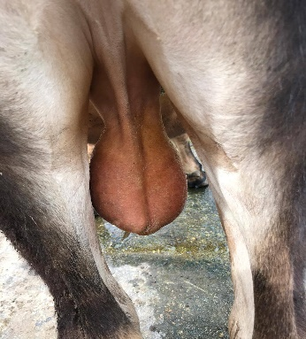
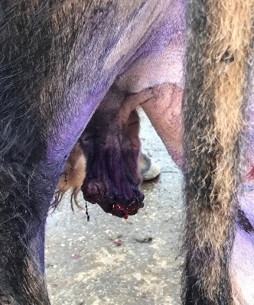

Bruce before castration Bruce after castration

Treatment post-op, for the next few days:
- Antibiotic cream was applied directly to the affected areas.
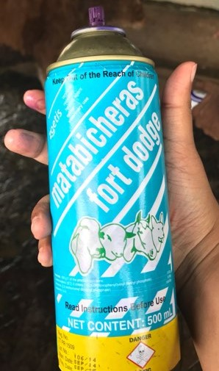

https://ar.zoetis.com/products/bovinos/matabichera-fd.aspx

- Screw worm spray was applied around the affected area.
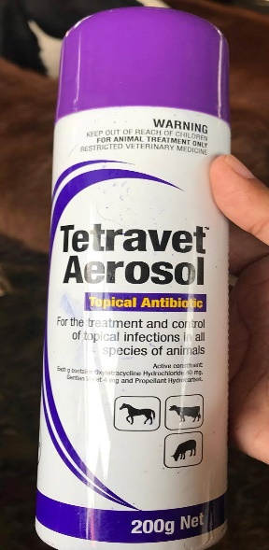

http://www.takamuljo.com/ItemDetails.aspx?ItemID=31&ProductName=

- Another dose of Penicillin was administered I.M 3 days after surgery.
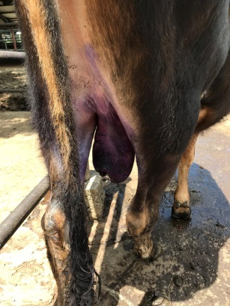

- Bruce will be monitored for the next 2 weeks.

