INTRA-OPERATIVE TECHNIQUES
FOR DISBUDDING

DISBUDDING:
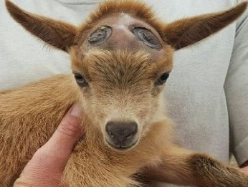
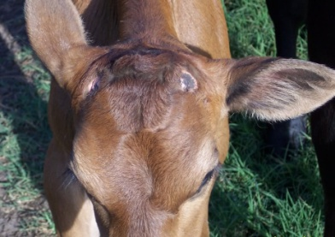
This is the process by which the horn-producing cells (corium) of the horn bud or the complete horn bud is removed. Disbudding is carried out in calves less than 2 months of age and in goats and sheep in the first less than 2 weeks after birth but can be done within the 1st week after birth.


TYPE OF  DISBUDDING | EQUIPMENTS USED | REASON FOR PROCEDURE | TECHNIQUES CARRIED OUT | COMPLICATIONS
Chemical Disbudding  (CAUSTIC PASTE)  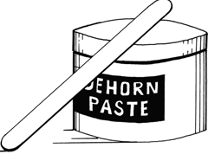 | Caustic paste  Gloves  Clipper  Marker  Petroleum Jelly  Wooden tongue depressor | It is bloodless, easy, non-invasive, effective, less stressful and traumatic than surgical or mechanical methods. Less risk of injury to the calf handler. | - Locate the horn buds  - Clip the hair from around the buds  - Use the marker to outline the area for application of the paste  - Apply petroleum on the skin at the base of the horn to prevent irritation to skin  - Ensure that gloves are being worn  - Use tongue depressor to apply paste | Caustic paste (sodium hydroxide, calcium hydroxide) applied to the horn bud can damage surrounding skin and/or the eyes if runoff occurs. Leading to irritation and damage (burning) as well as blindness of the animal.  Welfare concerns
RECOMMENDATIONS: keep animals in a confined area to avoid exposure to rain and avoid the paste coming into direct contact to the skin of other animals or handler.
http://ir.library.oregonstate.edu/xmlui/bitstream/handle/1957/20420/pnw626.pdf
https://www.youtube.com/watch?time_continue=4&v=Z1KcieP5H-E

