Drug name | Active ingredient | Time given/onset/ duration | Indication | Contraindication | Dose/route of administration/Withdrawal time
Xylazin 2%  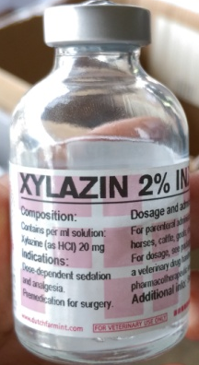 | Xylazine at a concentration of 20mg/ml  NOTE; only this concentration can be used in cattle | Given at 2:07pm  Onset at 2:17pm (10mins)  Duration : 45mins | Used in combination with other agents such as Ketamine for inducing anesthesia | Adverse effects such as : Salivation, ruminal atony,  bloating, regurgitation, hypothermia, diarrhoea, premature partuation and ataxia.  Do not give to ruminants that are dehydrated, debilitated or with urinary tract obstruction | Dose: 0.025mg/kg  Route- IM  Withdrawal:  8days -meat  48hrs –milk  Note :Dose for anxious or unruly cattle should be 0.05-0.1ml/kg of 2% Xylazine based on plumbs drug handbook
Ketamin 10%  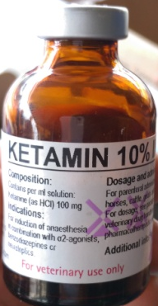 | Ketamine at 100mg/ml | Given at 2:08pm  Onset 2:18 (10mins)  Duration – 1hr | Used in combination with other agents such 2% Xylazine for inducing anesthesia | Respiratory depression  High doses- emesis , vocalization, erratic and prolonged recovery, cardiac arrest, dyspnea, muscular tremours | Dose- 0.05mg/kg  Route: IM  Withdrawal period  Milk- 3days  Meat-3days
Lidocaine injection BP 2%  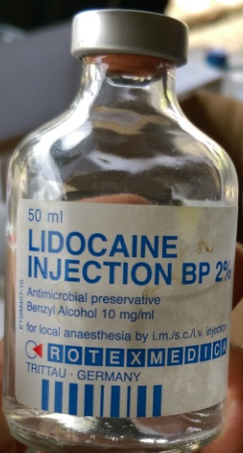 | Lidocaine at concentration 20mg/ml | Given at 2:45pm for left nerve block  Right night block given at 2:50  Eye lid /facial skin around horn desensitized at 2:47 (left), 2:52(right).  Onset – 2mins  Duration 10-20mins | Used as local and topical anesthetic agent | Toxicity signs may include: loss of consciousness, drop in blood pressure and respiratory collapse. | Dose- 0.2mg/kg  Withdrawal time-  Milk-96hrs  Meat- 5days
Tolazine 10%  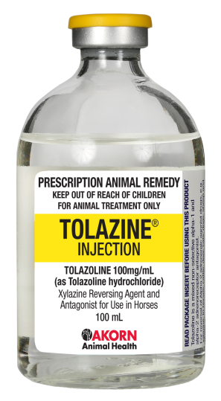 | Tolazoline at 100mg/ml- alpha-adrenergic blocker | Was not administered to animal | indicated for the reversal of effects associated with Xylazine | More sensitive to this drugs than horses. A dose od 1.5mg/kg IV can cause coughing, increased frequency of defecating and mild increases in breathing.  High doses such as 2-10mg/kg IV can cause bright red conjunctival mucous membranes, coughing, nasal discharge,salivation, laboured breathing, CAN depression, straining , headpressing, restlessness, severe diarrhoea , signs of abdominal pain  Rapid IV injection has been reported to cause significant cardiac stimulation, tachycardia, increased cardiac output, vasodilation, gastrointestinal distress | Dose-  2 to 4 times 0.025mg/kg (Xylazine Dose)  Withdrawal time-  milk - 48hrs  meat- 8days

Banamine  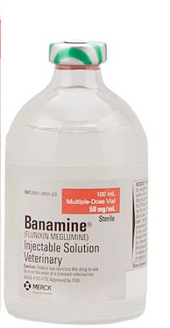 | FLUNIXIN MEGLUMINE)  50 mg/ml | Given at 2:38pm  ONSET- 2hrs  Duration – 30hrs | For the control of pyrexia associated with bovine respiratory disease, endotoxemia and acute bovine mastitis. BANAMINE Injectable Solution is also indicated for the control of inflammation in endotoxemia. | NSAIDs inhibit production of prostaglandins which are important in signaling the initiation of parturition. The use of flunixin can delay parturition and prolong labor which may increase the risk of stillbirth. Do not use BANAMINE Injectable Solution within 48 hours of expected parturition. Do not use in animals showing hypersensitivity to flunixin meglumine. Use judiciously when renal impairment or gastric ulceration are suspected. | The recommended dose for control of pyrexia associated with bovine respiratory disease and endotoxemia and control of inflammation in endotoxemia, is 1.1 to 2.2 mg/kg (0.5 to 1 mg/lb; 1 to 2 mL per 100 lbs) of body weight given by slow intravenous administration either once a day as a single dose or divided into two doses administered at 12-hour intervals for up to 3 days. The total daily dose should not exceed 2.2 mg/kg (1.0 mg/lb) of body weight. Avoid rapid intravenous administration of the drug.  Withdrawal:  Cattle must not be slaughtered for human consumption within 4 days of the last treatment. Milk that has been taken during treatment and for 36 hours after the last treatment must not be used for food
Combikel 40 LA  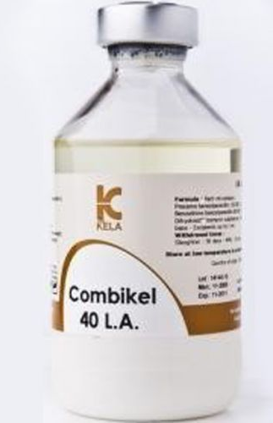 | Procaine benzylpenicillin eq.120 000 I.U. –  Benzathine benzylpenicillin eq.80 000 I.U. - Dihydrostreptomycin sulphate eq. 200 mg base - Excipients up to 1 ml | Given at 2:45pm  3 day duration of activity with minimum adverse effects | Prevention and treatment of infections caused by penicillin G and/or DHS susceptible microorganisms such as respiratory tract infections (shipping fever, bronchopneumonias, upper respiratory tract infections), uro-genital tract infections, necrobacillosis in calves and piglets, anaerobe infections (clostridial infections, tetanus, anthrax), polyarthritis (navel ill), mastitis, septicaemia, bacterial infections secondary to viral ones.  The drug also can be used in postoperative prevention of infections | With the administration of the drug, rapidly developing allergic reactions sometimes appear. Treatment of allergic reactions: glucocorticosteroids or / and antihistamines. Possible neural phenomena, neuromuscular blockade, vomiting, febrile state, abortions in pigs. Prolonged use of the drug may lead to deafness, vestibulotoxic and nephrotoxic symptoms.  Contraindications.  Do not use the drug with individual hypersensitivity to one of the components. Do not use lactating animal if milk is used for food purposes. Do not use intravenously.  Do not administer to animals with kidney failure | Route: IM  Dose –  Give a dose of 20,000I.U/kg (conc. 200,000I.U/ml) IM before the surgical procedure so the animal is protected for possible intra-operative infections.  Cattle, horses - 1 ml of the drug for 10-20 kg of animal weight once a day.  Withdrawal time-  Meat -112days  Milk -4days
Ivermectin  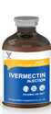 | Ivermectin 1%  Was not given to animal | Duration 2-3 days (cattle) | FDA approved for use in the control of gastrointestinal round worms, lung worms, sucking lice, mites. | STROMECTOL is contraindicated in patients who are hypersensitive to any component of this product. | Dose-0.2mg/kg  Route: SC  Withdrawal period  Milk- not established  Meat-35days
Atropine  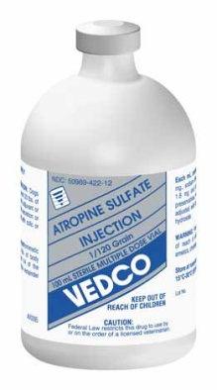 | Atropine sulphate  15mg/ml  Was not given to animal | Onset- 3-4mins  Duration-2-3hrs | For use as an antidote in the treatment of organophosphate insecticide poisoning of cattle, horses and sheep.  Atropine, this is one of the lead from emergency drugs; injections of atropine are used in the treatment of bradycardia. Therapeutic Effect.  Increased the heart rate,decreased Gastro Intestinal and respiratory secretion,reversal of muscarinic effects, bronchodilation, may have a spasmolityc action on the biliary and genitourinary tract. | Use of atropine in cattle may result in inappetence and rumen stasis that may persist for several days | Route: Iv, IM  Dose- 0.2mg/kg  Withdrawal times-  Milk-6days  Meat-28days
Epinephrine  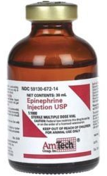 | Epinephrine  1:1000 solution]  Was not given to animal | Onset- 5 to 10 mins | Powerful, vasoconstrictor for the use in emergency for anaphylactic shock | Should not be used in cases where vasopressor drugs are contraindicated eg. Thyrotoxicosis, diabetes, toxaemia of preganancy | Cattle, Horses, Sheep and Swine: 1 mL per 100 lbs of body weight injected Intramuscularly or Subcutaneously  0.5-1.0 ml/45 kg 1:1000 solution IM or SQ q 15minutes

