INTRA-OPERATIVE TECHNIQUE
FOR DISBUDDING

DISBUDDING:
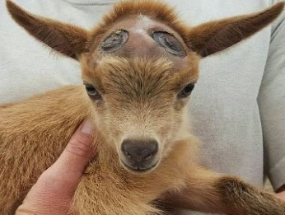
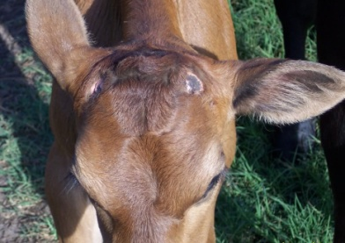
This is the process by which the horn-producing cells (corium) of the horn bud or the complete horn bud is removed. Disbudding is carried out in calves less than 2 months of age and in goats and sheep in the first less 2 weeks after birth but can be done within the 1st week after birth.


TYPE OF  DISBUDDING | EQUIPMENTS USED | REASON FOR PROCEDURE | TECHNIQUES CARRIED OUT | COMPLICATIONS
Mechanical Disbudding  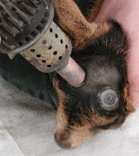  (HOT IRON DEHORNER) | Hot iron dehorner  Garden Gloves   | It is quick, bloodless, effective, and can be on used on calf less than 2 months and up to 3 or 4months of age | - Proper pre-operative treatment (refer to pre-op section).  - Select the correct size tube to fit over the horn bud and horn base, then Preheat the dehorning iron to a red colour.  - Place the cutting edge straight down over the horn.  - Apply pressure to the tube (push and twist) not exceeding a 10 second duration, remove the iron for another 10 second and repeat the process again until the horn buds are burnt to a golden brown. | This technique is very painful, and excessive heat applied during hot-iron disbudding can damage underlying bone and the brain.  Improper handling can lead to burn injuries to animal and handler.  Lambs and kids have smaller size and thinner skulls than cattle so they are more prone to injury from excess force or deep burns.  Thermal injury can lead to meningitis or cerebral malacia.
RECOMMENDATIONS:
- Emphasis should be placed on proper pre-op care (Administer sedation, analgesia and local anaesthetic) due to the level of pain elicit by this technique.
- Ensure that the proper size dehorning iron is used to minimize injuries to the animal.
- The procedure should be done by a skilled and experience person or under supervision by such person. This is because incorrectly done procedures lead to scars (partial horn growth)
- Lambs and kids have a smaller thinner skull than calves so take precaution not to use excessive force or long duration of heat when disbudding
- Proper post –op treatment to prevent any problems that might develop from the procedure (see post operative section).
https://www.youtube.com/watch?v=aZpyim7raNA

