Dehorning/Disbudding in relation to Anatomy

Disbudding

The horn grows from the skin around its base – at different rates with different breeds. The horn bud is usually free-floating in the skin over the skull base in calves less than about two months old.

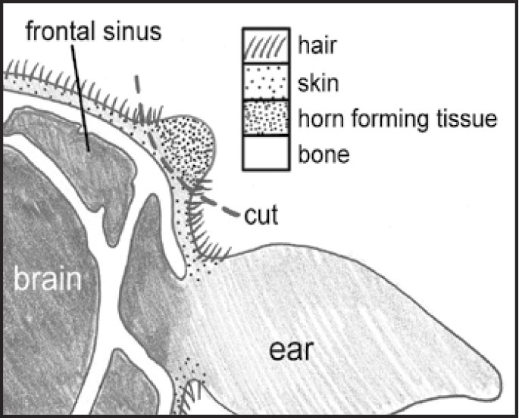

Dehorning

As the calf gets older, this horn bud attaches to the skull bone and a small horn form. After the horn bud attaches to the skull, the horn grows out from under the skin. It becomes a bony extension of the skull with the hollow centre of the horn opening into the frontal sinus. The brain lies directly under the frontal sinus covered by a thin layer of bone.
Dehorning after the horn attaches increases the risk of entering the frontal sinus and subsequent infection.
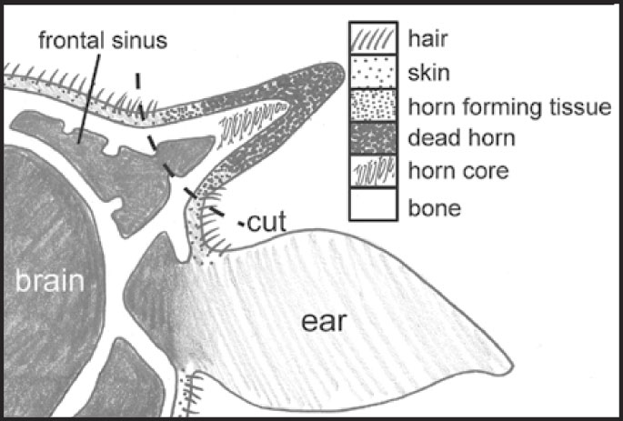

The horn grows from the skin around its base, so for successful dehorning you must remove or destroy a complete ring of hair (1cm wide) around the horn base. Check that the excised ring is wide enough because some horn will grow if the ring is not complete. A 1cm wide ring of hair is enough – any more will make a larger wound, cause avoidable pain, and delay healing

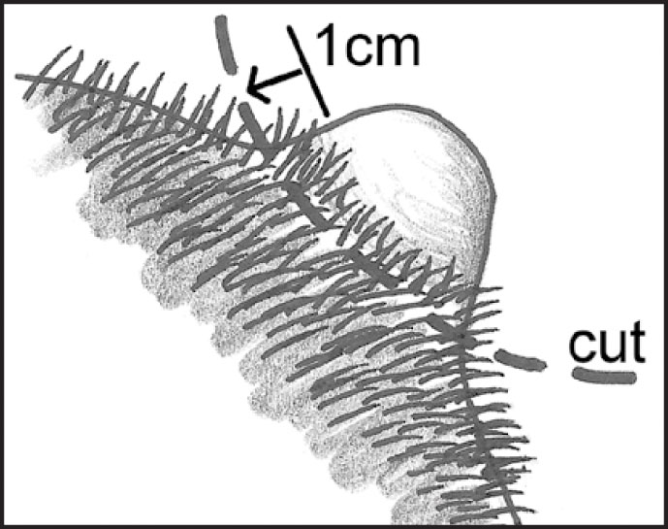

ANATOMY OF HORN

The keratin in the epidermis, when cornified and thickened, is referred to as horn. Horn is particularly resistant to mechanical and chemical damage. Cattle, some sheep, goats and antelope possess horns and these are permanent organs.
Breeds without horns are termed polled breeds.
Horns have a central, conical bony core or cornual process that grows out from the frontal bone of the skull. After 6 months of age, the bone becomes hollow and the space within it is continuous with the frontal sinuses. The surface of the bone is ridged and porous and is covered with papillated dermis that is continuous with the periosteum and epidermis which keratinises and forms the protective covering of the horn. The substance of the horn is similar to that of the hoof and is a mixture of tubules and intertubular horn. The new horn produced at the base is soft and often transparent and resembles the periople of the hoof, giving the horn a glossy appearance.

In the neonate, the bone portion is very small, with a thin dermal and epidermal covering. Removal of this covering will prevent the horn from growing and thus remove the requirement for disbudding later in life.

If the skin covering the horn bud is not removed, the horn will continue to grow throughout the animal's life from the base, apically. Growth zones are visible with differing thickness of the keratin layer, relating to the nutritional status of the animal at that time.

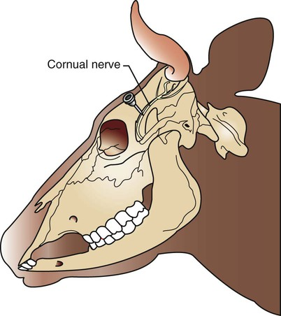

The dermis of the horn is supplied by the cornual nerve, which is a branch of the maxillary nerve (CN V). This nerve is often blocked to provide local anaesthesia in the disbudding or de-horning process.

The primary function of horns is to convey social hierarchy. Also, horns have a thermoregulatory roll in cattle and goats. When the ambient temperature increases, the blood flow through the dermis of the horn also increases, thus facilitating heat loss through radiation from the horn surface.

