**Tools Used for Dehorning of calf**

**Figure 1. Cauterizing hot iron**

This tool is used for both dehorning and disbudding. An iron is heated to red hot, then held firmly to the horn bud for about 10 seconds, destroying the horn-producing cells and preventing further growth.

**Advantages:** Bloodless, can be used in calves up to four months of age.

**Disadvantages:** More painful for the animal than caustic paste; iron may fail to get back up to heat between calves, resulting in ineffective disbudding; requires more physical restraint of animal than paste disbudding; poses a risk of injury to the handler. Can also result in thermal meningitis.

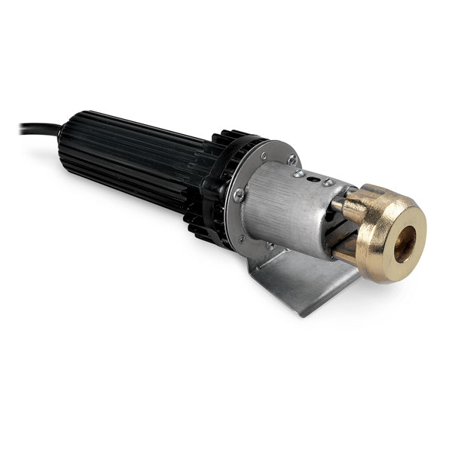

**Figure 2: Gigli saw wire**

Gigli wire is a flexible cutting wire with a toothed edge used to cut hard materials such as Fibreglass, casts, bone and horn.

**Important Considerations:** Takes a lot of “man power” and force to remove horn. Must ensure a layer of epithelial cells is removed with the horn, to ensure no more growth occurs.

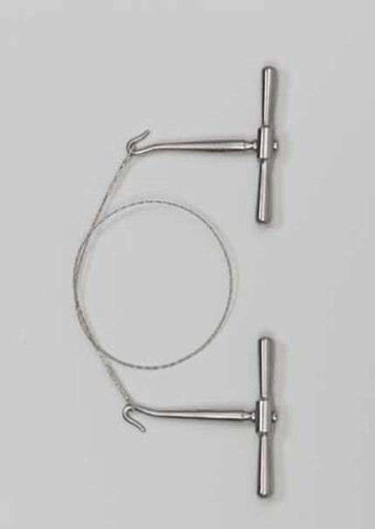

**Fig 3: Cattle hair clipper**

Clipper used for cutting the calf’s hair around the horns

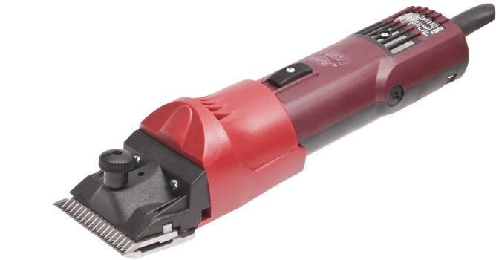

**Other tools that can be used for dehorning**

**Figure 4: Barnes or “Gouger” Dehorning**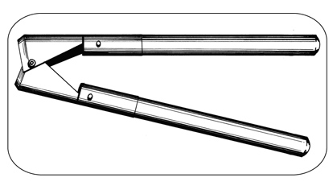

A Barnes dehorner is a hinged, closed set of sharp scoops which is placed over the horn against the base and surrounding skin. Opening the handles forces the cutting edges together, slicing through the skin and under the horn.

**Advantages:** Several instrument sizes available.

**Disadvantages:** Bloody; painful; poses risk of injury to the animal and handler.

**Figure 5: Keystone or Guillotine dehorning**

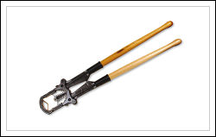

A keystone dehorner has two handles that move a blade downward against a plate or another blade, slicing through the base of the horn and surrounding skin.

**Advantages:** Can be used in older cattle with large horns.

**Disadvantages:** Greater risk of exposed sinus, infection and blood loss; painful; may lead to set-backs in overall health and performance, including weight loss; requires follow-up care; poses risk of injury to the animal and handler.