**Pre- operative Anesthesia**

Signalment:

* Patient no. 588
* Species: bovine
* Breed: Holstein
* Sex: Female
* Body weight: 500 kg

Restraint:

1. Figure 1- demonstration of tail restraint

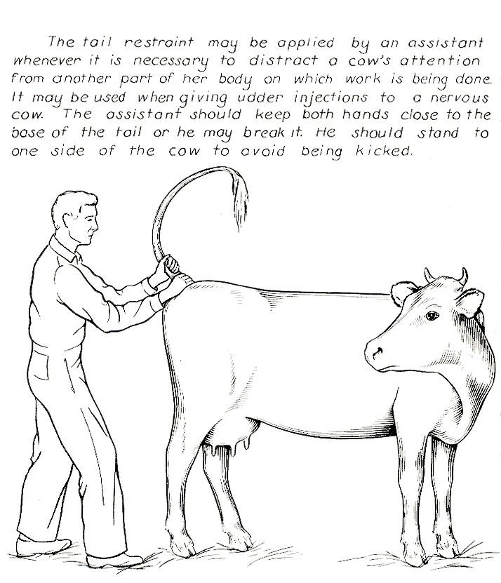

1. Neck clamp

Sedation:

Figure 2: Table showing the amount of drug used for sedation in cattle

|  |  |  |  |  |  |
| --- | --- | --- | --- | --- | --- |
| Name of drug | Concentration (mg/mL) | Dose (mg/kg) | Volume (mL) | Withdrawal period (day) | |
|  |  |  |  | Beef cattle | dairy  cattle |
| Xylazine | 20 | 0.025 | 0.625 | 5 | 3 |
| Ketamine | 100 | 0.05 | 0.25 | 3 | 2 |

**Intra- Operative Anesthesia:**

Figure 3: Table showing the amount of drug used for epidural block in cattle

|  |  |  |  |  |  |  |
| --- | --- | --- | --- | --- | --- | --- |
| Name of drug | Concentration (mg/mL) | Dose (mg/kg) | Volume (mL) | Withdrawal period (day) | | Toxic dose  (mg/kg) |
|  |  |  |  | Beef cattle | Dairy cattle |  |
| Lidocaine | 20 | 0.2 | 5 | 1 | 3 | 10 |

Procedure:

The drug is administered in the epidural space between the sacrococcygeal (S5-Co1) interspace or, more commonly, at the first coccygeal (Co1-Co2) interspace. The space is identified by gently lifting the tail up and down while simultaneously palpating for the 1st freely moveable joint caudal to the sacrum. Once the site has been identified the area is clipped and surgically prepared with 90% alcohol. The 18G needle is advanced ventrally at 15° angle in the center of the depression through the subcutaneous tissue and the ligament of the dorsal spinous process. The needle will penetrate the ligamentum flavum and tissue resistance will disappear.

Correct placement can be identified by:

Hanging drop: When the needle is inserted, 1 or 2 drops of lidocaine is instilled from syringe into the hub of the needle. Sub atmospheric pressure allows the drops to be aspirated.

The anesthesia can now be administered, the lidocaine is injected and no resistance should be encountered. During the injection the lidocaine will fill the epidural space and diffuse cranially.

Checking the efficacy of the epidural block – evaluate the tail tone of the patient by lifting the tail and pinching the skin around the vulva. The tail should be flaccid and the patient will elicit no reaction while pinching the skin.

Maximal effect is seen 10 to 15 minutes after administration and lasts for around one hour. Lack of anaesthetic effect within 10 minutes usually suggests that the injection was made outside of the epidural space.

**Post- Operative Anesthesia:**

Complications associated with epidural block: Complications are rare but can include postural instability and/or recumbency and haemorrhage due to puncture of a venous sinus. In cases where asepsis is not observed, infection may lead to a discharging tract or a permanently paralysed tail.