**Cow #588** was used in this lab

**Estimated weight of jersey cow** – 500kg

**Materials:**

18G needle 2% 0.025mg/ml xylazine

5ml syringe 10% 0.05mg/ml ketamine

Cotton

70% alcohol

**About the procedure:**

The area of muscle between the tuber coxae and ischial tuberosity was prepped by cleaning with 70% alcohol. (See Figure 1)

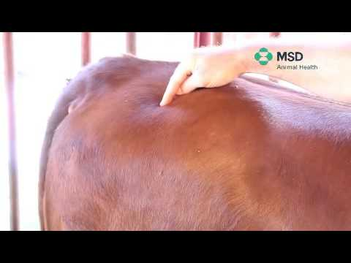 *Figure 1*

0.625ml of xylazine was administered using a 5ml syringe attached to an 18g needle into the right gluteal muscle. The needle was inserted initially into the musculature. The syringe was the attached to the needle, pulling back on the plunger to ensure that no blood vessel was entered, followed by administration of the drug.

0.25ml of ketamine was administered using a 5ml syringe attached to an 18g needle into the left gluteal muscle. The same procedure was followed as with the xylazine.

**Pre op considerations:**

Atropine causes increased viscosity of saliva hence is not preferred reversal drug for xylazine overdose.

Side effects of xylazine include bradycardia due to secondary AV block. 0.4mg/kg atropine used to combat this.

**Post op considerations:** abscesses, lameness