ANATOMY OF THE EQUINE LIMBS

THORACIC
LIMB

FIG 1. BONES OF THE LEFT EQUINE THORACIC LIMB
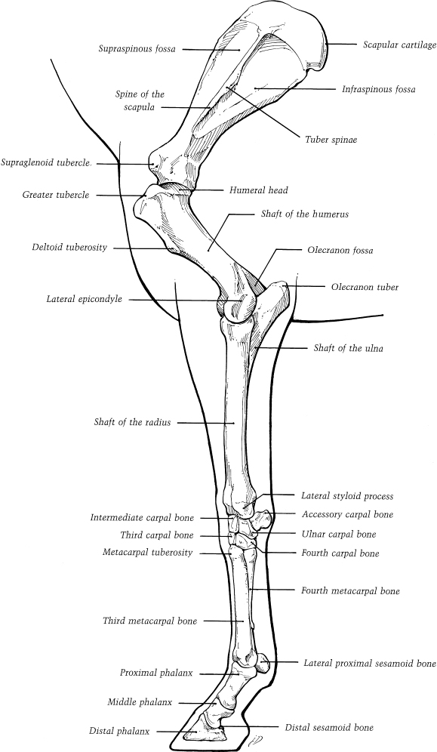
FIG 2. LATERAL ASPECT OF THE LEFT EQUINE SHOULDER
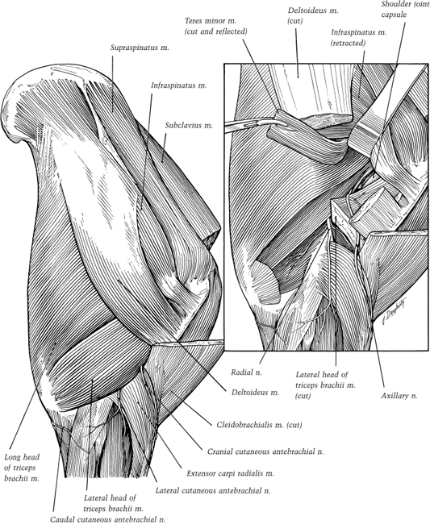
FIG 3. RIGHT SHOULDER AND DORSOSCAPULAR LIGAMENT
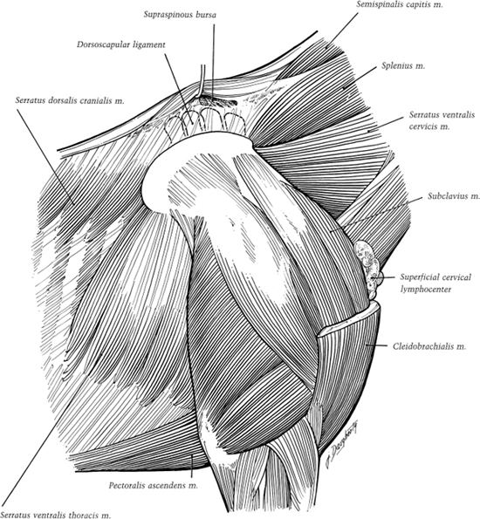

FIG 4. MEDIAL VIEW OF THE LEFT SHOULDER ARM AND PROXIMAL FOREARM
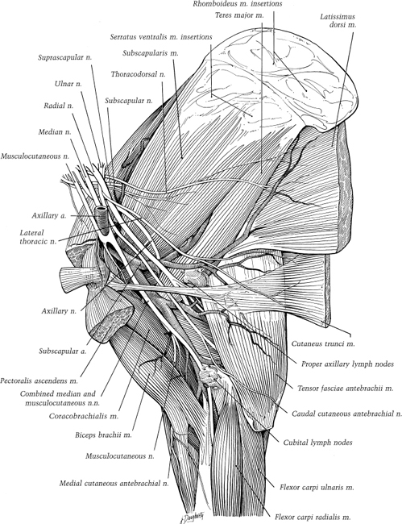
FIG 5. LATERAL VIEW OF THE LEFT DISTAL FOREARM, CARPUS AND PROXIMAL METACARPUS
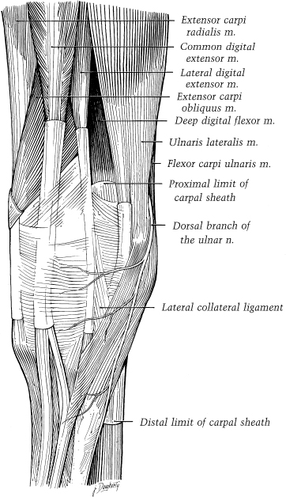
FIG 6. CAUDOMEDIAL VIEW OF A SUPERFICIAL DISSECTION OF LEFT ELBOW AND FOREARM
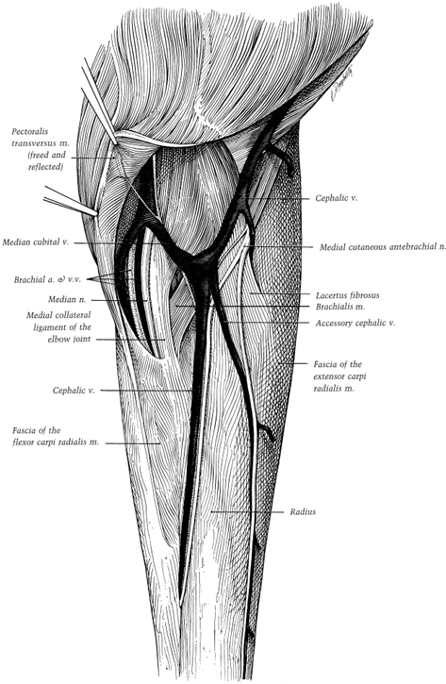
FIG 7. DEEP DISSECTION OF THE CAUDAL ASPECT OF THE CARPUS AND METACARPUS
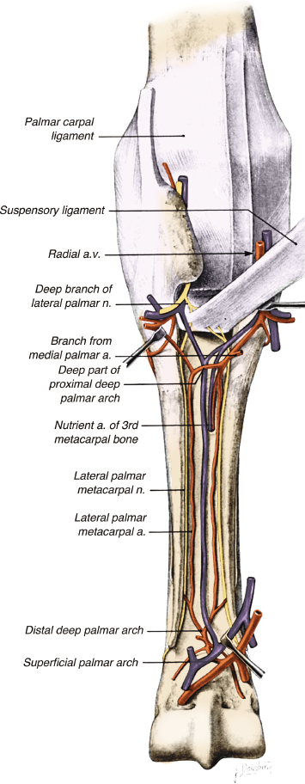

FIG 8. CAUDAL VIEW OF THE LEFT CARPUS AND METACARPUS
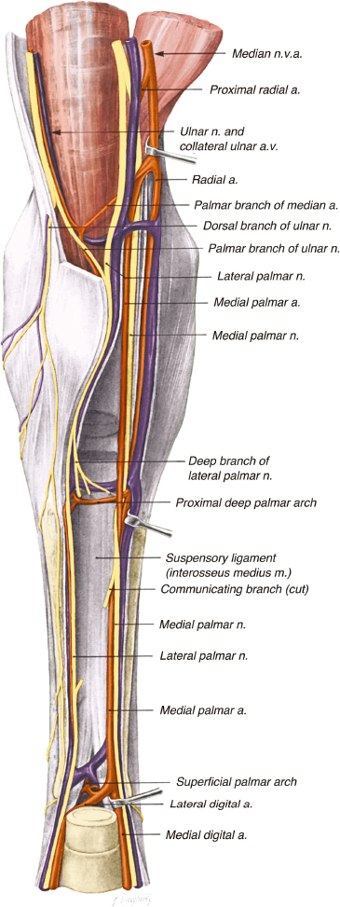

FIG 9. MEDIAL VIEW OF THE CARPAL LIGAMENTS
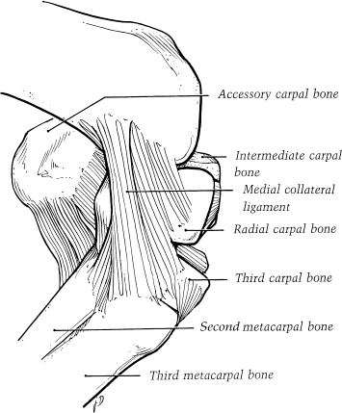

FIG 10. LATERAL VIEW OF THE CARPAL LIGAMENTS
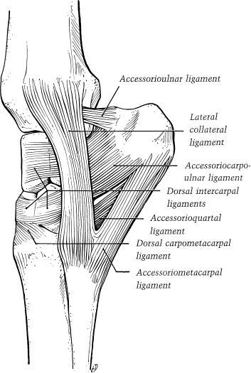

FIG 11. DORSAL VIEW OF THE LEFT CARPUS
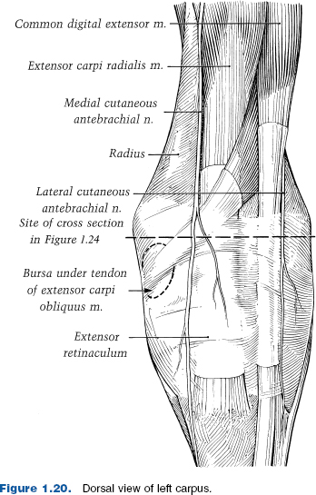

FIG 12. BLOOD AND NERVE SUPPLY TO THE FETLOCK AND DIGIT (1)
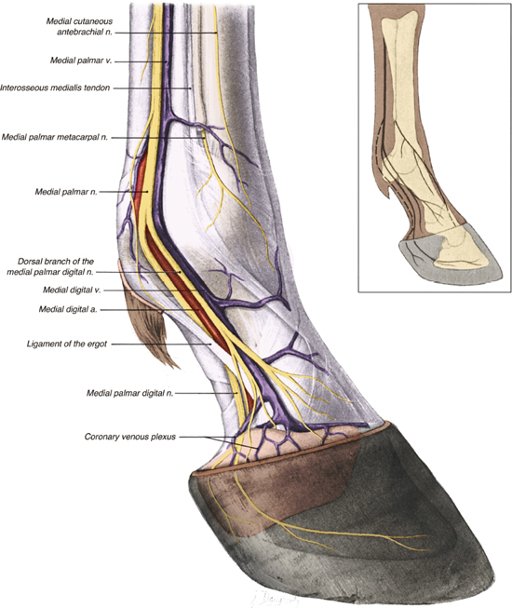

FIG 13. BLOOD AND NERVE SUPPLY TO THE FETLOCK AND DIGIT (2)
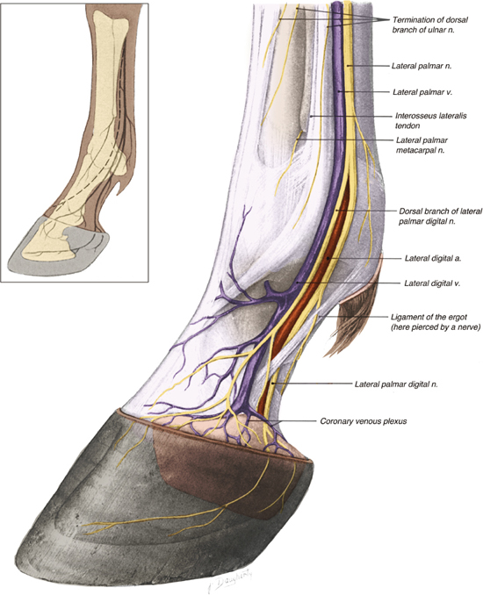

FIG 14. ARTERIAL SUPPLY TO THE DIGIT ANDFORELIMB
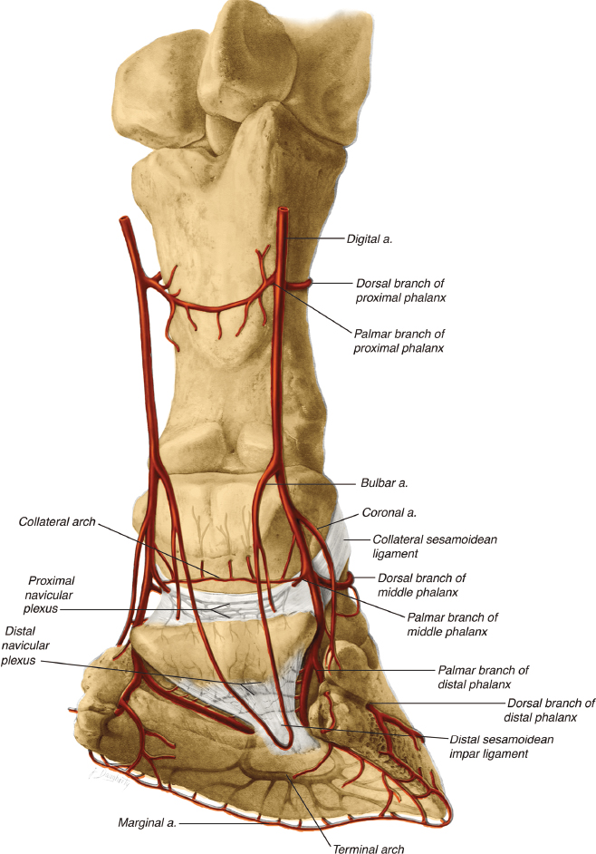

FIG 15. LIGAMENTS OF THE PASTERN
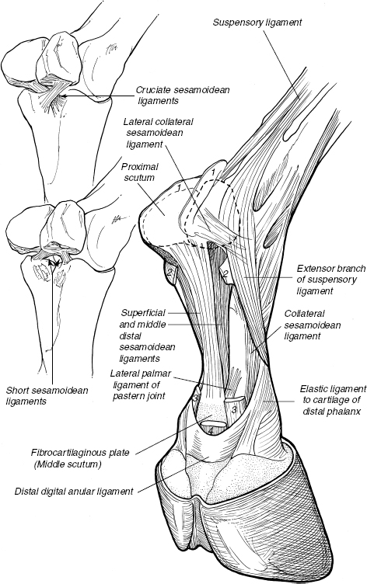

FIG 6. LIGAMENTS AND TENDONS OF THE PASTERN
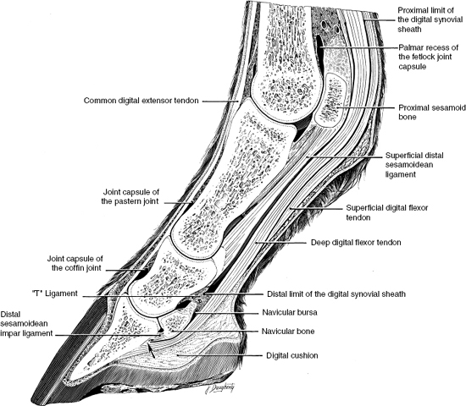

FIG 17. LIGAMENTS STABIIZING THE CARTILAGE OF THE DISTAL PHALANX
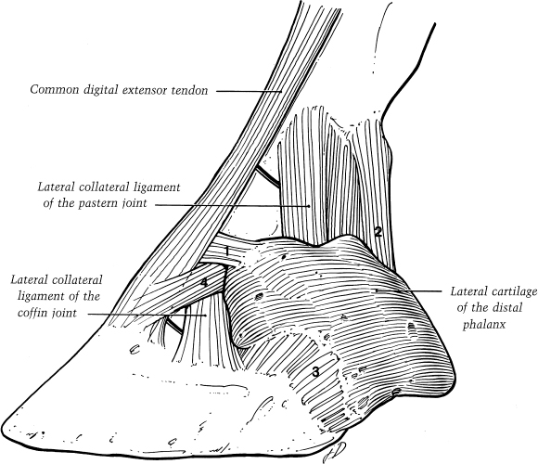

FIG 18. NAVICULAR BONE
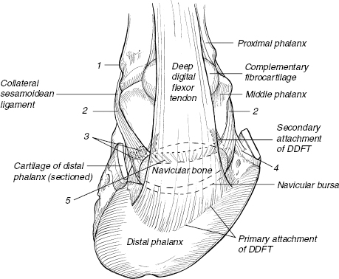

FIG 19. HOOF AND DERMIS
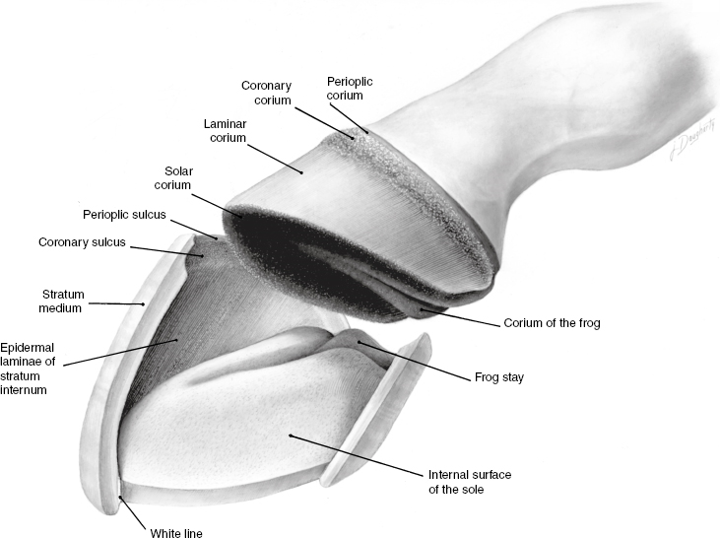

FIG 20. TOPOGRAPHY OF THE SOLAR SURFACE OF THE HOOF
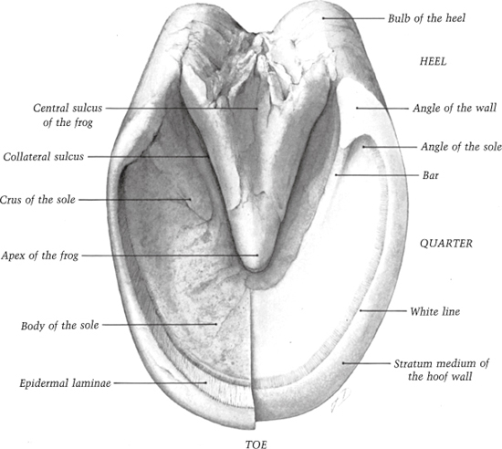
FIG 21. HISTOLOGY OF THE SOLE
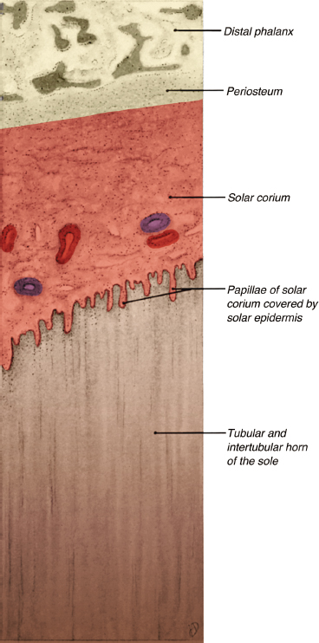
FIG 22. STAY APPARATUS OF THE EQUINE THORACIC LIMB
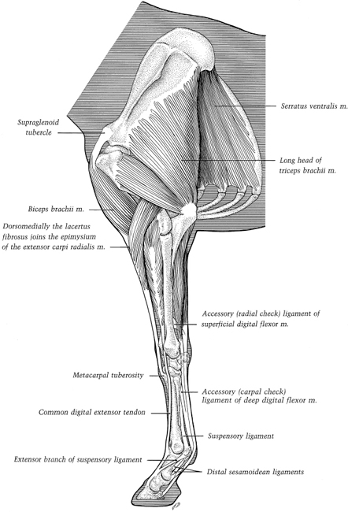

PELVIC
LIMB

FIG 23. LATERALVIEW OF THE BONES OF THE PELVIC LIMB
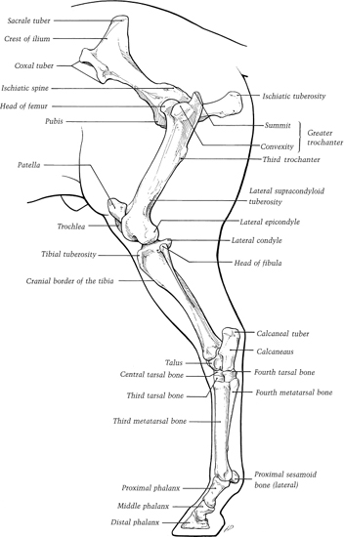
FIG 24. DEEP DISSECTION OF THE RIGHT HIP, LATERAL VIEW
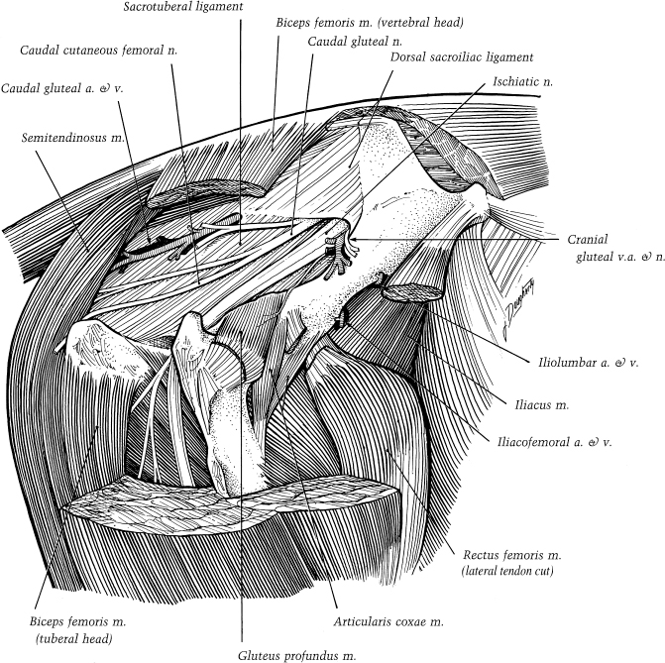

FIG 25. DEEP DISSECTION OF THE RIGHT HIP, VENTROMEDIAL VIEW
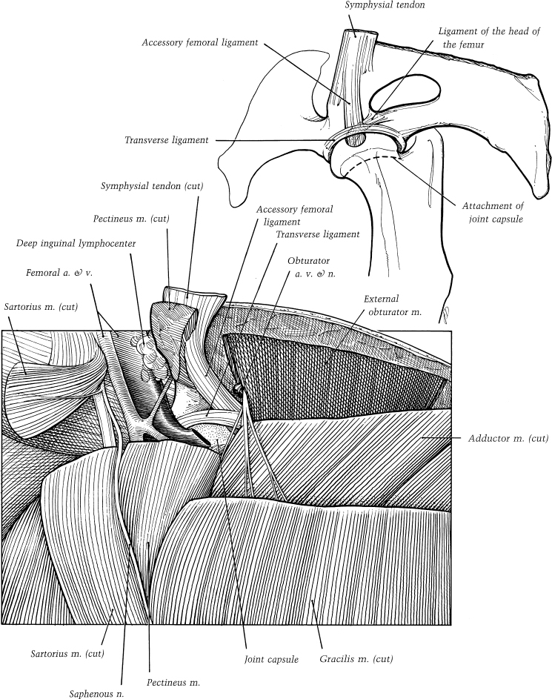
FIG 26. LATERAL DISSECTION OF THE RIGHT THIGH AND HIP
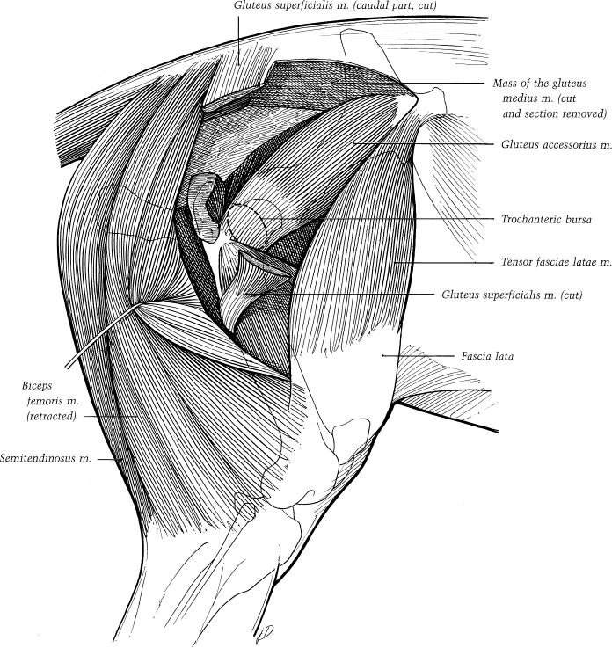
FIG 27. LATERAL VIEW OF THE RIGHT STIFLE AND THIGH
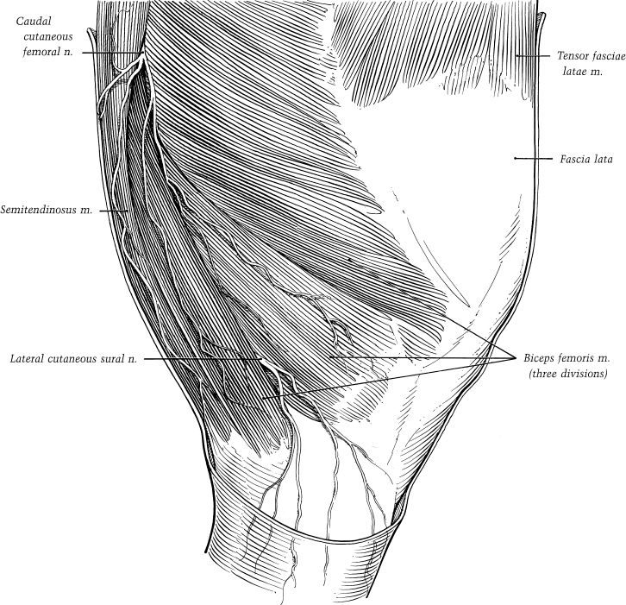

FIG 28. SUPERFICIAL DISSECTION OF THE LATERAL ASPECT OF THE LEFT STIFLE, CRUS AND TARSUS
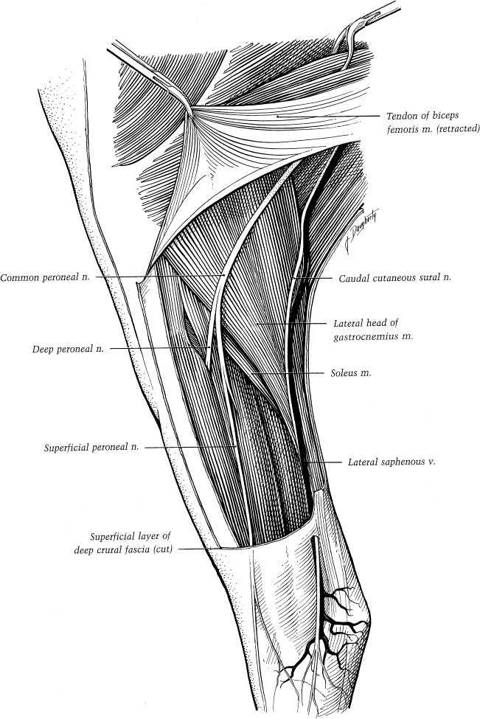
FIG 29. DISSECTION OF THE CAUDAL ASPECT OF THE RIGHT STIFLE AND CRUS
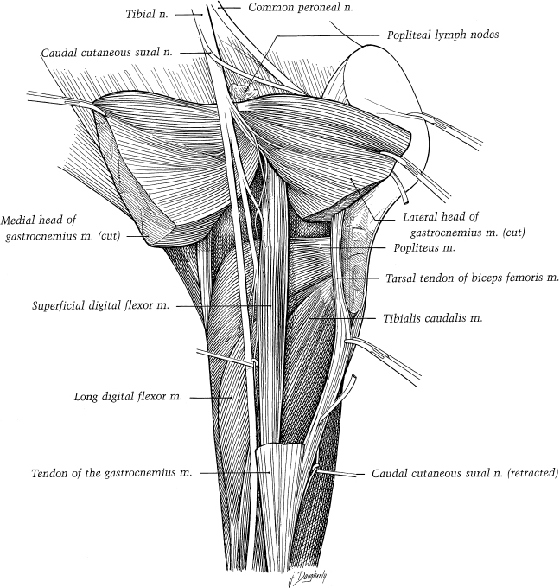

FIG 30. DEEP DISSECTION OF THE CAUDAL ASPECT OF THE RIGHT STIFLE
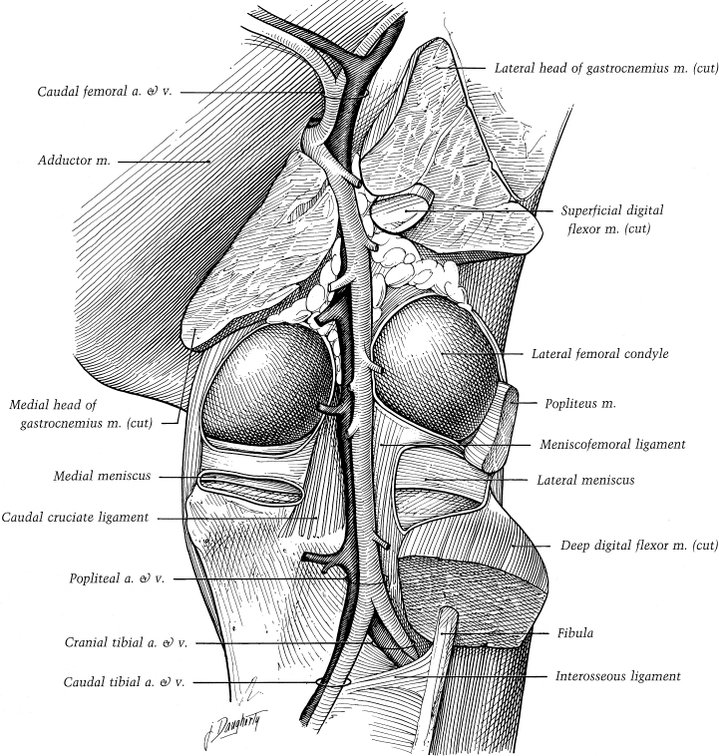
FIG 31. DEEP DISSECTION OF THE LATERAL ASPECT OF THE LEFT STIFLE
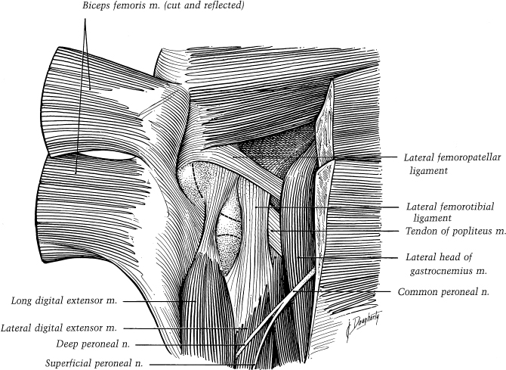
FIG 32. DEEP DISSECTION OF THE MEDIAL ASPECT OF THE LEFT STIFLE
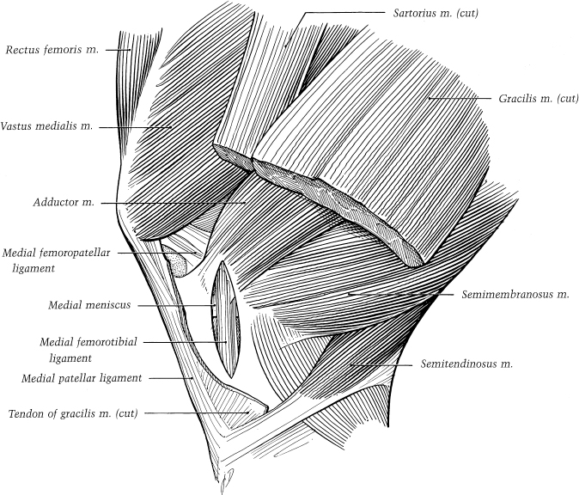

FIG 33. DORSAL VIEW OF THE RIGHT STIFLE, CRUS AND TARSUS
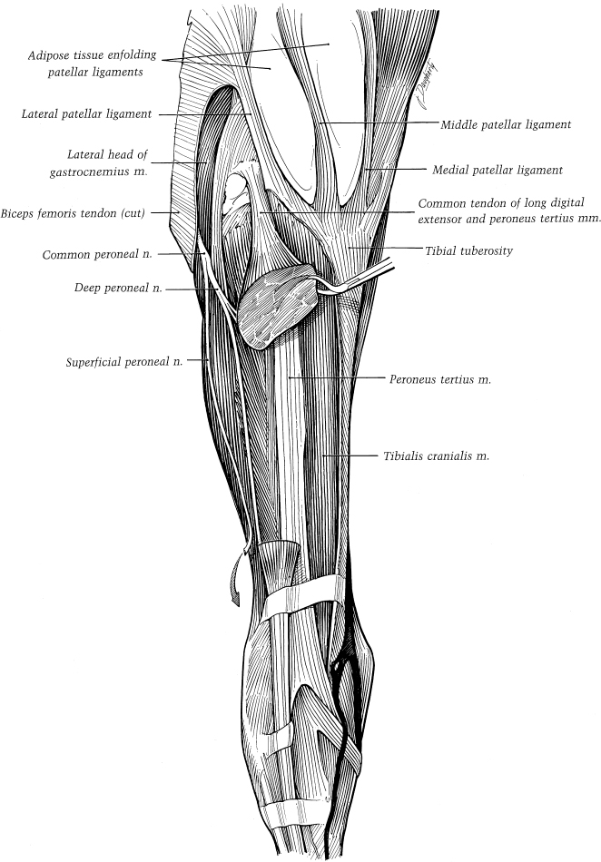
FIG 34. DORSAL VIEW OF THE RIGHT TARSUS
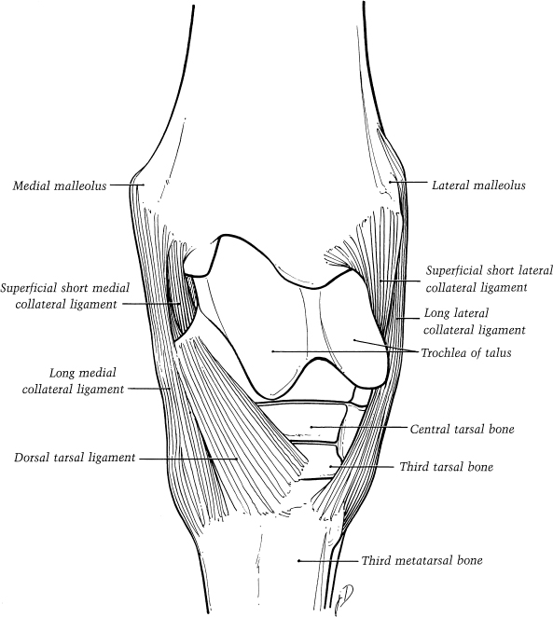
FIG 35. LATERAL VIEW OF LEFT TARSUS
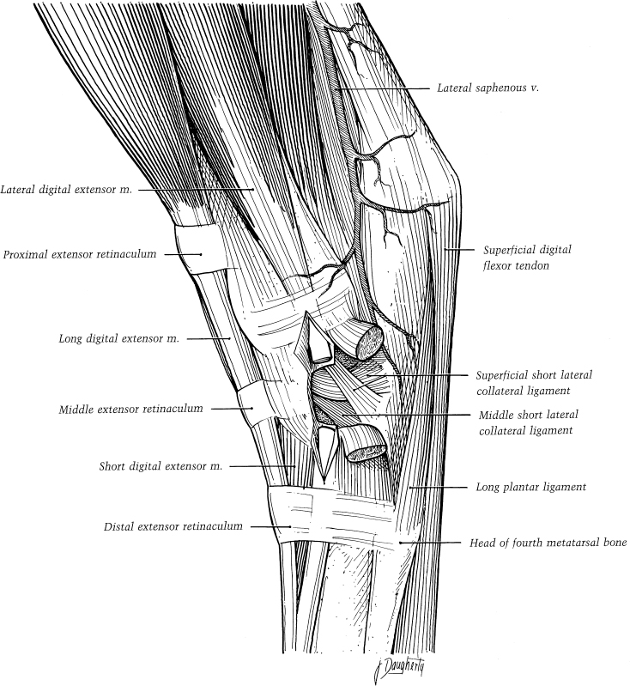
FIG 36. MEDIAL VIEW OF THE LEFT TARSUS
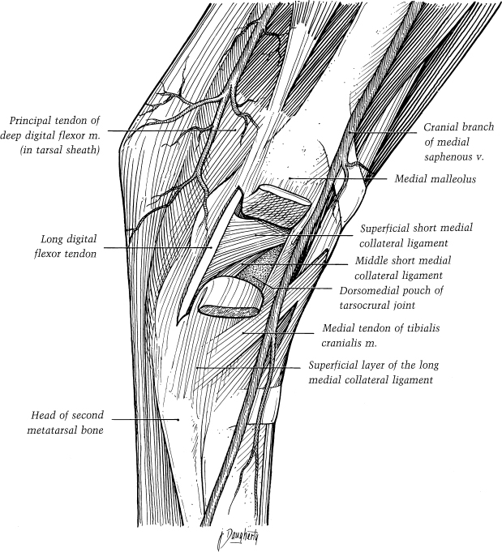
FIG 37. DORSAL DISSECTION OF THE RIGHT TARSUS
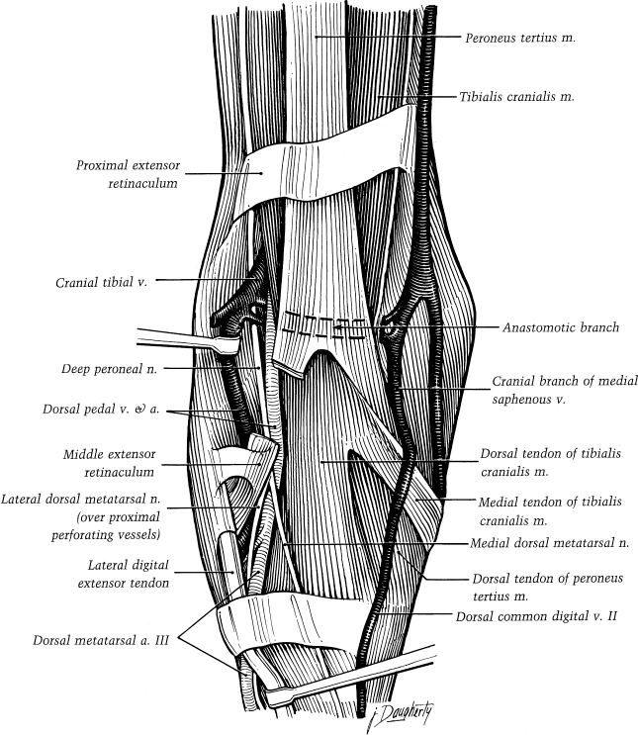

FIG 38. LATERAL VIEW OF LEFT DISTAL CRUS AND PES
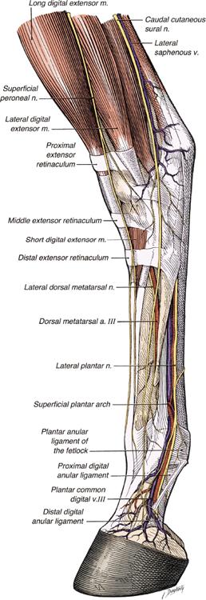
FIG 39. MEDIAL VIEW OF THE LEFT DISTAL CRUS AND PES
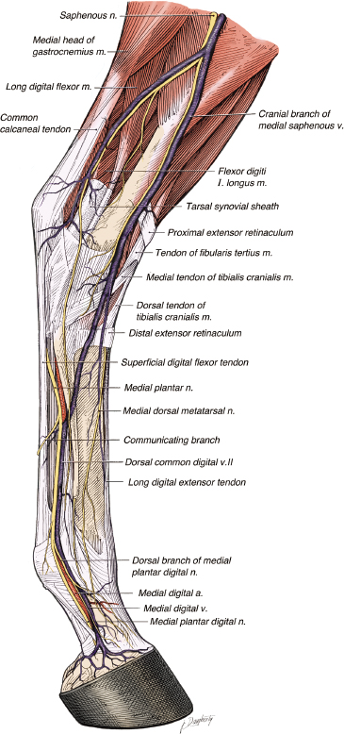
FIG 40. RECIPROCAL APPARATUS, LATERAL VIEW OF THE LEFT HINDLIMB
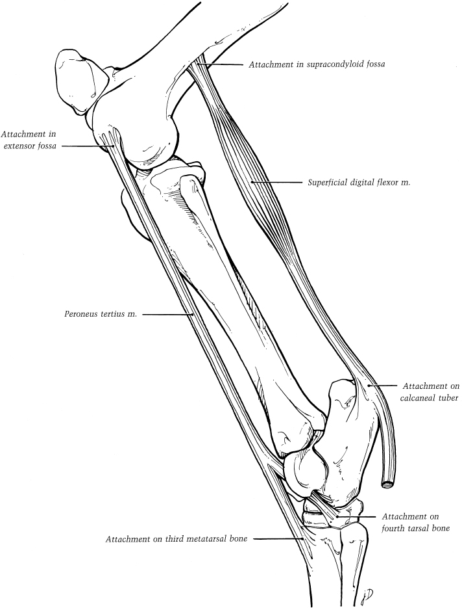
FIG 41. STAY APPARATUS OF THE EQUINE PELVIC LIMB
