Drugs used for nerve and joint blocking
Drug Name | Active Ingredient/s | Uses | Dosage | Onset of Action | Duration
Lidocaine  Hydrochloride 2% and Epinephrine (1:100,000) USP  Xylocaine (trade name)  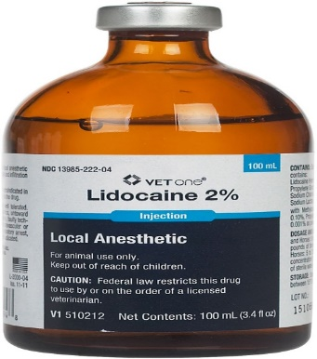 | Xylocaine,  Lignocaine  2% Lidocaine Hydrochloride  5.2% Propylene Glycol  0.5% Sodium 0.5% Chloride  Sodium Lactate  with 0.15% Methylparaben, 0.10% Sodium Metabisulfite, 0.03% Propylparaben and 0.001% Disodium Edetate as preservatives. | Local anaesthetic and antiarrhymmatic agent.  May be useful as an intravenously anaesthetic or analgesic adjunct.  Use as a partial intravenous anaesthesia (PIVA) protocols for its analgesic, anti-inflammatory and prokinetics effects.  Use in the prevention of post-operative ileus and reperfusion injury and for adjunctive treatment of endotoxemia. | 0.25-0.5mg/kg  Administered slowly and can be repeated 5-10 minutes.  Post-operative 1.3-1.4mg/kg IV.  For PIVA- 1.5-5mg/kg.  (Plumb’s Veterinary drug handbook, 8th Edition, page 847.)  Not for epidural or caudal use.  Administered IV. | 3-5 minutes | 30-40 minutes
Mepivacaine Hydrochloride (20mg/ml)  Carbocaine-V  (Trade Name)  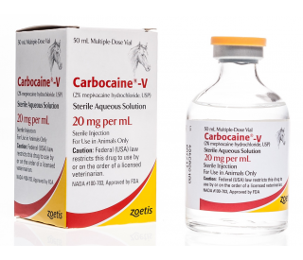 | 1 methyl-2,6 Pipecoloxylidide Monohydroholride.  Sodium chloride for tonicity and 0.1% Methylparaben as preservative.  Polocaine,  Carbocaine preservative free, Polocaine Dental, Polocaine-MPF, Scandonest 3% plain.  (Other trade names) | Use for infiltration around surgical site, nerve blocks, intra-articular and epidurals.  Has a longer lasting effect than lidocaine.  Useful in topical anaesthesia of the laryngeal mucosa prior to ventriculectomy.  Not to be use in horses intended for human consumption. | Nerve blocks 3-15ml  Epidurals  5-20ml  (standing)  Intra-articular  10-15ml  (Equimed.com)  Do not use Procaine hydrochloride with this drug well as Acepromazine may increase the toxicity of organophosphate.  Administered IM or Epidural. | 5-11 minutes | 1.5- 2 hrs
Bupivacaine Hydrochloride 0.5% (5mg/ml)  Marcaine (Trade Name)  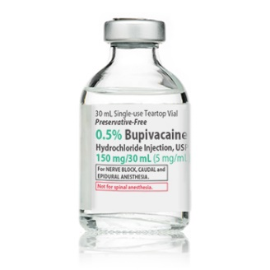 | 2-Piperidinecarboxamide, 1-butyl-N-(2,6-dimethylphenyl)-, monohydrochloride, monohydrate. Freely soluble in 95 percent ethanol and water, slightly soluble in chloroform or acetone. | The preferred drug for post-operative analgesia because off its relatively long duration of action.  Cardiotoxic if administered IV.  Not for spinal anaesthesia.  Not recommended for IV regional anaesthesia.  Frequently administered into the epidural space at the lumbosacral space for pelvic and peritoneal procedures. | Single dose 175mg/3hr  Maximum dose  400mg/24hr  Administered IM or Epidural. | Intermediate | 4-6hrs

