Nerve Block | Position/Land Mark/Technique | Needle size/Drug volume/Time | Nerves blocked | Regions Blocked
Lower Limb Nerve Blocks
Palmar /Plantar Digital  (PDN)  Note: Palmar forelimb and Plantar Hind limbs  Local anaesthetic is injected into superficial nerves on the back of the lower pastern, abolishing sensation in most of the foot  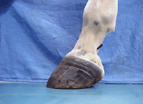 | In PDN block, horse is positioned standing or with foot elevated. Other positions while facing back with one hand holding limb and also facing forward with foot between your knees.  The needle is inserted directly over the palpable neurovascular bundle about 1 cm proximal to the cartilage of the foot.  The needle is directed distally, and 1.5 mL of local anesthetic solution is deposited near the junction of the nerve and the cartilage of the foot  Palmar/plantar digital nerves are palpated along the lateral and medial borders of the DDFT, palmar/plantar to the accompanying artery. 1-2cc of local analgesic solution are injected in the angle between the ungular cartilages of the distal phalanx and the palmar/plantar aspect of the pastern, on the palmar/plantar border of the neurovascular bundle. | Needle- 25 gauge, ¼ inch  Volume- 1-2cc  Time-5- 10mins | Forelimb- Median Palmar Nerve and Lateral Palmar Nerve  Hindlimb-Plantar digital Nerve | This results in desensitization of the entire foot including the:  - navicular bone  - navicular bursa  - suspensory ligaments of the navicular bone  - distal part of the DDFT the digital cushion  - corium of the frog  - solar and laminar dermis  - DIP joint  - distal phalanx.  Note:The only part of the foot that is not desensitized by a PDNB is the-  - dorsal aspect of the coronary band  - sensitive laminae of the dorsal wall of the toe.  Absence of skin sensation over the heels indicates that the block has taken effect.
Abaxial Nerve Block/basisesamoid nerve block  Note: used if horse lameness not reduced with PDN  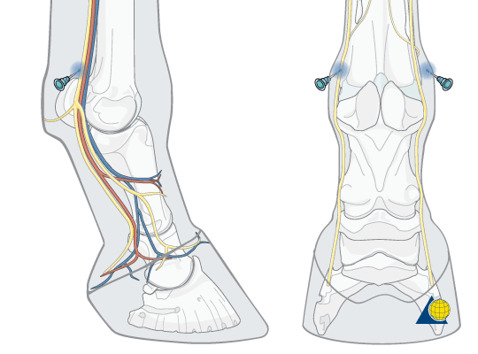  Local anaesthetic is injected around the same nerve as the PDNB but higher up the limb at the back of the fetlock. Abolishes sensation below the fetlock in the foot and pastern | Position: Horse standing or with foot elevated. Other positions while facing back with one hand holding limb and also facing forward with foot between your knees  Landmark: Distal border of proximal sesamoid bones  Technique : The dorsal and palmar/plantar digital nerves are part of the neurovascular bundle which is easily palpated over the abaxial surface of the proximal sesamoid bones. The needle is inserted in a distal direction, just palmar/plantar to the neurovascular bundle, by the base of the proximal sesamoid bone, and 2–3 mL of local analgesic solution is injected on both sides. | Needle:25 guage, ¾ inch  Volume: 1.5-2cc | Forelimb- Median Palmar Nerve and Lateral Palmar Nerve  Hindlimb-Plantar digital Nerve | Correct injection leads to desensitization of theentire foot including the:  - DIP joint  - distal sesamoidean ligaments and flexor tendons distal to the site of injection  - proximal interphalangeal (PIP) joint  - part of the fetlock joint.  The skin around the coronary band should be entirely desensitized.  A ring block of the pastern may be a useful alternative to the ASNB, because it avoids the sometimes confusing partial desensitization of the fetlock joint that is frequently achieved with an ASNB.  May possibly also block:  - Proximal sesamoid bones  - Fetlock joint  - Digital flexor tendon sheath
low palmar /plantar nerve block  Forelimb- low 4-point block  Hind Limb- low 6-point block  Note: performed after a negative response to the abaxial sesamoid nerve block (ABSNB)  This localizes the site of pain causing lameness to the fetlock.  Local anaesthetic is injected into two pairs of nerves just above the fetlock, abolishing sensation to the fetlock and below. In the hind limb, two more nerves at the front of the limb must also be injected  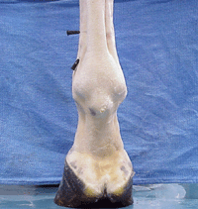 | Position: performed with the horse bearing weight on the limb, but it can also be performed with the limb held  Location:  1. Palmar metacarpal nerves (forelimb), Plantar metatarsal nerves(hindlimb)-- which are just distal to splint bone adjacent to Metacarpal3/Metatarsal 3. Be very catious here as it is very close to palmar fetlock pouch  2. Palmar/Plantar nerves—between DDFT and suspensory ligament, about 3-5cm to button of splint bone . Be catious as it is very close to flexor tendon sheath  3. Dorsal Metatarsal (hindlimbs only)—either side of extensor tendon.  Subcutaneous ring at level of plantar metatarsal nerves  Technique :  In the Low 4-point nerve block (low palmar and palmar metacarpal nerve block) (L4-PNB) ,the palmar nerves are desensitized by injection of 3 mL of local analgesic solution subcutaneously on either side of the limb, between the SL and DDFT at the level of the distal buttons of the splint bones.Local analgesic (2 mL) is injected over each palmar metacarpal nerve where these emerge to a subcutaneous location, just distal to the buttons of the splint bones.  In the hind limb, this block is referred to as the low 6-point nerve block, because some local anaesthetic solution has to be injected further dorsally from the plantar metatarsal nerves to desensitize the dorsal metatarsal nerves. | Needle: 25-gauge, 5/8-inch  22guage, 1 inch  Volume-2-5 cc per nerve | Lateral Palmar metacarpal nerve (fore)  Lateral plantar metatarsal nerve (hind)  Medial Palmar metacarpal nerve (fore)  Medial plantar metatarsal nerve (hind)  Lateral Palmar nerve (fore)  Lateral Plantar nerve(hind)  Medial Palmar nerve (fore)  Medial Plantar nerve(hind)  Lateral and Medial dorsal metatarsal nerve in Hind Limb | All structure of previous block (all of structures distal to the location of nerve block)  - Navicular structures  - Soft tissue structures of pastern and foot  - Sole, Laminae  - Three phalanges  - Coffin and Pastern and Fetlock joint  - Distal Digital tendon Sheath  This nerve block desensitizes all structures distal to the level of injection, although some skin sensation may still be present over the dorsal aspect of the fetlock due to additional innervation of this area by branches of the cutaneous antebrachii medialis nerve, which is a dorsal branch of the ulnar nerve.  Note : Significant proximal diffusion of local anaesthetic solution can occur with use of an ABSNB or L4(6)-PNB. Therefore the interpretation of results should include assessment of the time to effect. Improvement may be observed when lameness originates from the proximal metacarpal/metatarsal region especially if more than 15 minutes have elapsed following injection
High metacarpal nerve block( forelimb)  With : 1.High 4-point nerve block  2.wheat block  3.Lateral palmar nerve block at level of carpal bone | Lateral palmar nerve-  Position- standing or carpus slightly flexed  Landmarks- Groove distal to accessory carpal bone, approx 1.5 cm deep  Medial palmar nerve-  Position- standing  Landmark- Axial to Metacarpal 3 , adjacent to Metacarpal 3  Technique  The medial/lateral palmar and palmar metacarpal nerves are anesthetized slightly distal to the level of the carpometacarpal joint. The palmar nerve, a 25-gauge, 5/8-in. needle is inserted through fascia where the nerve lies near the dorsal border of the deep digital flexor tendon with 3–5 mL deposited over the nerve. The palmar metacarpal nerves slightly distal to the level of the carpometacarpal joint by inserting a 20- to 22-gauge, 1 ½-in. needle into the angle formed by the junction of the third metacarpal bone and the second or fourth metacarpal bone.  An easier alternative to the high palmar nerve block, when the site of pain causing lameness is suspected to be in the proximal portion of suspensory ligament, is the lateral palmar nerve block, which is performed, with the limb bearing weight, by inserting a 25-gauge, 5/8-in. needle over the lateral palmar nerve where it courses over the medial aspect of the accessory carpal bone. The needle is inserted in a medial to lateral direction at the distal third of a palpable groove, and 2 mL of local anesthetic solution is deposited | Lateral palmar nerve-  - 25 gauge , 5/8 inch needle  -5ml of anesthetics  Medial palmar nerve-  - 25 gauge needle  -2 to 5ml of anesthetics  Time-20min | High 4-point nerve block  -Lateral/medial palmar nerves  -lateral/medial plamar metacarpal nerve  Wheat block  -lateral palmer nerve  -medial palmer nerve | The palmar nerves are desensitised between the SL and the DDFT, deep to the heavy fascia of the flexor retinaculum, 2 to 3 cm distal to the level of the carpometacarpal joint.
High metatarsal nerve block( hindlimb)  .High4-/6-point nerve block (also known as Sub-tarsal nerve block)  Deep branch of the lateral plantar nerve block | Position: Standing or flexed  Landmarks: 2cm dital to head of metatarsal 4 (lateral spint), axial to Metatarsal 4, 1.5 cm deep  ~1 cm distal to the tarsometatarsal joint. When the proximal aspect of the suspensory ligament is suspected to be the site of pain causing lameness, 3–4 mL of local anesthetic solution can be deposited through a 20- to 23-gauge, 1-in. needle, axial to the lateral splint bone and ~1 cm distal to the tarsometatarsal joint, between the tendon of the deep digital flexor muscle and the suspensory ligament. The solution diffuses to anesthetize the deep branch of the lateral plantar nerve, which branches into the medial and lateral plantar metatarsal nerves that supply the proximal aspect of the suspensory ligament. | Needle – 21 gauge  Volume of anesthetic:  5ml | High 4-/6-point nerve block  -Lateral/medial plantar nerve  -Lateral/medial plantar metatarsal nerve  Deep branch of the lateral plantar nerve block | Blocks all structures of the tarsus including proximal suspensory ligament
Upper Limb Nerve Blocks
Median Nerve Block (forelimb) | Site: The caudomedial border of the radius just distal to the superficial pectoral muscle. The nerve lies cranial to the median artery and vein. | • Needle: 19-gauge, 2-inch (5-cm).  • Volume: 15–20 mL. |  | Skin is desensitized only at the medial aspect of the pastern
Ulnar nerve block (forelimb) | Site: In the muscular groove between the ulnaris lateralis and the flexor carpi ulnaris muscles on the caudal aspect of the antebrachium, 10 cm proximal to the accessory carpal bone, at a depth of 1-2cm. | • Needle: 20-gauge, 1-inch (2.5-cm).  • Volume: 15–20 mL. |  | Skin desensitization occurs on the proximodorsolateral aspect of the metacarpus.
Tibial nerve block | Site: Just caudal to the deep digital flexor tendon and cranial to the common calcaneal tendon about 10 cm proximal to the tuber calcis on the medial aspect of the limb deep to the fascia. | • Needle: 20-gauge, 1-inch (2.5-cm).  • Volume: 20 mL. |  | Skin sensation is usually lost over the bulbs of the heel.
Peroneal nerve block | Site: In the muscular groove between the long and lateral digital extensor muscles on the lateral aspect of the crus, 10 cm proximal to the lateral malleolus. The peroneal nerve has deep and superficial branches. 10ml are injected around the deep branch, about 3–5 cm deep and 5 mL around the subcutaneous superficial branch during withdrawal of the needle. | -Needle: 19-gauge, 1.5-inch (3.7-cm).  - Volume: 15 mL total (10 mL deep and 5 mL superficially). |  | - Skin desensitization usually occurs on the proximolateral aspect of the metatarsus.

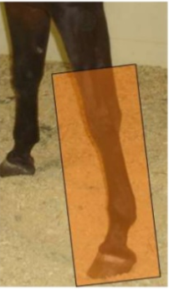
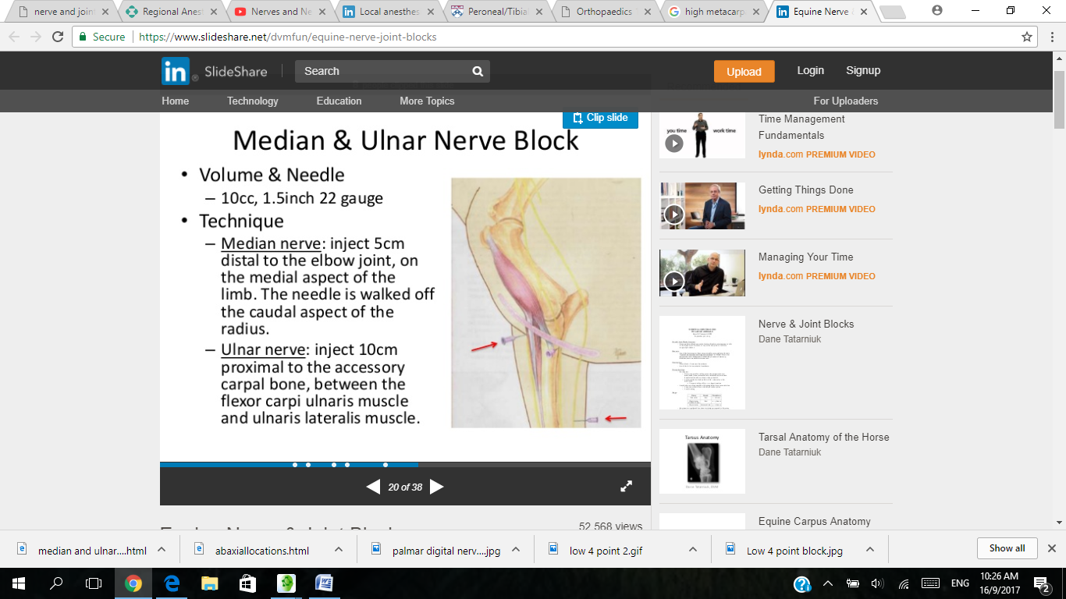

Pic 1 Pic 2
Picture 1 and 2 showing the areas in the horse limb where the needle is placed for local anesthetic and area desensitized respectively in the median/ulnar nerve block in the forelimb

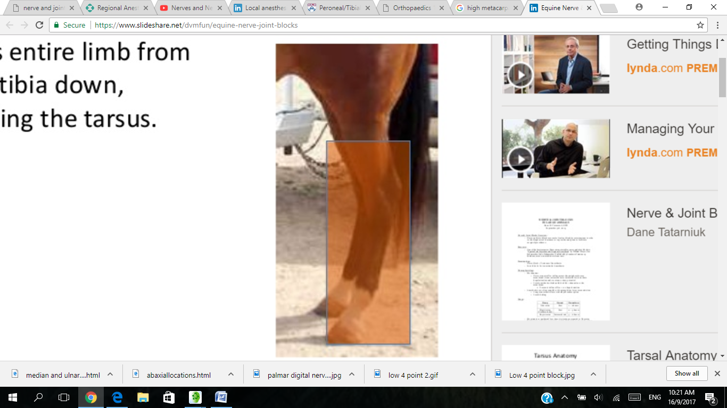
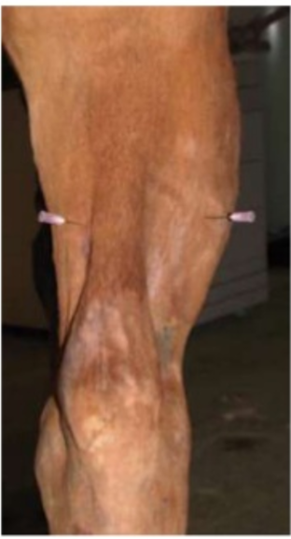
Pic 3 Pic 4

Picture 3 and 4 showing areas in the horse limb where the needle is placed for local anaesthetic and areas desensitized respectively in the tibal/peroneal nerve block in the hindlimb

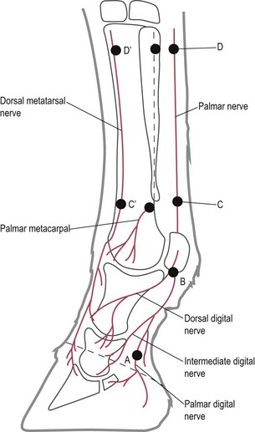
This Diagram is showing the schematic representation of the nerve blocks of the lower limb. Labels A, B, C and D mark the sites for the palmar digital, abaxial sesamoid, low 4-point and high 4-point injections respectively. C′ and D′ mark the additional sites for the low and high 6-point injections in the hind limb.

