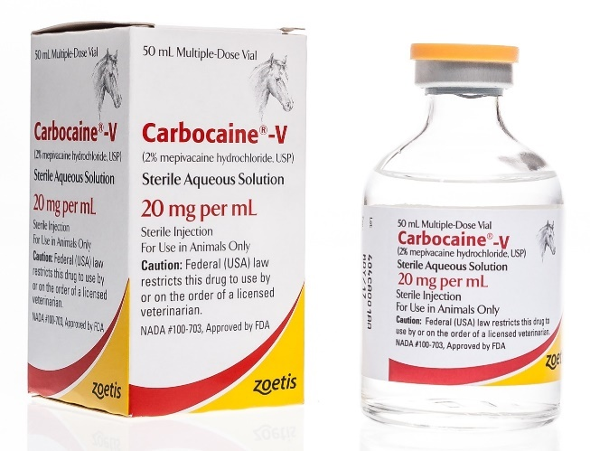
AGENT: Mepivacaine HCL
TRADE NAME: Carbocaine
CHEMICAL NAME: 1- methyl-2’,6’-pipecoloxylidide
monohydrochloride

ONSET: Rapid (5-10 minutes)
DURATION: 120-180 minutes

INDICATIONS:

Mepivacaine Hydrochloride 2% solution is used as a local anesthetic for infiltration around a surgical site, nerve blocks and joint anesthesia (typically used in lameness examinations), epidural (spinal) anesthesia, and topical and/or infiltration anesthesia of the lining of the throat and larynx prior to laryngeal surgery in equines. It is used in a similar manner to Lidocaine hydrochloride, but has a longer-lasting effect. It is often used to anesthetize portions of the hoof or lower leg for surgical procedures and is less effective than Lidocaine for topical anesthesia.

DOSAGE & ADMINISTRATION:
- Nerve block (diagnosis of lameness, firing, pain relief in osteoarthritis, navicular disease) 3-15ml
- Epidural anesthesia (animal standing) 5-20ml
- Intra – articular anesthesia (removal of fracture chip, bone and bog spavin, arthritis) 10-15ml

