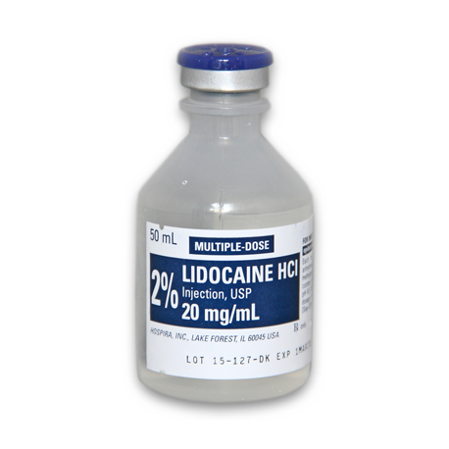
AGENT: Lidocaine HCL
TRADE NAME: Xylocaine
CHEMICAL NAME: Diethylaminoacet -2,6 xylidiide
ONSET: Rapid (5-10 minutes)
DURATION: Intermediate (60-90 minutes)

AVAILABLE AS:
- An aqueous solution in various concentrations (0.5 -5%) with or without epinephrine.
- A gel in concentration of 2-5%
- A 10% lignocaine spray
- A transdermal preparation.

INDICATIONS:
Lidocaine HCI is a potent local anesthetic and anti-arrhythmic agent. It is compatible with most commonly used IV infusion solutions. Compatibility is dependent upon factors, such as pH, concentration, temperature, and dilutants used. It is considered to be a class IB (membrane-stabilizing) anti-dysrhythmic agent. It is use as a local and topical anesthetic, lidocaine is used to treat ventricular arrhythmias. The most commonly used local anesthetic in clinical equine practice. It is also used to treat ventricular arrhythmias.

ADVANTAGES:
- Extreme stability
- More rapid diffusion
- Longer duration of action
- Useful surface analgesic activity on mucous membranes and cornea

DOSAGE:
- For peripheral nerve blocks and caudal epidural anesthetics:
0.2 -0.3 mg/kg (i.e. approximately 5-8 ml of the 2% solution in an average horse)

