Hormonal Agents
Metricure 500mg [intrauterine suspension 19G]
Progesterin Rep
Estradiol Cypionate (ECP) 2mg/ml
Lutalyse
Fertiline solution injectable
Oxyto-Kel 10 I.U (oxytcin)
Eazi-Breed CIDR: progesterone [cattle insert]
Drugs | Active Ingredients | Uses | Dosages | Withdrawal period | Contraindications
Progesterin Rep | Progesterone 50mg | Use in habitual abortion, threatened abortion,  nymphomania, sterility, mammary under development,  and oestrus control.  Must be given intramuscular route only. | Cows and mares: 50 to 100 mg per animal daily, as needed.  Sheep and goats: 10 to 15 mg per animal daily, as needed.  Sows: 15 to 25 mg per animal daily, as needed.  Dogs and cats: 2 to 4 mg per kg of body weight daily, as needed. | No withdrawal period
Estradiol Cypionate (ECP) 2mg/ml  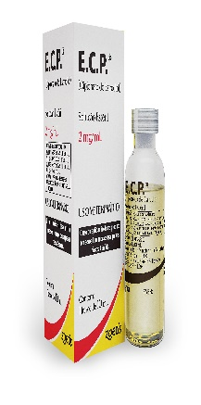 | Estrogen | Used primarily to induce estrus behaviour and receptivity in mares and to treat estrogen-responsive incontinence. |  |  | Illegal in food producing animals.  Cn cause fetal malformations of the genitourinary system and induce bone marrow depression in the fetus.
Lutalyse | Dinoprost injection | effective only in those cattle  having a corpus luteum. | Please see Jamaicabroilersgroupcompendium2017
Fertiline solution injectable  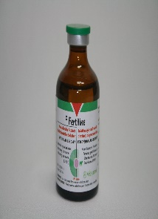 | Gnrh | See page 683-4 in Plumbs’ Veterinary Drug Handbook, 8th Edition. | Hypothalamic hormone used to treat ovarian follicular cyst in cattle.  Also use to reduce time interval from calving to first ovulation.  In cats used as an alternate therapy to FSH or hCG to induce estrus in cats with prolong anestrus. |  | None
Oxyto-Kel 10 I.U (oxytcin) | 20 USP Units of oxytocic activity per mL  Preservative: 0.5% w/v  chlorobutanol. | Aid in the treatment of cows, mares, sows,  ewes, dogs and cats with the foll:  To induce labor  To stimulate milk let down after partuition.  Preventing or controlling postpartum uterine haemorrhage.  To aid in the correction of a prolapsed uterus. | May be injected subcutaneously, intramuscularly or intravenously.  For rapidity of action and maximum effectiveness in mastitis treatment, the  intravenous route is recommended.  Cows 1.0 to 2.0 mL  For obstetrical use  Cows and mares 2.5 to 5 mL  Sows and ewes 1.5 to 2.5 mL  Dogs 0.25 to 1.5 mL  Cats 0.25 to 0.75 mL  To stimulate milk let down  Cows 0.5 to 1.0 mL  Sows 0.25 to 1.0 mL | For food 3 days after the latest treatment.  Milk animals within 24 hrs after last treatment must  not be used as food.  When drug is administered to dairy cattle at a dose up to 1 ml no milk  withdrawal period can be observed. | Early stages of labour, mechanical obstruction  and in cases showing cardiac disease or renal disease.  Excessive dosage may cause spasm of coronary arteries and high blood  pressure.
Eazi-Breed CIDR  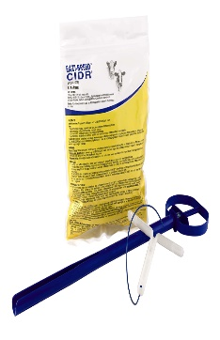 | Progesterone, 0.3 gram | 1 insert per animal | Inserted inside the vagina of the cow and remove 7 days later.  Helps to improve the effectiveness of reproduction programs by tightening estrous synchronization so groups of cows and heifers begin cycling and come into heat and can be bred in a narrower window. | N/A

