Gastrointestional Agents
Scourban Plus oral suspension
Propylene Glycol Oral Solution (PCE-Glycol)
N-Butylscopolammonium bromide, ‘Buscopan compositum’

Drugs | Active ingredients | Doses | Uses | Contraindications
Scourban Plus | Sulphaguanidine 639mg, sulphadimidine 639mg, sulphadiazine 852mg, kaolin 3.1g, hyoscine hydrobromide 0.6mg, plus electrolytes, glycine and pectin. | Administer orally  Double these doses for the initial treatment. Thereafter, treat as above night and morning for 3-5 days. Give dehydrated animals additional fluid and electrolyte replacement | Prevention and treatment of bacterial infections causing gastroenteritis and scour/pneumonia complex. For restoring electrolyte loss, reducing intestinal mobility and elimination of bacterial toxins.  For use in horses, cattle, sheep, goats, pigs, dogs and cats. | Withdrawal period:  MEAT: 14 days.  MILK: 35 days
  Animal | Dose
  Small Animals | 4–8mL/8–10kg bwt
  Lambs | 5mL
  Calves, Pigs and Other Large Animals | 30mL/25kg bwt
  Piglets | 1–2ml`
Propylene Glycol Oral Solution (PCE-Glycol)  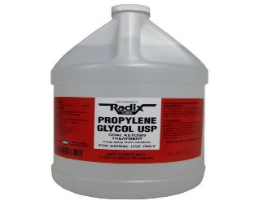 | Propylene  Glycol | Use to treat ketosis in cattle. | 8oz for up to 10 days. | Cats are very sensitive and may develop  Heinz body anaemia.
N-Butylscopolammonium bromide, ‘Buscopan compositum’  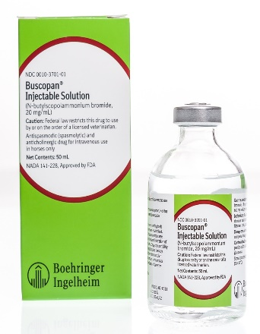 | Quaternary Ammonium | A drug for horses  Control of abdominal pain (colic).  May be a beneficially in horses in combination with oxytocin to treat esophageal obstruction and an aid in performing rectal examination. | 30mg/100kg of body weight  Can be administred IV or IM | Not to use in horses intended for consumption

