Anti-inflammatory
Dexamethasone
Banamine

Drugs | Active ingredients | Uses | doses | Withdrawal period | Contraindications
Banamine  (Non steroidal)  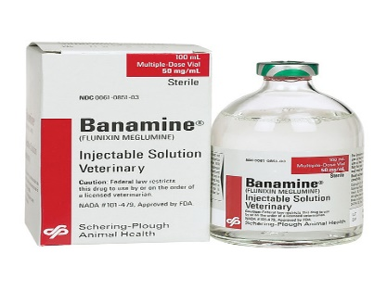 | Flunixin Meglumine | Can treat horses, cattle, swine and dogs.  Very potent inhibitor of cyclooxygenase and exhibits aagelsic, anti-inflammatory and antipyretic activity. | Plumb Veterinary drug book, 8th Edition  Pages 622-3 | Milk- 36 hours  Meat – 4-6 days | May have hypersensitivity in some horses and cattle
Dexamethasone  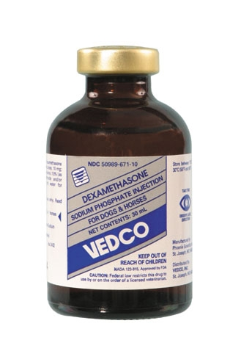 | Glucocorticoids | Approved for use in dogs, cats, horses, and cattle. | Administered IV or IM  Bovine-5 to 20 mg intravenously or intramuscularly.  Equine - - 2.5 to 5 mg intravenously or intramuscularly | Milk- 72 hours | Do not use in viral infections during the viremic stage.  Over dosage of some glucocorticoids may result in sodium and fluid retention, potassium loss, and weight gain.  Causes laminitis in horses

