Anaesthics
Bupivacaine (localized)
Lidocaine (localized)
Ketamine Hcl 20%
Natrium Pentobarbital
Thiopental
Pre-anaesthics
Atropine sulphate 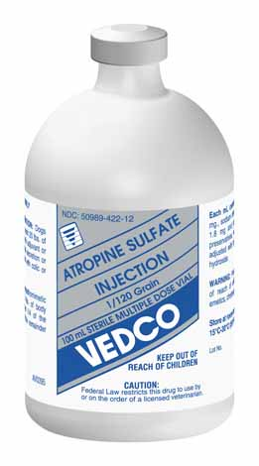
Active ingredients: Atropine Sulfate 0.54 mg., Sodium Chloride 9 mg., Benzyl Alcohol (preservative) 1.5%, Water for Injection
used as a preanesthetic adjuvant or to reduce salivation, bronchial secretion or internal peristalis associated with colic or diarrhea.
Drug can be administered IV, SQ or IM
Dosage - Plumbs Veterinary drug handbook, 8th edition. Pages 128-9.
As an antidote for parasymphathomimetic drugs, 1 mL for each 7.5 lbs. of body weight. It is suggested that 1/4 of the dosage be injected I.V. and remainder I.M. or S.C.
Contraindicated in patients with narrow-angle glaucoma
Withdrawal time: none mandated in food animals but FARAD recommends for meat 28dys and milk for 6 dys
In the UK slaughter with withdrawal for cattle, sheep and pigs is 14 dys (antimuscuranic), 28 dys (antidote); milk is 3 dys( antimuscuranic) and 6 dys (antidote).
Post-anaesthics
Dopram injection

Drugs | Active ingredients | Uses | Dosage |  | Contraindications
Dopram injection  (Doxapram Hcl)  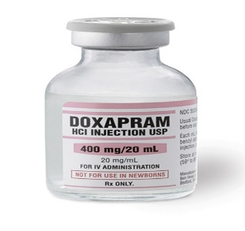 |  | CNS stimulant  Use to stimulate respiration during and after general anaesthesia.  Approved for use in dogs, cats and horses. | Recommended doses are 1–5 mg/kg, IV,  in dogs and cats, or 1–2 drops under the tongue of apneic neonates.  In adult horses, the dosage is 0.5–1 mg/kg, IV, while foals are dosed carefully at 0.02–0.05 mg/kg/min, IV.  msdvetmanual.com  NB. Does not increase the level of oxygen in the blood. |  | Should not be used as a substitute for aggressive artificial respiratory support in instances of severe respiratory distress.  Side effects: Irregular heartbeat, elevated blood pressure, hyperventilation and in some cases, seizures.
Cefokel 50mg/ml

Sedatives
Bomazine
Natrium Pentobarbital
Analgesia
Bomazine
Bupvicaine
Ketamine Hcl 20%
Flunixanime [Flunixin Meglumine injection] 50mg/ml “Banamine”-

Banamine  (Non steroidal)  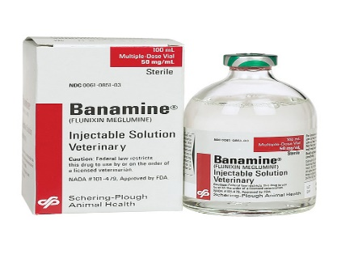 | Flunixin Meglumine | Can treat horses, cattle, swine and dogs.  Very potent inhibitor of cyclooxygenase and exhibits aagelsic, anti-inflammatory and antipyretic activity. | Plumb Veterinary drug book, 8th Edition  Pages 622-3 | Milk- 36 hours  Meat – 4-6 days | May have hypersensitivity in some horses and cattle

