Vitamins, minerals and supplements

Drugs | Active Ingredients | Uses | Dosages | Withdrawal period | Contradictions
Injectable iron  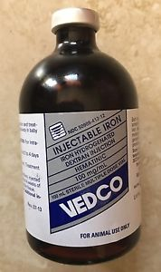 | Ferric hydroxide in complex with a low molecular weight dextran with 0.5% phenol as a preservative. | the prevention or treatment of iron deficiency anemia in baby piglets. | Should be given IM only.  1 mL (100 mg) at 2-4 days of age.  May be repeated in approximately 10 days.  www.drugs.com | No withdrawal period. | Prostration with muscular weakness. In extreme cases, death may result.  Should not be considered a substitute for sound animal husbandry.
Vitamin K injection | Phytonadione 10 mg | Used as a coagulant.  Cattle, horses, swine, sheep, goats, dogs and cats.  Aid in the treatment of coagulation disorders associated with  hypoprothrombinemia due to Vitamin K deficiency or interference with Vitamin K activity  and poisoning with anticoagulant  rodenticides in dogs. | Acute hypoprothrombinemia (with hemorrhage):  0.25 to 2.5 mg per kg of body weight (slow IV injection at a rate not to exceed 1 mg/minute).  Non-acute hypoprothrombinemia:  IM or subcut: 0.25 to 2.5 mg per kg of body weight.  Whenever possible, the intramuscular or subcutaneous administration  route should be employed.  For intravenous administration dilute with preservative free 5% dextrose,  0.9% sodium chloride injection or 5% dextrose in 0.9% sodium chloride  injection. Do not use other diluents. | No withdrawal period.  Protect from light and store in a dark place.
Vitamin B complex  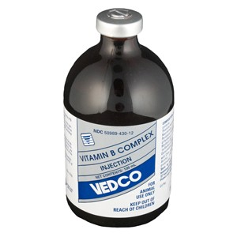  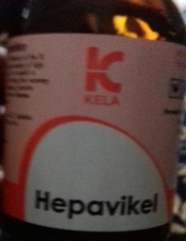 | Thiamine hydrochloride 10 mg (Vit. B1) Riboflavin sodium phosphate 5.4 mg (Vit. B2) Pyridoxine hydrochloride 4 mg (Vit. B6) Cyanocobalamin 10 mcg (Vit. B12) Nicotinamide 25 mg Dexpanthenol 5 mg . | Use as a supplemental source of B complex vitamins in cattle, swine and sheep. | Can be administered either IM or SUB  Adult Cattle- 1 to 2 mL per 100 pounds of body weight.  Calves, Swine and Sheep- 5 mL per 100 pounds of body weight  www.belgacomhosting.be/kelalab/index | N/A | Hypersensitivity reactions to the parenteral administration.
Cal-plus  (Calcium, Magnesium, Phosphorus and Dextrose injection) | Calcium Borogluconate (equivalent to 19.1 mg/mL of  calcium) 23.0% w/v  Sodium Hypophosphite (equivalent to 10.0 mg/mL of  phosphorus) 2.85% w/v  Magnesium Chloride Hexahydrate 4.5% w/v  Dextrose Monohydrate 15.0% w/v | Can be administered intravenous, subcutaneous or intraperitoneal  in cattle, sheep and swine. Should be administered strictly intravenously  in horses. Dosage should be divided over several sites  for subcutaneous injections. Inject slowly and carefully.  Warm to body temperature before administration. | Adult Cattle and Horses 250-500 mL,  Adult Sheep and  Swine 50-125 ml.  Can be repeated in several hours if required. | N/A | Do not retain partially used bottle. Use only if solution is clear.
Aminolean | A clear, yellow  aqueous liquid containing Dextrose 5 g, calcium chloride  dihydrate 15 mg, potassium chloride 20 mg, magnesium  sulfate trihydrate 20 mg, sodium acetate trihydrate 250  mg, thiamine HCl 10 mg, nicotinamide 150 mg, pyridoxine  HCl 10 mg, vitamin B12 5 mcg, riboflavin 5-phosphate  sodium 4 mg, d-panthenol 5 mg, casein hydrolyste. | Aids in the supportive treatment of debilitated  animals and for supportive treatment of severe diarrhea in  cattle, swine and horses. Also aids in counteracting  the protein, electrolyte and vitamin loss. | Warm to body temperature prior to administration.  Administer slowly by intravenous or intraperitoneal  injection in cattle and swine. Administer by intravenous  injection ONLY in horses.  Mature Cattle, Horses & Swine: 2 mL/kg of body weight  Calves, Foals & Piglets: 5 mL/kg of body weight | No withdrawal period.

