DRUG | TRADE NAME | ACTIVE INGREDIENT | INDICATIONS | DOSAGE | CONTRAINDICATION | WITHDRAWAL
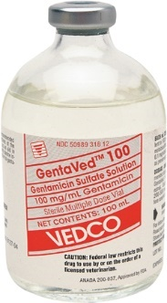 | Gentamycin 100 | Gentamicin Sulfate | This is used in horses to control bacterial infections of the uterus; it also is used to improve conception in mares with uterine infections. | Pigs: 5mg/kg, PO/IM in neonates; 1.1mg/kg in weanlings PO. 2.2mg/kg  Horses: 6.6mg/kg, IV/IM Foals: 11-15 mg/kg  Sheep: 5mg/kg IM | Do not administer to animals with compromised hepatic and or renal function. You can get hypersensitivity to gentamycin. | In Pigs, wait 40 days for slaughter in piglets, 14 for neonatal swine, 10 days for adults and weanlings
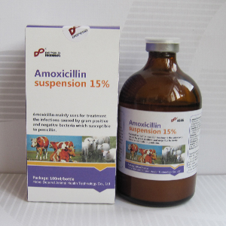 | Amoxicillin | Amoxicillin base | Used to treat calves, cattle, goats, swine and sheep with urinary tract, respiratory and gastrointestinal infections caused by bacteria. | Horses: 20-30mg/ kg PO,  Foals: 15-30mg/ kg IV/IM,  Cattle: 6-10mg/kg  Calves: 7mg/kg PO | You can get hypersensitivity. | For Meat: 21 days.  For Milk: 3 days.
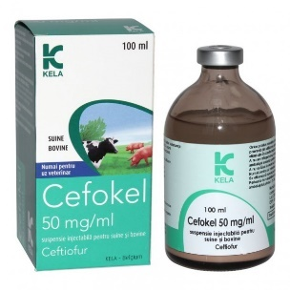 | Cefokel 50mg/ml suspension for injection | Ceftiofur HCL | In cattle it is used to treat for footrot and bacterial respiratory disease  In pigs, it is used to treat respiratory disease caused by bacteria. | Cattle: Respiratory disease: 1mg /kg, SC.  Footrot: 1mg/kg SC injection.  Pigs: 3mg/kg, IM or 1 ml/16kg at each injection. | Do not inject via the intravenous route. Do not administer to animals with hypersensitivity to beta lactam antibiotics | For Pig meat: 5 days.  For Cattle Meat: 8 days.
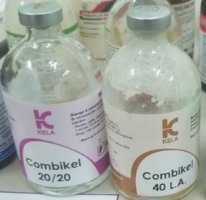 | Combikel  (available in 20 & 40 L.A) | Procaine Benzyl- penicillin, Dihydrostreptomycin | Used to treat respiratory tract infections. | 20LA: Horses, cattle, pigs 12.5ml/2kg b.w  40 LA: Cattle: 5-10 ml/kg. Horses, Pigs: 0.1ml/kg. IM or SC routes may be used in both. | Do not administer to animals with compromised renal system | Slaughter after 30 days  You can milk 5 days after last application.
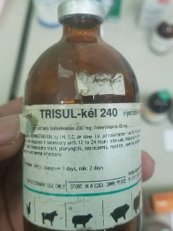 | Trisul-kel 240 | Trimethoprim/ Sulfa-methoxazole | Used to treat prostate infections | Cattle: 25mg/kg, IV, IM, Calves: 48mg/kg IV/IM  Swine: 48mg/kg, IM  Horses: 15-30 mg/kg, PO | Do not use in animals intended for food. | Not to be used in food animals
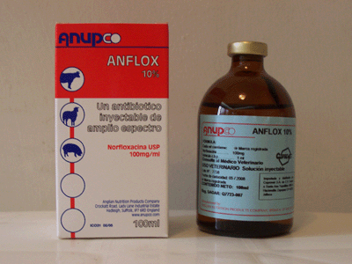 | Anflox 10% | Norfloxacin | Active against Gram-positive and Gram-negative bacteria and mycoplasma | Cattle:10mg/kg/b.w | Do not use with other quinolone antibiotic drugs. | For meat: 4 days  For milk: 4 days
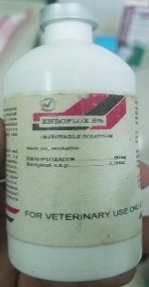 | Enroflox 8% | Enrofloxacin | Used to treat in swine, cattle, calves and sheep with gastrointestinal and respiratory infections. | Swine: 1 ml per 20 - 40 kg body weight for 3 - 5 days.  Calves, cattle, sheep and goats: 1 ml per 20 - 40 kg body weight for 3 - 5 days IM,SC | Hypersensitivity to enrofloxacin. | For meat: sheep, goats, cattle and calves: 21 days. Swine: 14 days  For milk: 4 days.
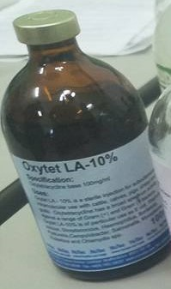 | Oxytet 19% L.A | Oxytetracycline | It is a broad-spectrum antibiotic drug. | 1ml per 1 0 kg bodyweight  Cattle: 20 ml Pigs: 1 0 ml  Calves: 5 ml | Hypersensitivity reactions to tetracycline. Pregnant animals. | Wait 7 days for slaughter
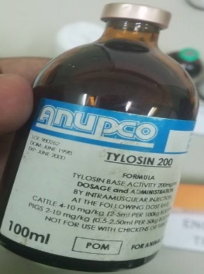 | Tylosin 200 | Tylosin Tartrate | It is used to treat cattle with respiratory infections as well in swine to treat arthritis.  . | Swine: 8.8mg/kg IM q12  Sheep & goats: 10mg/kg SC  Cattle: 17.6mg/kg IM daily. Bronchonpneumonia – 4mg/kg | Fatal in horses. | In cattle meat: 21days  For milk: 72hours cattle  For pig meat: 14 days
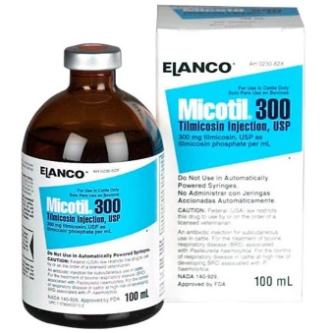 | Micotil 300mg | Tilmicosin | It is used to treat cattle and sheep with respiratory disease. | 10mg/kg SC | Do not use in lambs less than 15 kg body weight. | Wait 7 days for slaughter
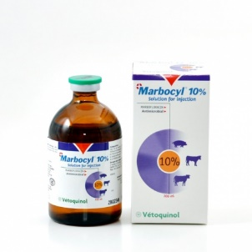 | Marcobyl 10% | Marbofloxacin | It is used in cattle to treat respiratory infections and in swine to treat metritis. | Cattle:2mg/kg/day (1ml/50kg) in a single daily injection IM,SC,IV  Pigs: IM | Avoid treating young animals. | For milk: 36hrs  For meat: Cattle 6 days  Pigs 4days
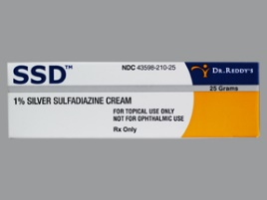 | Thermazene | Silver Sulfadiazine | Used to treat burn wounds | The cream is applied over a sterile wound | NA | NA
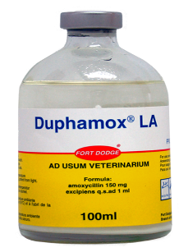 | Duphamox | Amoxicillin Trihydrate | A broad-spectrum antibiotic drug used for bacterial infections in cattle, sheep, pigs. | Cattle and Pigs: 1ml/10kg IM | Not to be used in animals with hypersensitivity. | For Cattle: Meat – 23 days, Milking – 84 hours
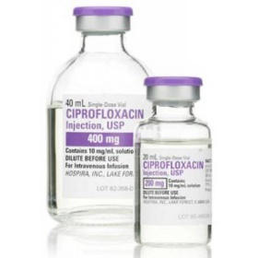 | Cifran | Ciprofloxacin | It is used to treat both Gram – and gram + bacterial | Cattle:7.5- 12.5mg/kg single dose or 2.5- 5mg/kg | Not used in animals used for food as well as horses. | NA

