DRUG | TRADE NAME | ACTIVE INGREDIENT | INDICATION | DOSAGE | CONTRAINDICATION | WITHDRAWAL
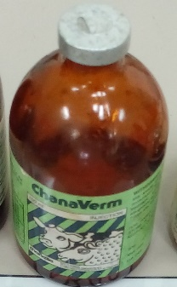 | ChanaVerm | Levamisole | Used to treat nematodes found in the gastrointestinal tract. | Cattle, sheep, pigs, goats:5mg/kg IM.  Horses: 5-10 mg/kg SC | This drug should not be used together with Chloramphenicol
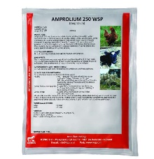 | Amprolium | Amprolium HCL | It is used for treating protozoal infections. | Cattle, sheep: 3g/20 kg b.w during 5 days (via drinking water) | NA | For meat:3 days  For milk:3 days
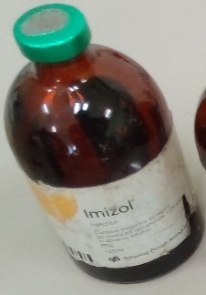 | Imizol | Imidocarb diproprionate | Used to treat dogs with babesia infections. | SC 6.6 mg/kg (3 mg/lb) b.w Repeat the dose in two (2) weeks, for a total of two (2) treatments. | The preferred route of administration is IM and IV | For cattle meat: 213 days.  For milk: 21 days
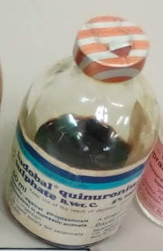 | _ | Quinuronium sulphate | This drug is used to treat animals infected with Babesia. | 0.3-0.5mg/kg birth weight for cattle, sheep, pigs | Do not used this drug for long periods of time.

