DRUG | DRUG  NAME | ACTIVE INGREDIENT | INDICATIONS | DOASGE | CONTRAINDICATION | WITHDRAWAL
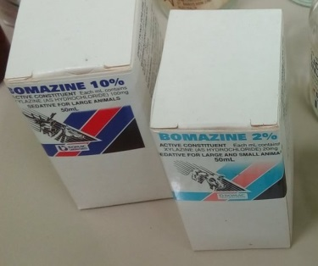 | Bomazine (available in 2% & 10%) | Xylazine Hydrochloride | For sedation, analgesia and muscle relaxation | Sheep and Goats :  Intravenous  0.15-0.3 ml/ 25 kg  Intramuscular  0.25-0.5 ml/ 25 kg  Cattle :  Intravenous  0.25-0.75 ml/ 100 kg  Intramuscular  0.5-1.75 ml/ 100 kg | Xylazine should be avoided in Weak animals | Milk:7days  Meat: 2 days
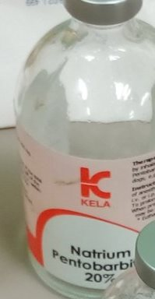 | Natrium pentobarbital | Sodium pentobarbital | Barbiturate leading to immediate depression of the cerebral cortex, subcortical structures, vital cerebral centres. Overdoses can be used for euthanasia | Cattle: 30mg/kg IV for Hydrocarbon toxicity. Sedation:  1-2 g IV.  Horse: 15-18 mg/kg IV  Pigs: 30mg/kg IV.15-30mg/kg as aesthetic.  Sheep and Goats: 20-30mg/kg IV (adults). Lambs: 15-26mh/kg IV | Hypovolemia, anaemia, cardiac and respiratory diseased animals | ____
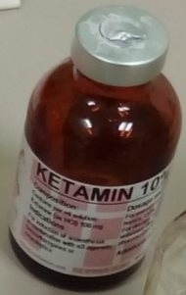 | Ketamine 10% | Ketamine HCI | For diagnostic and surgical procedures that do not require skeletal muscle relaxation and restraint. | Cattle: Analgesia 0.4-1.2 mg/kg/hr.  Horse 2 mg/kg IV, 5 minutes following 1 mg/kg IV Xylazine.  Swine 6-11 mg/mg IM after or in conjunction with sedative/tranquilizer | CNS depressions | ____
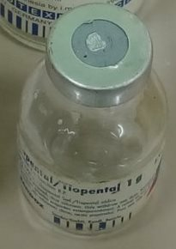 | Thiopental |  | For general anaesthesia used with other aesthetics or by itself for short procedures | Cattle: 8.14 - 15.4 mg/ kg IV. Calves under 2 weeks: 15-22 mg/kg IV  Horse: With pre -aesthetic tranquilizer: 8.25mg/kg IV  Pigs: 5.5-11mg/kg IV  Sheep: 9.9-15mg/kg IV | Heart diseases, shock, myasthenia gravis. | _____
  Thiopental
  Sodium
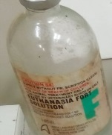 | Euthanasia Fort Solution | Pentobarbital | Intravenous euthanasia | 150 mg/kg IV in all large animals | Do not use for anaesthesia. | ___
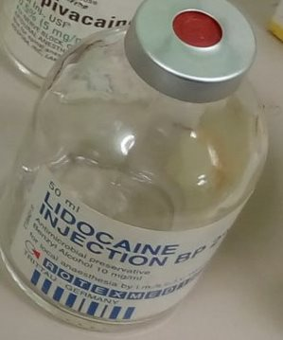 | Lidocaine | Lidocaine HCL | Potent local aesthetic for producing epidural and nerve conduction anaesthesia. | Epidural: Cattle and Horses - 5 to 15 mL  Dogs and Cats - 1 mL per 10 pounds of body weight  Nerve Block: Cattle and Horses - 5 to 20 mL | Known hypersentivity to the drug | ______
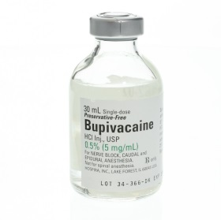 | Bupivacaine | Bupivacaine HCL | Local anesthetic, commonly used for analgesia for surgical incisions. This medication is often given as an epidural prior to surgery or as a nerve-blocking agent to help minimize the discomfort. | Cattle: 0.125mg/kg | Coagulopathies, sepsis, skin infections over the injection site, and pelvic/sacral fractures. | _______

