Polyamide (Nylon) ideal for skin closures
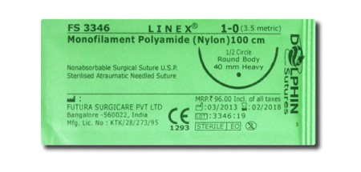
Polypropylene used skin closure, soft tissue approximation and ligation
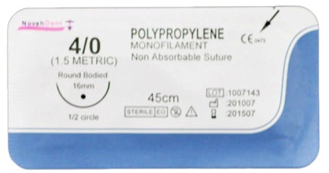

Polybustester (Novafil) used soft tissue approximation and ligation
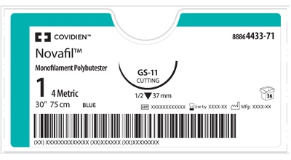
Stainless Steel use in abdominal wound closure, hernia repair, sterna closure and orthopaedic procedures.
