Silk used for general soft tissues
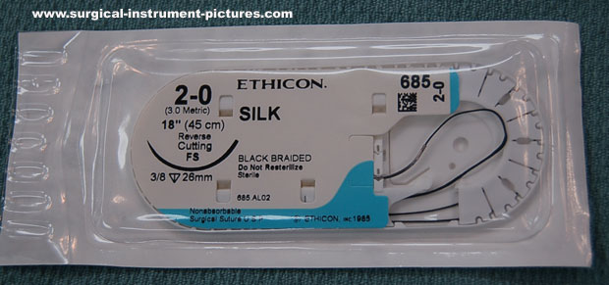
Polyamide general soft tissues
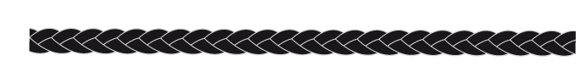
Polyester used for permanent, removable fixtures, cardiovascular surgery.
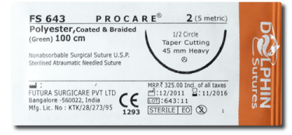
Polymerised Caprolactam (Vetafil or Supramid) used for limited skin closure
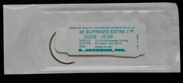

Stainless Steel used in orthopaedic surgery
