Polydioxanone ( PDS II) used in soft tissues
e.g ophthalmic surgery & paediatric cardiovascular tissue etc.
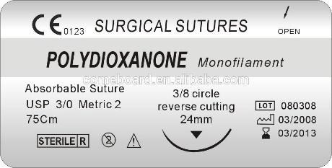

Polyglyconate ( Maxon) used in soft tissues.
e.g wound healing for 6 weeks
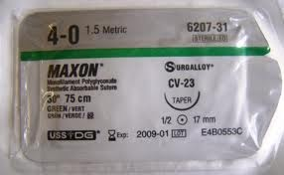
Poliglecaprone 25 (Monocryl) used frequently for subcuticular dermis closures of the face.
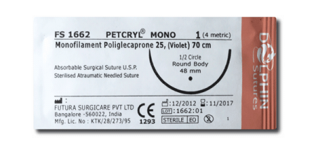

Glycomer 631 (Biosyn) used in laparotomy incisions
