Catgut used for soft tissues e.g. ophthalmic surgery etc.
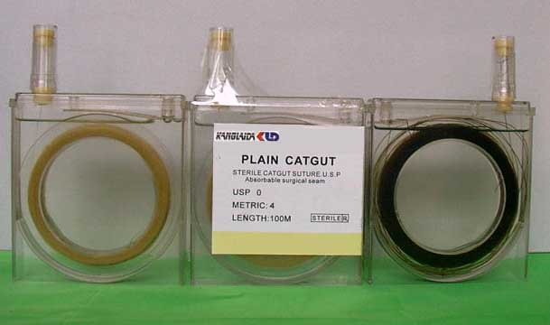
Polyglycolic acid (PGA) used for soft tissues e.g. ophthalmic surgery but not cardiovascular and neurological surgeries.
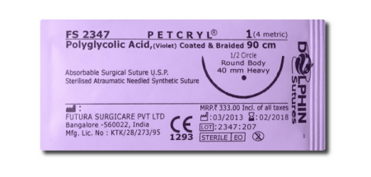
Polyglactin 910 (Vicryl) used in laparotomy.
