RIGHT FLANK EXPLORATORY LAPAROTOMY
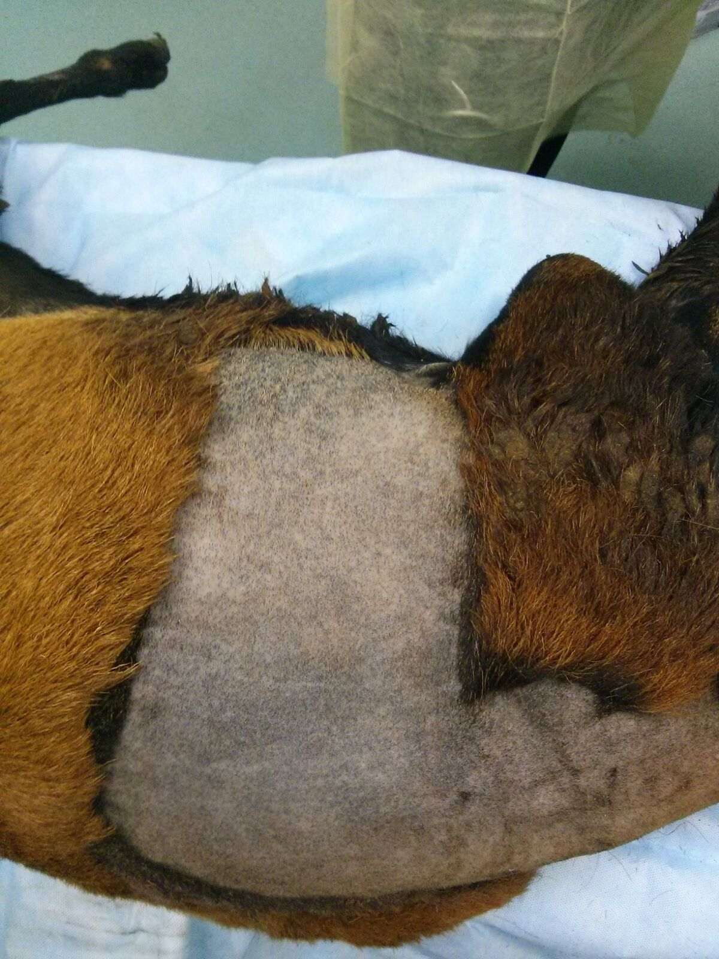  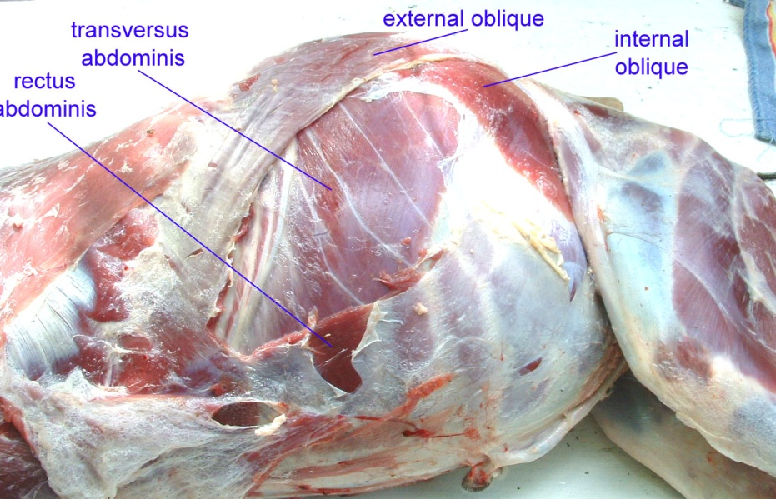  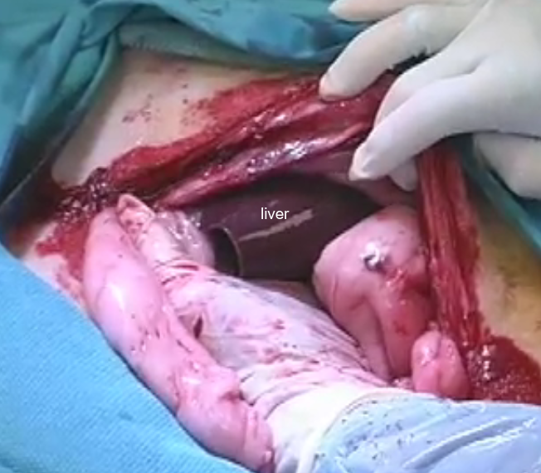  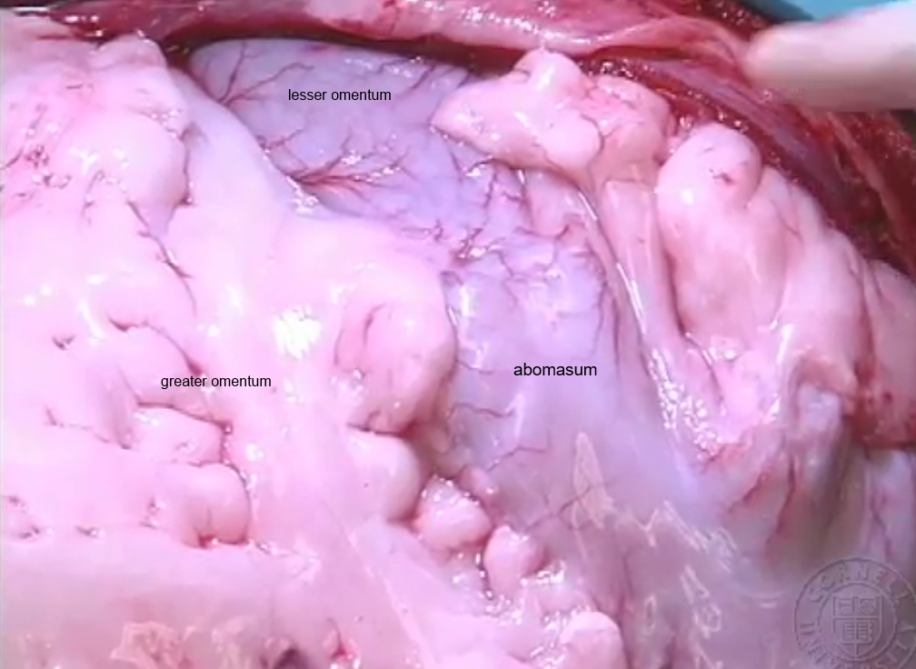  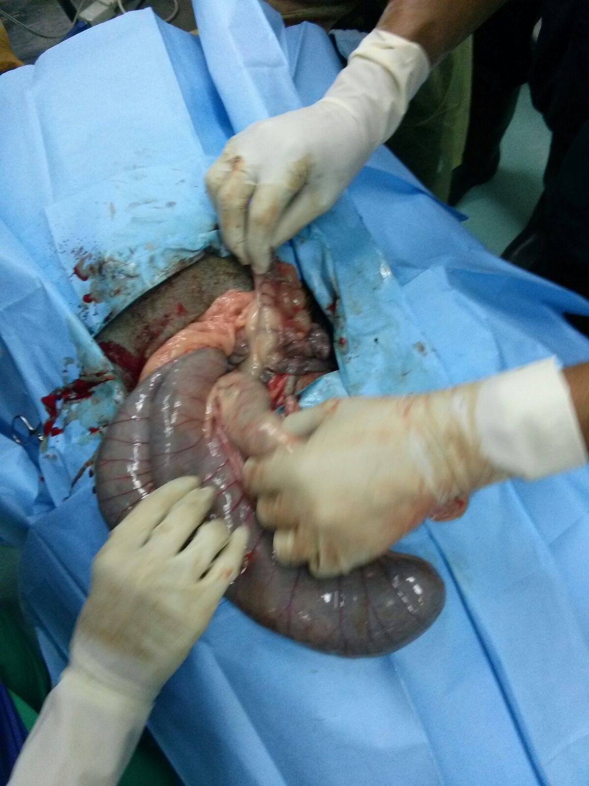  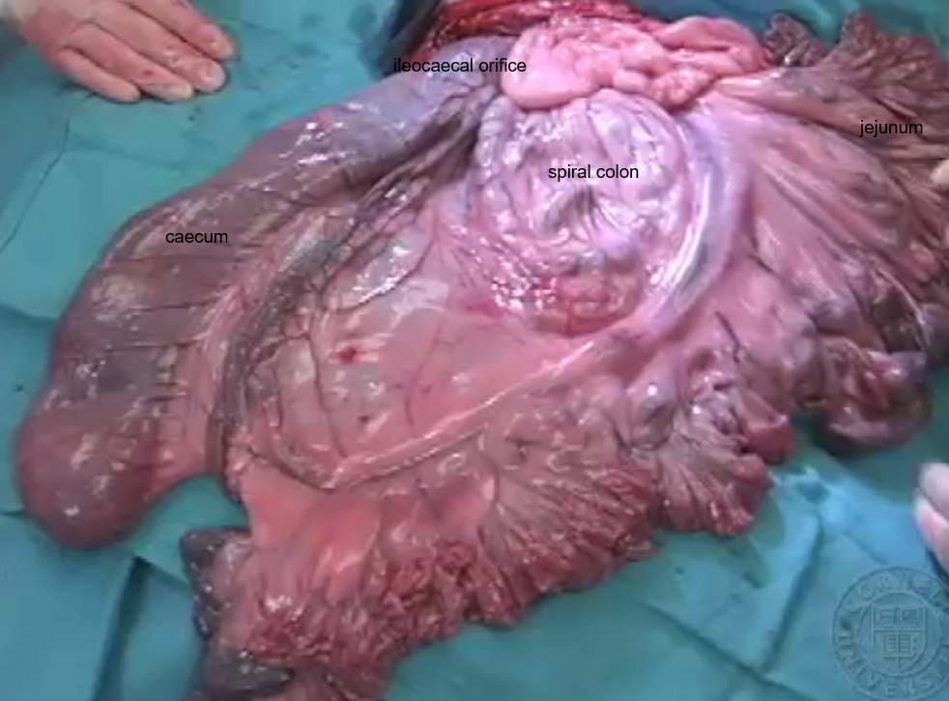  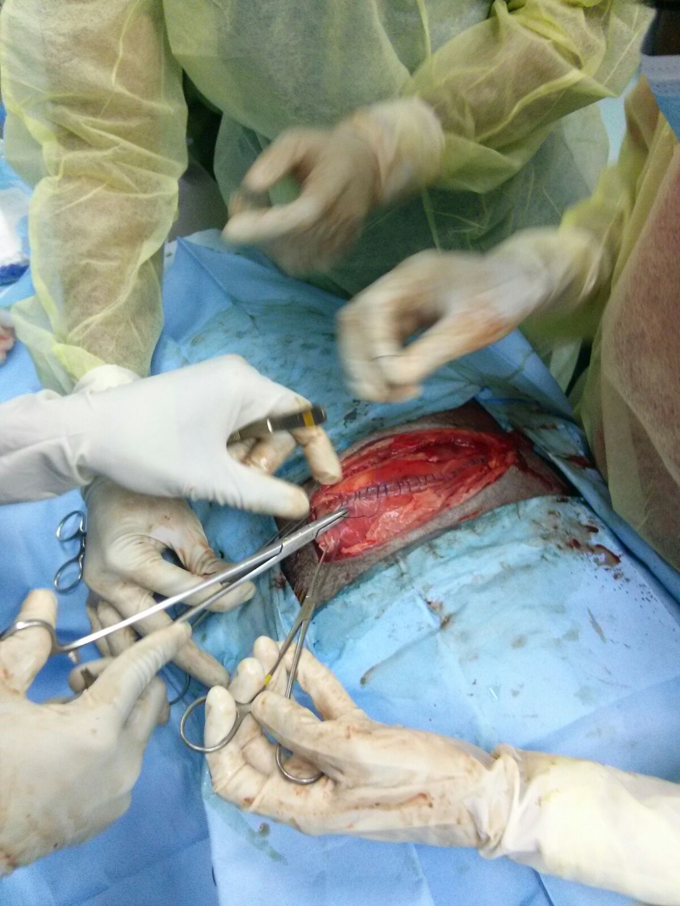  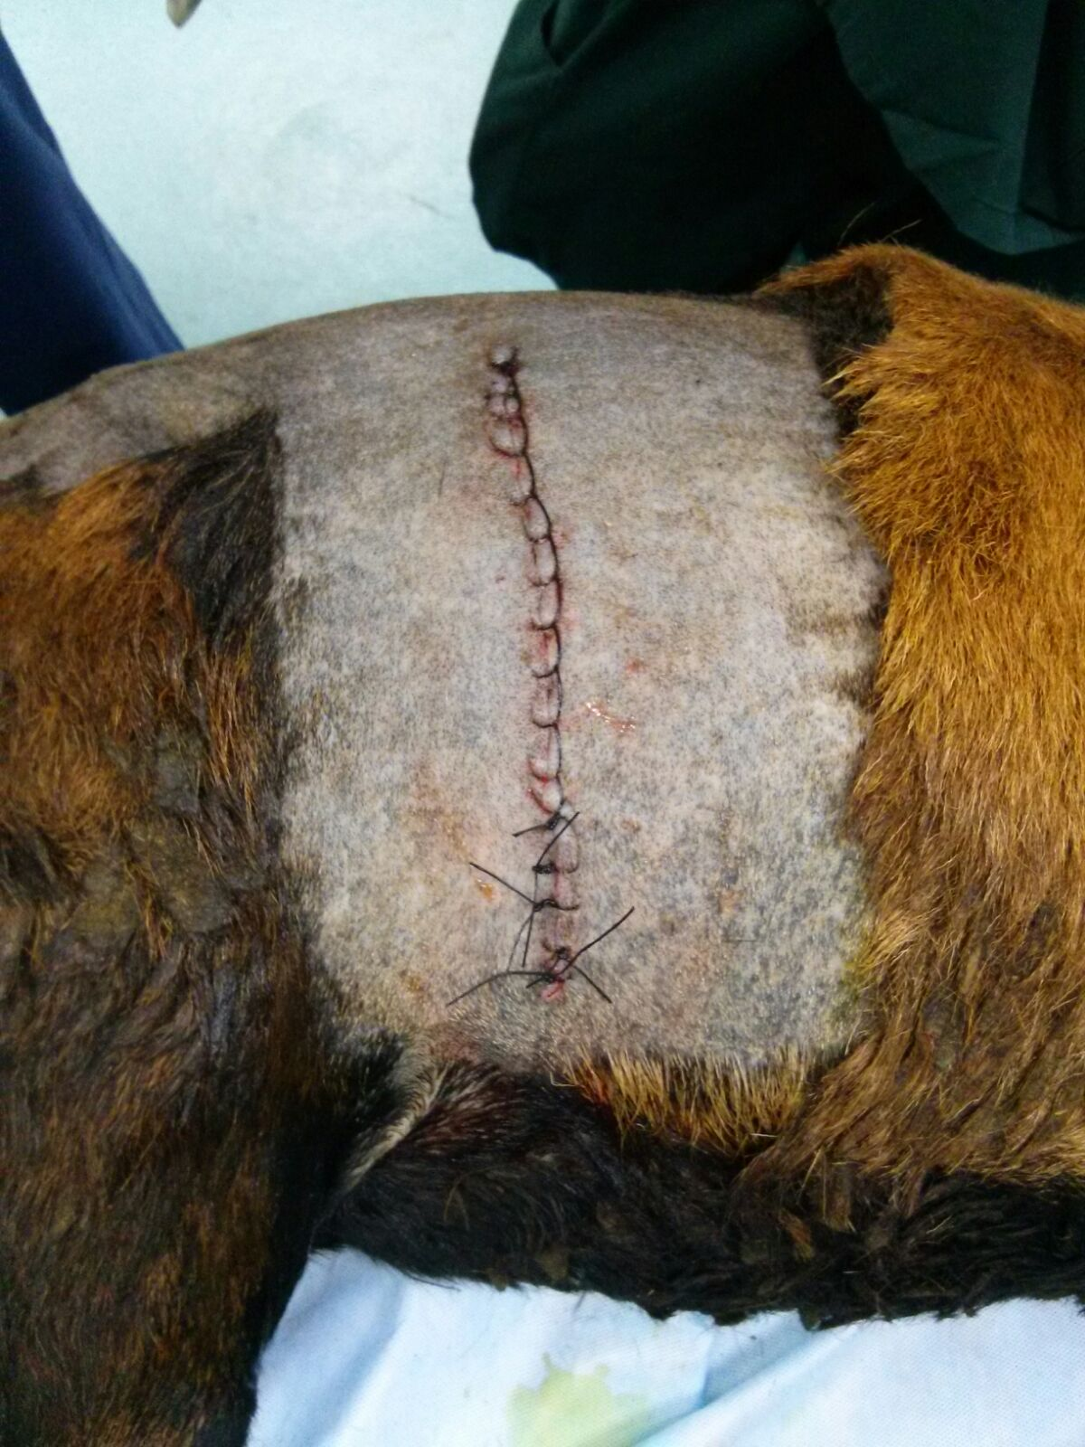 | Methodology;  - The size, position and orientation of the duodenum should be evaluated.  - It should be flaccid, 3-4 cm in diameter, and oriented horizontal in the dorsal third of the incision  - A skin incision is made midway between the last rib and the tuber coxae, approximately 20cm in length  - Haemostats can be placed if there is excessive bleeding with ligation of blood vessels  - The cutaneous trunci muscle is incised using forceps as a guide, to make sure that no deeper tissues are incised  - The incision is continued through the external abdominal oblique; these muscle fibres runs in a caudoventral direction  - A small incision is made through the internal abdominal oblique and continued with scissors; these fibres run in a cranioventral direction  - The transverse abdominus and peritoneum is then incised by tenting and then cut with scissors; these muscle fibres of the transverse abdominus runs transversely, while the peritoneum feels slippery upon touch  - Abdominal exploration is then performed by sweeping hands under the incision  - The right kidney should be located in the dorsal retroperitoneal space, cranial to the incision  - The Liver is next found in the right lateral compartment cranial to the 13th rib - edges sharp (not rounded), firm, smooth surface colour of uniform dark blue-brown to purple  - As the caudal border of the liver is palpated in the ventral direction the gall bladder is encountered. feels like a - tube sock filled with a viscous fluid and may be distended if the anorectic.  - The caudal border of the liver is palpated to the ventral extent.  - This will leave the surgeon in the cranial abdomen, against the diaphragm (feel the heartbeat with the hand palm down)  - Below the caudal border the liver is what compartment of the reticulum (honeycomb feel)  - Once the reticulum has been assessed for hardware disease, the ventral peritoneum is swept for adhesions or remnants of the falciform ligament  - In the ventral compartment of the abdomen, proceed behind the omental curtain into the central compartment for the left kidney (12 cm straight in, suspended 12 cm from dorsum)  - With the palm directed ventral, proceed along the right rumen wall in a cranio-ventral direction until the omasum encountered it feels feel like a soccer ball  - On the dorso-caudal surface of the omasum in a fold of omentum, you find the left gastric artery (should run cranial to caudal unless a displacement has altered the orientation  - Palpate the intestines for foreign bodies, gas distended loops, sausages, or faecal balls (all bad things)  - Go under the left kidney and over the caudal sac of the rumen into the left compartment to feel for signs of peritonitis or a DA.  - Proceed along the cranial ribcage to locate the spleen - feels granular  - The rectum located within the pelvis - centre of the pelvic canal suspended by the mesorectum  - The peritoneum and transversus abdominus will be sutured using - #2 chromic gut in simple continuous pattern  - Towel clamps can be used to separate the underlying organs from the suturing site  - The internal abdominal oblique and external abdominal oblique muscles will be sutured using # 2 Polysorb braided absorbable suture in a simple continuous pattern  - The skin will be sutured using #3 vetafil/barunamid in a Ford interlocking suture pattern  - 2 inches of skin should be closed using a simple interrupted suture pattern to allow for drainage if there is any subcutaneous infection  - The closed surgical site is then cleaned of any traces of blood with gauze and saline

