**INTRA-OP**

* **TEAT LACERATION**

Teat lacerations can be generally classified into a few groups which include: fresh vs chronic, vertical vs horizontal, proximal as opposed to distal and sharp vs crushing. With regard to prognosis for healing and return to function: fresh is better than chronic, vertical lacerations are better than horizontal, proximal is better than distal, sharp better than crushing and streak canal involvement decreases prognosis.

**Wound debridement**

1. The wound is carefully but aggressively debrided and lavaged. All the necrotic tissue is removed by scraping the tissue with a scalpel blade until viable tissue is exposed (pink and diffuse bleeding of the tissue). The margin of the skin may need to be trimmed using the scalpel blade or scissors.

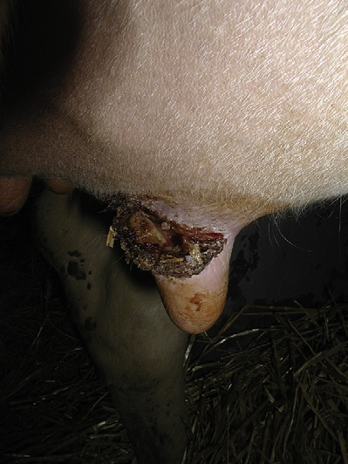

PICTURE SHOWING INITIAL WOUND BEFORE DEBRIDMENT

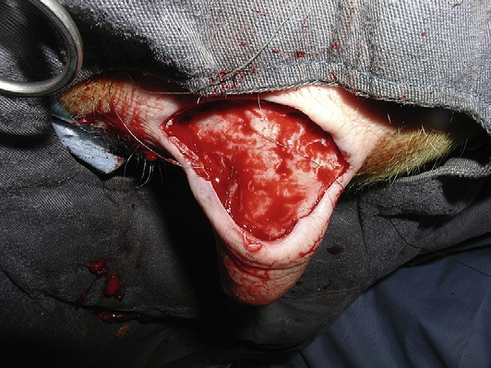

PICTURE SHOWING THE SAME WOUND AFTER DEBRIDEMENT

**Laceration repair**

1. If involved, the mucosa and the submucosa are first reconstructed. A linear defect is reconstructed using a simple continuous pattern with a synthetic absorbable suture material (Dexon II, Vicryl) of size 3.0 or 4.0 mounted on a swedged-on atraumatic needle. If delayed healing is suspected (extensive transverse laceration, mastitis), a slow resorbing monofilament suture (PDS II) is the preferred material to use.
2. With complex configurations or transverse laceration, a simple interrupted pattern should be used. The muscular and subcutaneous layers are closed with a simple continuous pattern.
3. With large skin flaps, it is recommended to place some walking sutures to decrease dead space. However doing so will increase the surgical time and may compromise the vascularisation of the teat. Care must be taken to place only what is necessary to hold the flap safely.
4. The skin is carefully apposed using a simple interrupted, horizontal mattress or cruciate pattern. The one handed suture technique was incorporated when doing the skin closure for practice purposes in this lab.

Care is taken to leave the skin sutures slightly loose because swelling is expected at the surgery site.

1. When severe postoperative edema is suspected (transverse and/or chronic laceration), vertical or horizontal mattress sutures around or through stenting material (IV drop set) can be used to decrease risk of wound dehiscence. With complex lacerations, a “V” flap will need to be sutured. However, dehiscence of the tip of the flap often occurs. A corner suture or a 3-point buried mattress suture can be placed. Throughout the procedure, the surgery site is frequently lavaged with saline. Antibiotics can be added to the lavage solution. Cefazolin (1g/liter) to the flush solution. Hemostasis is performed to avoid formation of mural hematoma that may obstruct the teat cistern during machine milking.
2. Skin sutures should be removed no later than 8 to 10 days after surgery; when left in place for a longer period, suture tract infection or inflammation appears around the stitches

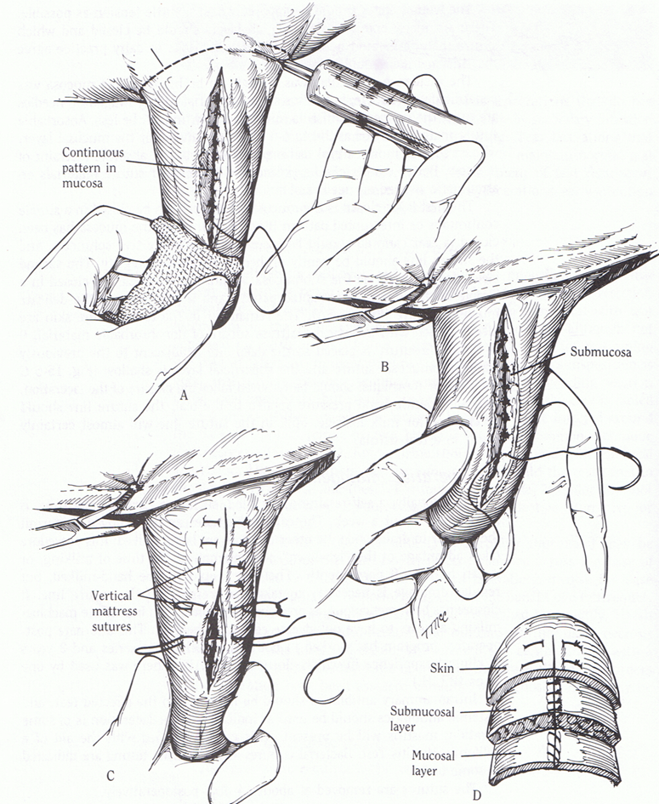

PICTURE SHOWING SUTURE PATTERNS NECESSARY FOR ALL THREE LAYERS OF THE TEAT

* **STRICTURES OF THE TEAT ORIFICE**

1. Incise the teat orifice with a teat bistoury or a No. 11 Bard-Parker blade; incise the teat orifice at “quarter-clock” positions.
2. While incising, check the ease of milking several times.
3. Optimal incising will allow slight free dripping. Cows with apical obstructions (traumatic or congenital) are usually presented as 'hard milkers'. The stenosis may be temporarily relieved by longitudinal radiate incisions of the sphincter or the fibrosed canal with a Danish teat knife or by widening the opening with a teat dilator. A self-retaining teat canula prevents postoperative stenosis.

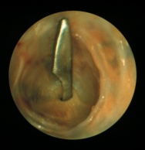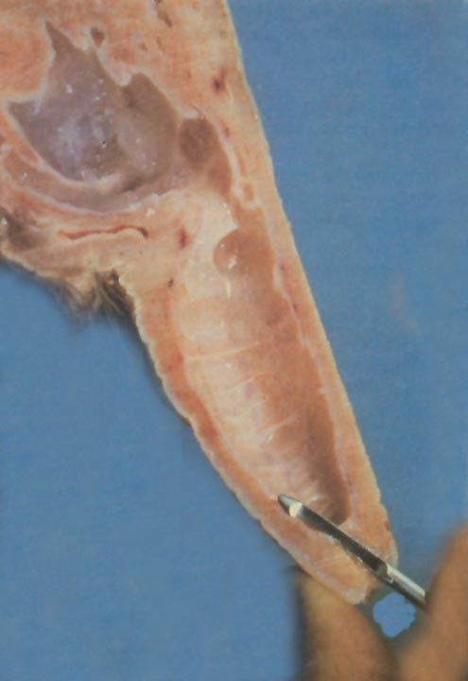

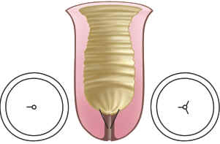

PICTURES SHOWING THE SURGICAL TECHNIQUE