MAMMORY SURGERY EQUIPMENT
NAME | PICTURE | DESCRIPTION
Teat bistoury | 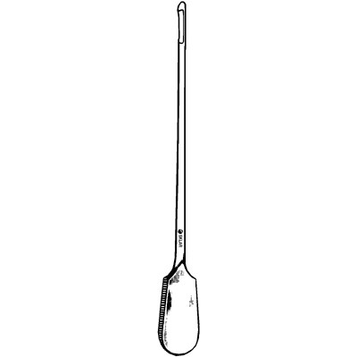 | A long, narrow-bladed knife, with a straight or curved edge and sharp or blunt point (probe-point); used for opening or slitting cavities or hollow structures.
Cornell teat curette | 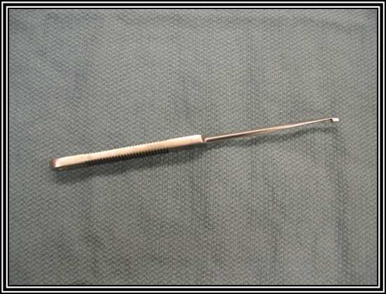 | has a long thin neck and a flat blade with a blunt-ended turned around tip with a straight cutting edge. Designed for curetting back towards the operator.
Spiral teat curette | 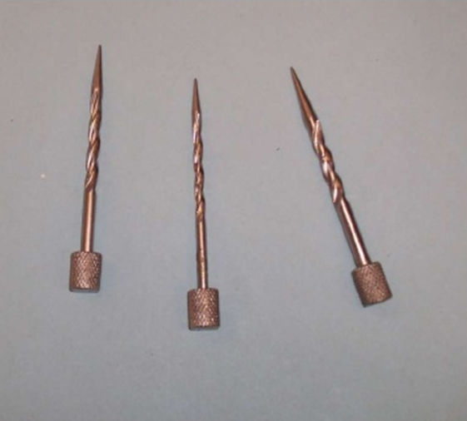 | Enlarge the teat cannal
Hug’s tumor extractor | 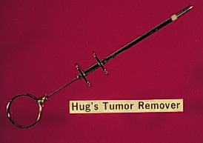 | To remove a mass inside the teat cistern
Teat tumor(mass) extractor | 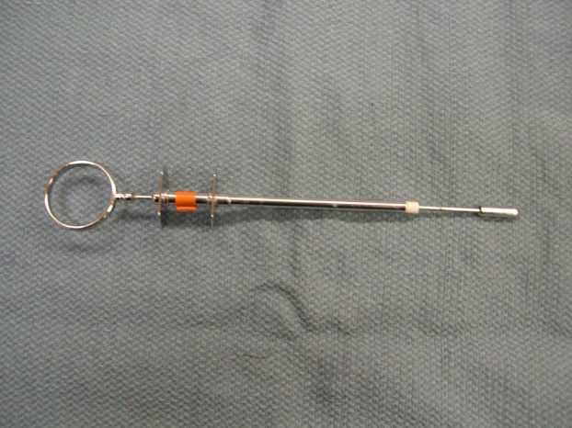 | To remove a mass inside the teat cistern
Teat cannula | 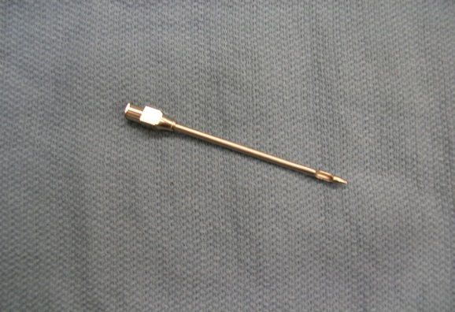 | short, narrow, 1 inch diameter round-pointed metal or plastic tube used to pass from the exterior, through the teat canal and into the teat cistern. Used to relieve pressure in the gland when the teat canal is obstructed.
Teat tube |  | Used to relieve pressure in the gland when the teat canal is obstructed. have a bulge followed by a constriction near the hub so that the tube is self-retaining
Lichty teat knife | 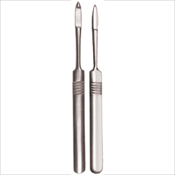 | To enlarge tight streak canals
Doyen clamp | 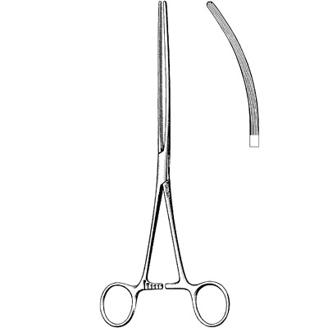
Alligator forcepts | 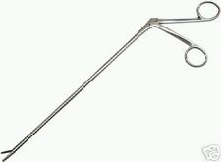 | Remove milk stones or floating calculi

