Walking sutures technique
Step 1 - After administering general anesthesia, prepare the skin around the wound for aseptic surgery. Prepare and drape a wide area around the wound so that when the walking sutures advance the skin, they do not pull haired skin from under the drape.
Manipulate the skin around the wound to determine where the most skin is available for wound closure.
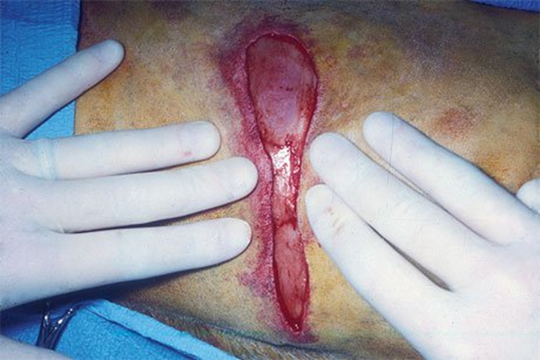
Step 2 - Undermine the skin around the wound along with any underlying panniculus muscle. Preserve large direct cutaneous blood vessels coming from underlying tissues to the dermis or panniculus muscle (at the tip of the forceps).
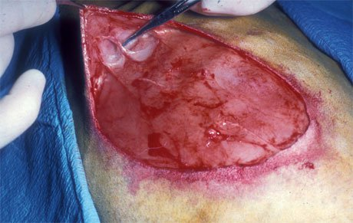
Step 3 - Using 2-0 or 3-0 absorbable suture material with a swaged needle, place the first walking suture near the junction of the undermined skin and the underlying tissue.
Pass the first suture bite through the deep portion of the dermis but not through the full-thickness of the skin (A in photo and schematic).
Pass the needle perpendicular to the wound edge to help conserve blood supply to the skin. By carefully observing the deep portion of the dermis in areas without a panniculus muscle, you can avoid incorporating large vessels into the suture, thus ensuring adequate blood supply to the skin.
You should feel some resistance to the needle passage; this resistance indicates proper placement in the dermis. Before completely passing the needle through the partial thickness of the dermis, place some tension on the needle. A dimple should form on the epidermis, further indicating that the needle is properly placed. Then complete the needle passage.
Take the second suture bite toward the center of the wound (B in photo and schematic). To ascertain precisely where to take the second bite, pinch the area of the first bite between your thumb and forefinger, with your thumb on the dermal skin surface and your forefinger on the epidermal surface. Stretch the skin toward the center of the wound as far as possible, and place the first suture bite down against the underlying tissue. Take the second suture bite at this point, incorporating the dense muscle fascia. If the bite is being placed in granulation tissue with secondary wound closure, place it deeply so it can pass through the dense collagenous base of this tissue.
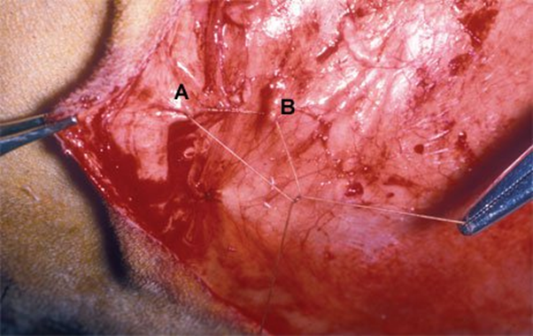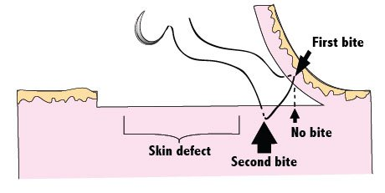
Step 4 - When the suture is tied, a portion of skin is advanced toward the center of the wound because of skin elasticity. It is helpful to have an assistant surgeon stretch the skin into place as you tie the suture. The assistant surgeon should place a thumb over the first suture bite area in the skin and use his or her thumb and other fingers to stretch the skin. As the assistant surgeon holds the area of the first bite down with his or her thumb against the area of the second suture bite, tie the suture.
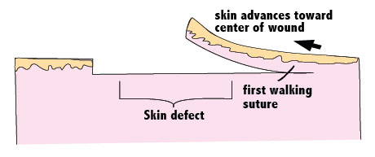
Step 5 - Place the walking sutures in staggered rows, thereby moving the skin across the defect. The skin is usually halfway across the wound after two or three rows of sutures have been placed
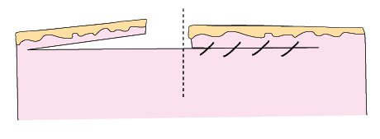
Step 6 - After repeating the procedure on the opposite side, the wound should be almost closed. If a wound is adjacent to a body structure or orifice (e.g. prepuce), use walking sutures only to advance skin on one side of the wound to prevent distortion of the structure or orifice.
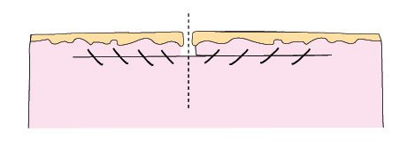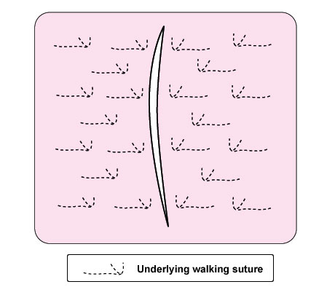
Step 7 - Close the skin with staples or simple interrupted 2-0 or 3-0 nonabsorbable sutures with no tension. (Each pair of broken lines in the photo indicates the position of an underlying walking suture.)
