***ANATOMICAL DIFFERENCES***

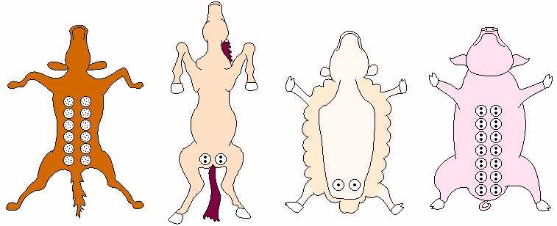

|  |  |  |  |
| --- | --- | --- | --- |
| COWS | SHEEP & GOAT | HORSES | PIGS |
| Inguinal region | Inguinal region | Inguinal region | Inguinal, Abdominal and Thoracic regions |
| -4 glands (quarters)  -4 teats  -4 teat canal | -2 glands  -1 teat  -1 teat canal | -4 glands (quarters)  -2 teats (short and laterally flattened)  -2 teat canals | -6-7 glands  -12-14 teats (small long cylindrical – 2 inguinal pairs, 3 abdominal pairs, 2 thoracic pairs)  -2-3 teat canals |
| Goat teats larger than sheep  Supernumerary teat common |
| Fine hairs on teat |
| *External pudendal artery (main)*   * Through the inguinal canal then into the udder, forming a sigmoid flexure * Branch into Cranial and Caudal Mammary Arteries   *Ventral Perineal Artery (to caudal aspect)*   * Comes from internal Pudendal Artery   Venous ring above base of udder drained by *External Pudendal Vein and Subcutaneous Abdominal (milk) Vein* | | | *Internal and External Thoracic Vessels*   * Thoracic glands   *External Pudendal and Caudal Superficial Epigastric Vessels*   * Abdominal glands   *External and Internal Pudendal Vessels* (via perineal branches)   * Inguinal glands |
| Lactating Glands: Hair absent from middle and tip of teat  Non-lactating Glands: Mainly consists of interstitial tissue with abundant fatty tissue | | |  |

