Client Education

Study of post amputation survival of cattle in herd.

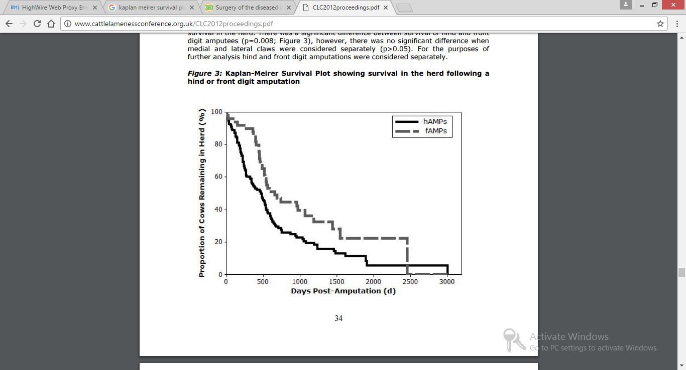

Survival analysis was used to determine if the digit removed significantly influenced survival in the herd. There was a significant difference between survival of hind and front digit amputees

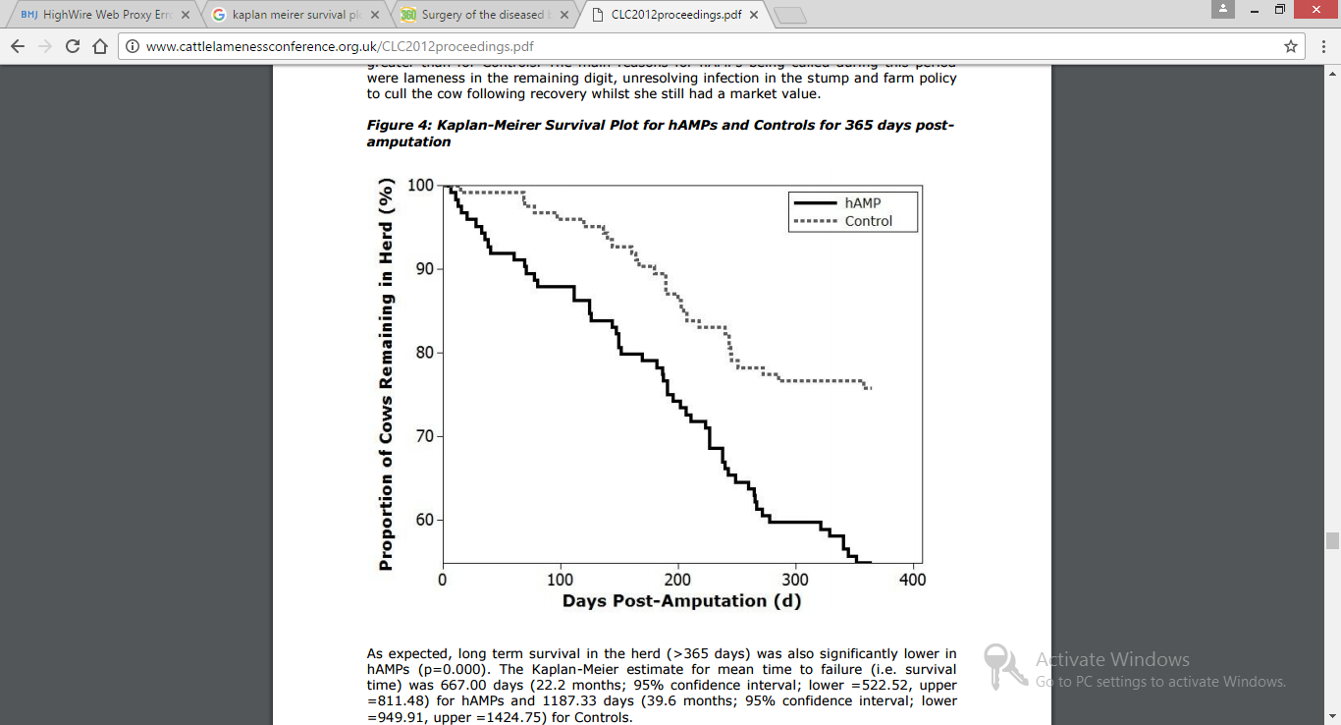

Figure 4 shows the survival curve for hAMPs and Controls in the 365 days post- amputation. Examining the gradients of the survival plots it is apparent that the first 100 days post-amputation is the critical time during which culling rates for hAMPs is much greater than for Controls. The main reasons for hAMPs being culled during this period were lameness in the remaining digit, unresolving infection in the stump and farm policy to cull the cow following recovery whilst she still had a market value.