**Locomotion Scoring of Dairy Cattle**

Locomotion scoring is based on the observation of cows standing and walking (gait), with emphasis on their back posture.

Use of locomotion scoring is effective for early detection of claw (hoof) disorders, monitoring prevalence of lameness, comparing the incidence and severity of lameness between herds and identifying individual cows for hoof trimming.

**Dairy Cattle Locomotion Scores and Descriptions**

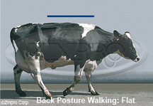

**Clinical Description:** Normal

Stands and walks normally with a level back. Makes long confident strides.

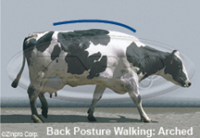

**Clinical Description:** Mildly Lame

Stands with flat back, but arches when walks. Gait is slightly abnormal.

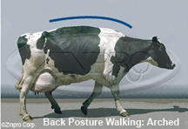

**Clinical Description:** Moderately Lame

Stands and walks with an arched back and short strides with one or more legs. Slight sinking of dew-claws in limb opposite to the affected limb may be evident.

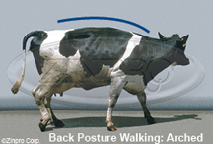

**Clinical Description:** Lame

Arched back standing and walking. Favouring one or more limbs but can still bear some weight on them. Sinking of the dew-claws is evident in the limb opposite to the affected limb.

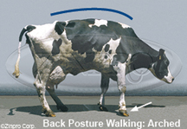

**Clinical Description:** Severely Lame

Pronounced arching of back. Reluctant to move, with almost complete weight transfer off the affected limb.