**Callicrate Bander Closed Castration**

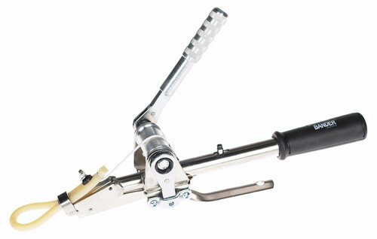This technique for castration involves the placement of an elastic rubber band around the scrotum of the animal above the level of the testes.

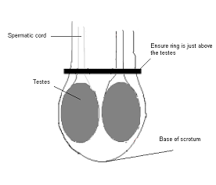Upon completion of preoperative procedures (sedation, local anesthesia, analgesia, prophylactic antibiotics (discretion based on the environment and likelihood of infections), tetanus shots and proper restraint) then the testes can be palpated and ensure both testes are present. The testes can then be pulled down to the base of the scrotum where the elastic band can be slipped over the scrotum to above the level of the testes. Load the callicrate bander with the loop and ensure the clip seam is positioned facing upwards then crank the lever to the proper tension required for castration and crimp the clip. The excess elastic can then be cut.

This method is bloodless. It works by restricting the blood supply to the scrotum and testes thus there is tissue necrosis until the entire scrotum falls off.

The process may be painful and the pain can extend for several weeks- mainly seen by reduced growth rates and decreased appetites.

Variation of the callicrate bander method is the cryptorchid method in which the elastic band is placed below the testes after the testes have been lifted to very close to the body wall. The part of the scrotum below the level of the band will atrophy and become necrotic and fall away but the testes remains tucked close to the body wall. The heat from the body should be enough to cause infertility as it compromised sperm production but with the benefit of still producing testosterone which can increase growth rates.

**Burdizzo Castration Method**

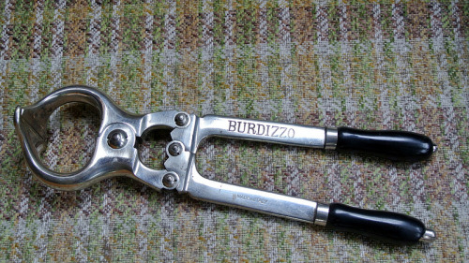This technique involved clamping the testicular blood vessels and the spermatic cords of the testes causing the testes to atrophy however the blood supply to scrotal sac is not compromised as such the scrotum remains.

Preoperative procedures should involve all those mentioned previously.

The spermatic cord should be isolated and pulled laterally (so as to isolate it from the median raphe and reduce the amount of the scrotum that will be crushed) then the burdizzo is placed so that only that spermatic cord is held within the jaws of the burdizzo (not across the entire scrotum, you do NOT want to crush the blood supply to the scrotum). Slowly close the burdizzo ensuring the spermatic cord remains in the crush area (finger can be placed in such a way that it stabilizes the spermatic cord laterally to reduce slipping of the cord), once the cord is surely in place, continue to stabilize the cord (caution when crushing so as to not accidentally clamp the fingers) then completely close the burdizzo to crush the cord, hold for 30 to 60 seconds. Repeat on the next side for the other testis ensuring you stagger the crushes. 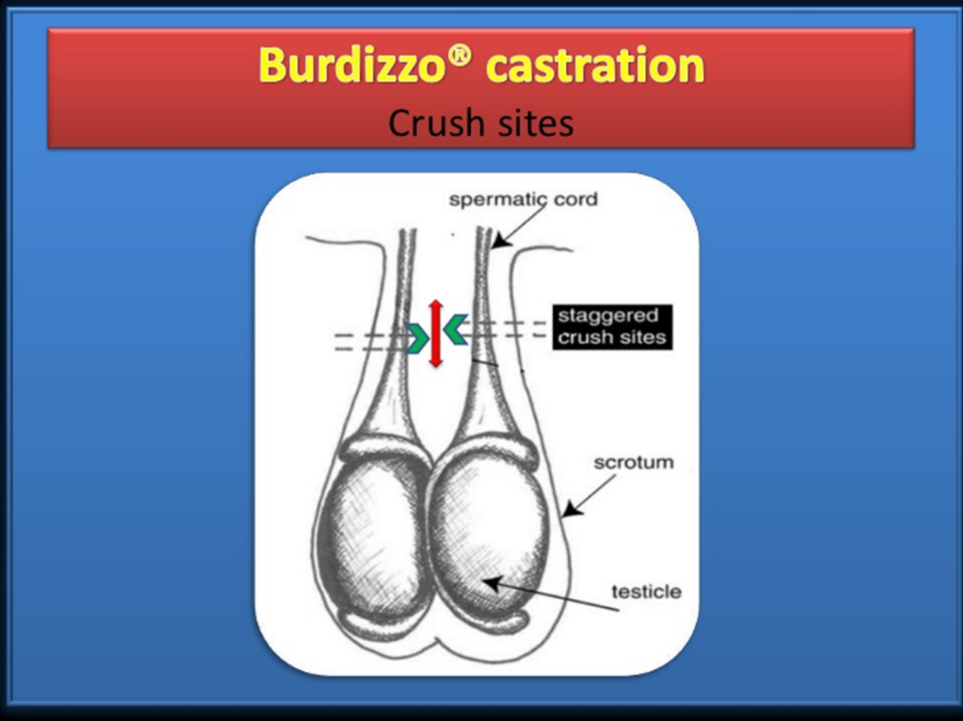Two crushes on each side can be used for added security (place them about 1cm apart)

Both testes should atrophy and there will not be sperm production.

The entire scrotum cannot be crushed at one time as it would disrupt the blood flow to the entire scrotum as the median raphe is crushed. This would cause death and necrosis of the entire scrotum (gangrene) and can open the animal up to infections.